**Chapter 8: Fair Division**

Many students believe that mathematics hasn’t changed in several hundred years. However, the field of fair division is relatively young. Some of the methods discussed in this chapter were developed after the 1940s. This is an open field of study in mathematics. The methods we will look at do not always give the best possible answer but they are the best methods we have at this point in time.

Fair division tries to divide something in an equitable way. It can be used to divide up an estate, a jewelry collection, or a piece of land among heirs. Fair division can also be used to split up the assets of a business when a partnership is being dissolved. It can even be used by roommates to divide up the cleaning chores when the cleaning deposit is on the line.

**Section 8.1: Basic Concepts of Fair Division**

How do we divide items or collections of items among 2 or more people so that every person feels he/she received a fair share: Different people may assign a different value to the same item. A “fair share” to one person may not be the same as a “fair share” to another person. The methods in this chapter will guarantee that everyone gets a “fair share” but it might not be the “fair share” he/she wanted.

People often refer to fair division as a game. It has players and rules just like a game. The set of goods to be divided is called S. The players P1, P2, P3,…, Pn are the parties entitled to a share of S. Each player must be able to assign a value to the set S or any subset of the set S.

In a **continuous** fair-division game the set S is divisible in an infinite number of ways, and shares can be increased or decreased by arbitrarily small amounts. Typical examples of continuous fair-division games involve the division of land, cake, pizza, etc… A fair-division game is **discrete** when the set S is made up of objects that are indivisible like paintings, houses, cars, boats, jewelry, etc. A pizza can be cut into slices of almost any size but a painting cannot be cut into pieces. To make the problems simple to think about, we will use cakes or pizzas for continuous examples and collections of small candies for discrete examples. A **mixed** fair-division game is one in which some of the components are continuous and some are discrete and is not covered in this book.

The method we use to divide a cake or pizza can be used to divide a piece of land or to divide the rights of access to mine the ocean floor (between countries). The method we use to divide a mixed bag of Halloween candy can be used to divide a large jewelry collection. This book will not get to all of them but we can also use fair division ideas to decide which transplant patient gets a liver when it becomes available, or to help two companies merge (who is CEO, who has layoffs, which name to use, etc.).

**Rules:** In order for the division of S to be fair, the players in the game must be willing participants and accept the rules of the game as binding.

* The players must act rationally according to their system of beliefs.
* The rules of mathematics apply when assigning values to the objects in S.
* Only the players are involved in the game, there are no outsiders such as lawyers.

If the players follow the rules the game will end after a finite number of moves by the players and result in a division of S.

**Assumptions:** We must assume the following:

* The players all play fair.
* They have no prior information about the likes or dislikes of the other players.
* They do not assign values in a way to manipulate the game.
* All players have equal rights in sharing the set S. In other words, if there are three players, each player is entitled to at least 1/3 of S.

If these assumptions are not met, the division may not be totally fair.

**What is a fair share?**

The basic idea in a continuous fair division game is that S is divided into pieces. Each player assigns a value to each piece of S. Based on these values a player decides which pieces he/she considers a fair share. Since each player is entitled to at least a proportional share of S, it is easy to determine what is considered a fair share.

**Example 8.1.1: Determining Fair Shares**

Four players Abby, Betty, Christy, and Debbie are to divide a cake S. The cake has been sliced into four pieces, S1, S2, S3, and S4 (not necessarily the same size or with the same amount of frosting). Each of the players has assigned a value to each piece of cake as shown in the following table.

**Table 8.1.1: Values of Each Piece of Cake**

|  |  |  |  |  |
| --- | --- | --- | --- | --- |
| Player/Piece | S1 | S2 | S3 | S4 |
| Abby | 10% | 50% | 30% | 10% |
| Betty | 30% | 30% | 10% | 30% |
| Christy | 40% | 20% | 20% | 20% |
| Debbie | 25% | 25% | 25% | 25% |

Which of the pieces would each player consider a fair share?

Since there are four players, each player is entitled to at least  of S.

The fair shares are highlighted in the following table.

**Table 8.1.2: Fair Shares for Each Player**

|  |  |  |  |  |
| --- | --- | --- | --- | --- |
| Player/Piece | S1 | S2 | S3 | S4 |
| Abby | 10% | 50% | 30% | 10% |
| Betty | 30% | 30% | 10% | 30% |
| Christy | 40% | 20% | 20% | 20% |
| Debbie | 25% | 25% | 25% | 25% |

**Find the Value of a Piece of S:**

How did the players in Example 8.1.1 determine the value of each piece: Part of the value is emotional and part is mathematical. Consider three heirs who must split up an island consisting of a stretch of beach, a small mountain, and a large meadow. A person who really likes the beach may be willing to settle for a smaller piece of the island to get the beach.

For the examples in this chapter, all cakes will be drawn in two-dimensions. The height of the cake is not relevant to the problem as long as the cake is uniform in height.

It will be helpful to remember that there are 360◦ in a full circle.

**Example 8.1.2: The Value of a Slice of S, #1**

Fred buys a half strawberry, half vanilla cake for $9. He loves vanilla cake but only likes strawberry cake so he values the vanilla half of the cake twice as much as the strawberry cake. Find the values of slices S1, S2, and S3 in the following figure.

**Figure 8.1.3: Half Strawberry/Half Vanilla Cake with Three Slices**

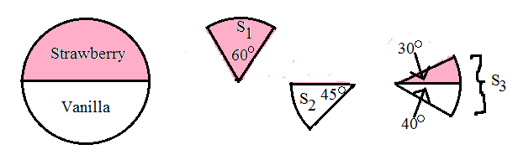

Find the value of each half of the cake using algebra.

Let x = the value of the strawberry half of the cake.

Then 2x = the value of the vanilla half of the cake.

The total value of the cake is $9.



The strawberry half is worth $3 and the vanilla half is worth $6.

1. Value of S1:

60◦ is 1/3 of 180◦ (the strawberry half of the cake) so the slice is worth 1/3 of $3.



1. Value of S2:

45◦ is 1/4 of 180◦ (the vanilla half of the cake) so the slice is worth 1/4 of $6.



1. Value of S3:

Since S3 is part strawberry and part vanilla we must find the value of each part separately and then add them together.



**Example 8.1.3: The Value of a Slice of S, #2**

Tom and Fred were given a cake worth $12 that is equal parts strawberry, vanilla and chocolate. Tom likes vanilla and strawberry the same but does not like chocolate at all. Fred will eat vanilla but likes strawberry twice as much as vanilla and likes chocolate three times as much as vanilla.

**Figure 8.1.4: Three-Flavored Cake**

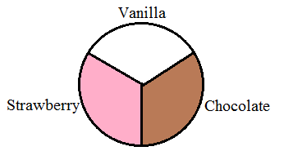

1. How should Tom divide the cake into two pieces so that each piece is a fair share to him?

The cake is worth $12 so a fair share is . Tom must cut the cake into two pieces. They do not have to be the same size but they do have to have the same value of $6 in Tom’s eyes. Tom does not like chocolate so all the value of the cake is in the strawberry and vanilla parts. Also, Tom likes vanilla and strawberry equally well so each of these parts of the cakes are worth $6 in his eyes.

**Figure 8.1.5: How Tom Sees the Cake**

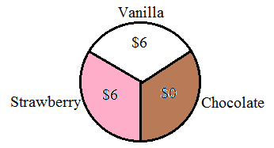

The easiest division is to cut the cake so that one slice contains all the strawberry part and half the chocolate part and the other slice contains all the vanilla part and the other half of the chocolate part.

**Figure 8.1.6: Tom’s Two Pieces**

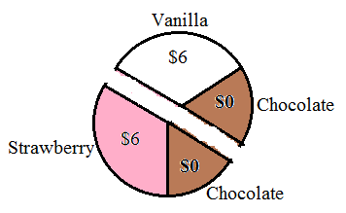

Note that Tom could slice the cake along a chord of the circle as shown below. The mathematics involved in that type of cut is beyond the scope of this course

**Figure 8.1.7: Another Possibility for Tom’s Two Pieces**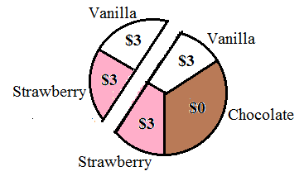

1. How should Fred divide the cake into two pieces so that each piece is a fair share to him?

Let x = value of the vanilla part to Fred.

Then 2x = value of the strawberry part.

Also, 3x = value of the chocolate part.



**Figure 8.1.8: How Fred Sees the Cake**

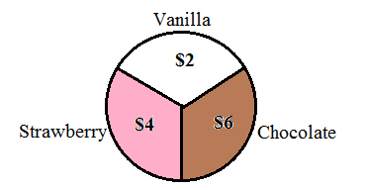

Fred needs to cut the cake into two pieces so that each piece has a value of $6. An obvious choice would be to make the chocolate part one of the pieces and both the vanilla and strawberry parts the other piece. As you can see in Figure 8.1.9 each of the pieces is worth a total of $6.

**Figure 8.1.9: First Possibility for Fred’s Two Pieces**

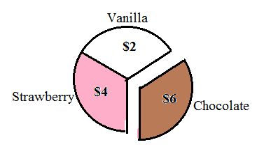

1. Find another way for Fred to divide the cake.

There are many possibilities. Let’s assume he wants to cut the chocolate part in half since he likes chocolate the most. This will guarantee that Fred gets some of the chocolate part regardless of which piece he gets in the game. The chocolate part is worth $6 to Fred so each half of the chocolate piece would be worth $3.

**Figure 8.1.10: Dividing the Chocolate Part in Half**

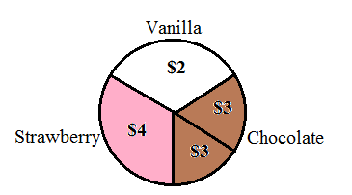

Fred needs to add another $3 worth of cake to each of the chocolate pieces. It is easy to see that Fred needs to cut the cake somewhere in the strawberry part so that the strawberry part is cut into two pieces. Let’s call the smaller piece of the strawberry part “piece 1” and the larger piece of the strawberry part “piece 2.” Piece 1 needs to be worth $1 and piece 2 needs to be worth $3 so that each slice of the cake ends up with a total of $6.

**Figure 8.1.11: Dividing the Strawberry and Vanilla Parts**

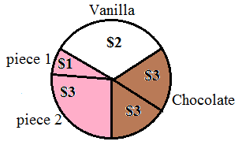

The strawberry part of the whole cake is 1/3 of the cake or  . Piece 2 is worth $3 of the $4 for the strawberry part so it is ¾ of the 120◦ or 90◦. Piece 1 would be 120◦ - 90◦ = 30◦.

**Figure 8.1.12: Second Possibility for Fred’s Two Pieces**

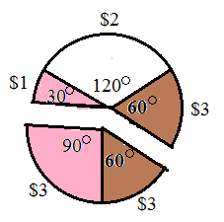

**Example 8.1.4: The Value of a Slice of S, #3**

George and Ted wish to split a 12-inch sandwich worth $9. Half the sandwich is vegetarian and half the sandwich is meatball. George does not eat meat at all. Ted likes the meatball part twice as much as vegetarian part.

**Figure 8.1.13: Sub Sandwich**

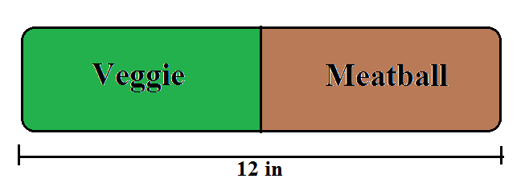

1. How should George divide the sandwich so that each piece is a fair share to him?

George is a vegetarian so all the value is in the vegetarian half of the sandwich. He should divide the vegetarian part of the sandwich in half. One piece will be all of the meatball part plus three inches of the vegetarian part. The second piece will just be three inches of the vegetarian part.

**Figure 8.1.14: How George Should Cut the Sandwich**

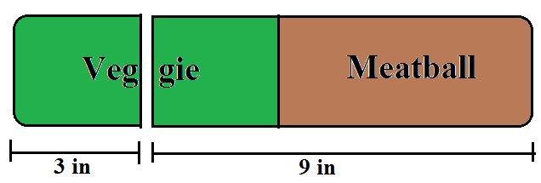

1. How should Ted divide the sandwich so that each piece is a fair share to him?

Let x be the value of vegetarian part of the sandwich.

Then 2x is the value of the meatball part of the sandwich.



Ted sees the meatball part with a value of $6 and the vegetarian part with a value of $3. A fair share to Ted would be $4.50, half the value of the sandwich. Ted must divide the sandwich somewhere in the meatball part.



**Figure 8.1.15: How Ted Should Cut the Sandwich**

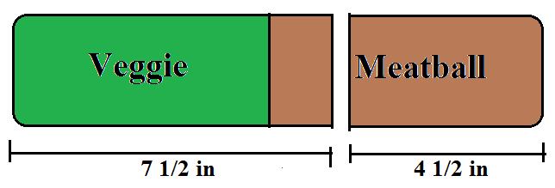

**Section 8.2: Continuous Methods 1: Divider/Chooser and Lone Divider Methods**

The Divider/Chooser method and the Lone Divider method are two fairly simple methods for dividing a continuous set S. They can be used to split up a cake or to split up a piece of land. The Lone Divider method works for three or more players but works best with only three or four players. The Divider/Chooser method is a special case of the Lone Divider method for only two players.

**Divider/Chooser Method:**

If you have siblings you probably used the Divider/Chooser method for fair division as a kid. Remember when Mom told one child to break the candy bar in half and then the other child got to choose which half to take: That was the Divider/Chooser method. It is a very simple method for dividing a single continuous item between two players. Simply put, one player cuts and the other player chooses. Call the object to be divided S. The divider is the player who cuts the object S. The divider is forced to cut the object S in a way that he/she would be satisfied with either piece as a fair share. The chooser then picks the piece that he/she considers a fair share. Once the chooser picks a piece the divider gets the remaining piece. The divider always gets exactly half the value of S. The chooser sometimes ends up with more than half of the value of S. This sounds contradictory but remember that each player has his/her own value system.

**Example 8.2.1: Divider/Chooser Method with a Pizza**

Bill and Ted want to divide a pizza that is half cheese and half pepperoni. Bill likes cheese pizza but not pepperoni and Ted likes all pizza equally.

**Figure 8.2.1: Half Cheese and Half Pepperoni Pizza**

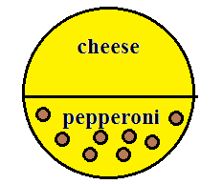

1. If Bill cuts and Ted chooses, describe the fair division.

Bill likes cheese but not pepperoni so he sees all the value of the pizza in the cheese part. He cuts the pizza in a way that half of the cheese part ends up in each piece. The most obvious way to do this is to cut it in half vertically. You might think that Bill would choose half the pizza as the cheese side and half as the pepperoni side in the hopes he would end up with the entire cheese side. However, that would not be a division that results in two equal halves in his eyes. In other words, he could end up with the entire pepperoni side which he does not like.

**Figure 8.2.2: Bill’s Division of the Pizza**

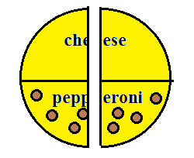

Since Ted likes all pizza equally and both parts are the same it does not matter which piece Ted chooses. Let’s say he chooses the piece on the right.

Ted is happy because he got half of the pizza, a fair share in his value system.

Bill is happy because he got half of the cheese part of the pizza, half of the value (or a fair share) in his value system.

1. If Ted cuts and Bill chooses, describe three different fair divisions.

Remember that one of our assumptions is that Ted does not know that Bill only likes the cheese part of the pizza. Since Ted likes all pizza equally, he should cut the pizza in half in terms of the volume (for our two-dimensional pizza, cut it in half in terms of the area).

1. Ted could cut the pizza in half vertically just like Bill did in part (a). It would not matter which piece Bill chose since both pieces are the same.

**Figure 8.2.3: Ted’s Division of the Pizza, #1**



1. Ted could cut the pizza in half horizontally so that one piece was all cheese and the other piece was all pepperoni.

**Figure 8.2.4: Ted’s Division of the Pizza, #2**

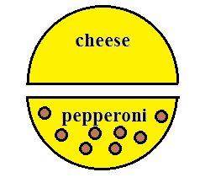

Bill would choose the cheese half and Ted would get the pepperoni half. Bill is happy because he gets 100% of the value of the pizza in his value system. Ted is happy because he gets 50% of the value of the pizza in his value system.

1. Ted could cut the pizza at an angle so that each piece is part pepperoni and part cheese.

**Figure 8.2.5: Ted’s Division of the Pizza, #3**

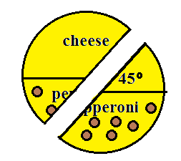

Since Bill only likes the cheese part, he should choose the piece on the left with the 75% of the cheese part of the pizza. Bill is happy because he gets 75% of the value of the pizza in his value system. Ted is happy because he gets 50% of the value of the pizza in his value system.

**Example 8.2.2: Divider/Chooser Method with a Sub Sandwich (Example 8.1.4 Continued)**

In Example 8.1.4, George and Ted want to split a 12-inch sandwich worth $9. Half the sandwich is vegetarian and half the sandwich is meatball. George does not eat meat at all. Ted likes the meatball part twice as much as vegetarian part. We already figured out how each player should cut the sandwich.

1. If George cuts which piece should Ted choose?

**Figure 8.2.6: George’s Division of the Sandwich**



Ted sees the meatball part with a value of $6 and the vegetarian part with a value of $3. Half of the vegetarian part would be worth $1.50 to him. The larger part of the sandwich would have a value of $6.00 + $1.50 = $7.50 and the smaller part of the sandwich would have a value of $1.50. He should choose the larger part of the sandwich.

1. If Ted cuts which piece should George choose?

**Figure 8.2.7: Ted’s Division of the Sandwich**



George does not eat meat so the smaller all meatball piece is worth $0 to him. The larger piece contains all the vegetarian part of the sandwich so it contains all the value to him. George should choose the larger piece which is worth $9 to him.

Note that in Example 8.2.2, part (a), Ted’s piece was worth $7.50 to him and in part (b) George’s piece was worth $9 to him. In both situations, the chooser ends up with more than a fair share. The divider always gets exactly a fair share. Given the choice, it is always better to be the chooser than the divider.

**Lone Divider Method:**

The Divider/Chooser method only works for two players. For more than two players we can use a method called the Lone Divider method. The basic idea is that a divider cuts the object into pieces. The rest of the players, called choosers, bid on the pieces they feel are fair shares. Each chooser is given a piece he/she considers a fair share with the remaining piece going to the divider. As we saw in the Divider/Chooser method, the divider always gets exactly a fair share but the choosers may get more than a fair share.

**Example 8.2.3: Lone Divider Method, Basic Example**

Three cousins, Russ, Sam, and Tom want to divide a heart-shaped cake. They draw straws to choose a divider and Russ is chosen. Russ must divide the cake into three pieces. Each piece must be a fair share in his value system. Assume Russ divides the cake as shown in the following figure.

**Figure 8.2.8: Russ’s Division of the Cake**

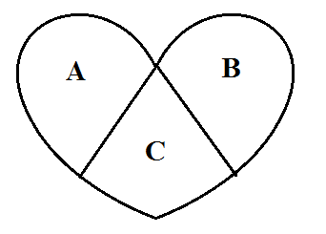

Sam and Tom now bid on each piece of the cake. They privately and independently determine a value for each piece of the cake according to their value system.

Sam sees the value of the cake as: Piece A – 40%, piece B – 30%, and piece C – 30%.

Tom sees the value of the cake as: Piece A – 35%, piece B – 35%, and piece C – 30%.

Since there are three players, a fair share would be 1/3 or 33.3%.

Each player writes down which pieces they would consider a fair share of the cake. These are called the bids.

Sam would bid {A} and Tom would bid {A, B}.

Neither Sam nor Tom consider piece C to be a fair share so piece C goes to Russ, the divider.

Sam only considers piece A to be a fair share so give Sam piece A.

Tom would be satisfied with either piece A or B. Since piece A was given to Sam, Tom gets piece B.

Notice that Sam believes his piece is worth 40% of the value and Tom believes his piece is worth 35% of the value so both of them got more than a fair share. The divider Russ got a piece worth exactly 33.3% or a fair share in his opinion. The divider always receives exactly a fair share using this method.

**Summary of the Lone Divider Method:**

1. The n players use a random method to choose a divider. The other n-1 players are all choosers.
2. The divider divides the object S into n pieces of equal value in his/her value system.
3. Each of the choosers assigns a value to each piece of the object and submits his/her bid. The bid is a list of the pieces the player would consider a fair share.
4. The pieces are allocated using the bids. Sometimes, in the case of a tie, two pieces must be combined and divided again to satisfy all players.

**Example 8.2.4: Lone Divider Method with a Cake, No Standoff**

A cake is to be divided between four players, Ian, Jack, Kent, and Larry. The players draw straws and Ian is chosen to be the divider. Ian divides the cake into four pieces, S1, S2, S3, and S4. Each of these pieces would be a fair share to Ian. The other three players assign values to each piece as summarized in Table 8.2.9

**Table 8.2.9: Players’ Valuation of Shares**

|  |  |  |  |  |
| --- | --- | --- | --- | --- |
|  | S1 | S2 | S3 | S4 |
| Ian | 25% | 25% | 25% | 25% |
| Jack | 40% | 30% | 20% | 10% |
| Kent | 15% | 35% | 35% | 15% |
| Larry | 40% | 20% | 20% | 20% |

Since there are four players a fair share is 25% of the cake. The three choosers submit their bids as follows:

Jack: {S1, S2}, Kent: {S2, S3}, and Larry: {S1}

The distribution is fairly straightforward. Larry gets S1 since it is the only piece he considers a fair share. With S1 taken Jack will get S2, his only remaining possible fair share. With S2 taken Kent will get S3, his only remaining possible fair share. That leaves S4 for the divider Ian.

**Example 8.2.5: Lone Divider Method with a Piece of Land, Simple Standoff**

**Figure 8.2.10: A Map of the Land**

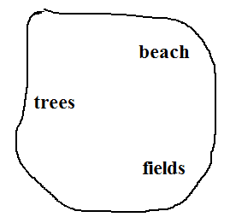

Amy, Bob and Carly want to divide a piece of land using the lone-divider method. They draw straws and Bob is chosen as the divider. Bob draws lines on the map to divide the land into three pieces of equal value according to his value system.

**Figure 8.2.11: Bob’s Division of the Land**

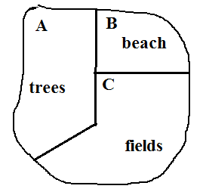

Amy and Carly bid on the pieces of land that they would consider fair shares. Both of them like the beach and the fields but not the trees so their bids are Amy: {B, C} and Carly: {B, C}.

Since neither Amy nor Carly want piece A with the trees, that piece will go to the divider Bob.

Both Amy and Carly would be happy with either of the remaining pieces. A simple way to allocate the pieces is to toss a coin to see who gets piece B with the beach. The other player would get piece C with the fields.

**Example 8.2.6: Lone Divider Method with a Piece of Land, More Complicated Standoff**

Let’s look at the land in Example 8.2.5 again. This time let’s assume the bids are Amy: {B} and Carly: {B}.

Since both Amy and Carly want the same piece of land we have a standoff. Neither of the women want pieces A and C so give one of them to the divider Bob. Toss a coin to choose which piece he gets. Let’s assume the toss results in Bob getting piece A.

To resolve the standoff we combine pieces B and C to make one large piece.

**Figure 8.2.12: Combining Pieces B and C**

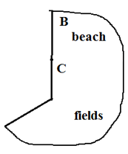

We now have one piece of land to be divided equally between two players. Amy and Carly can use the Divider/Chooser method to the finish the division. Toss a coin to determine the divider. Assume Amy is chosen to divide and divides the land as shown in Figure 8.2.13.

**Figure 8.2.13: Amy’s Division of the Piece**

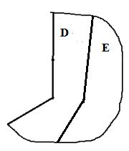

Let’s assume that Carly picks piece E, leaving piece D for Amy, to complete the fair division.

You can see from the previous examples that sometimes the lone divider method is very straight forward and other times it can be more complicated. Imagine how complicated the method could become with 10 players. Regardless of the number of players or how complicated the division is, one fact remains. The choosers always get at least a fair share while the divider only gets an exact fair share. It is better to be a chooser than the divider.

**Section 8.3: Continuous Methods 2: Lone Chooser and Last Diminisher Methods**

The Lone Chooser method, like the Lone Divider method, is an extension of the Divider/Chooser method. The Lone Chooser method for three players involves two dividers and one chooser. It can be extended to N players with N-1 dividers and one chooser. We will focus on the three player Lone Chooser method in this book.

The Last Diminisher is a very different method from the Divider/Chooser methods we discuss in this book. In a sense, everyone is a divider and everyone is a chooser. The Last Diminisher method works well when many players must divide a continuous object like a cake or a piece of land.

**Lone Chooser Method:**

In the Lone Chooser method for three players, there are two dividers and one chooser. The basic idea is that the two dividers use the Divider/Chooser method to divide the object into two pieces. At this point each of the dividers believes that he/she has at least half the value of the object. Next each divider divides his/her piece into three smaller pieces for a total of six pieces. The chooser then picks one piece from each of the dividers’ pieces leaving all three players with two pieces each.

**Summary of the Lone Chooser method:**

1. Randomly choose one player to be the chooser, C. The other two players are dividers, D1 and D2.
2. The dividers D1 and D2 use the Divider/Chooser method to divide the object into two pieces.
3. Each of the dividers D1 and D2 subdivide his/her piece into three pieces of equal value. Use the same ideas as we used in the Divider/Chooser method for determining the value of each piece.
4. The chooser assigns a value to each of the six pieces according to his/her value system. The chooser then picks the piece with the greatest value from each of the dividers. Each of the dividers keep his/her other two pieces.

**Example 8.3.1: Lone Chooser Method for Three Players**

Fred, Gloria, and Harvey wish to split a three-flavored cake worth $36 that is one-third chocolate, one-third strawberry, and one-third vanilla. Fred does not like chocolate, but likes strawberry and vanilla equally well. Gloria likes chocolate twice as much as vanilla and likes strawberry three times as much as vanilla. Harvey likes chocolate and strawberry equally but likes vanilla twice as much as chocolate or strawberry. Use the Lone-Chooser method to find a fair division for the cake.

**Figure 8.3.1: Three-Flavored Cake**

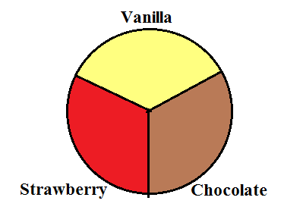

First let’s figure out how each player values each of the pieces of the cake.

Fred sees the chocolate part of the cake as having a value of $0 since he does not like chocolate. All of the value of the cake is in the strawberry and vanilla parts. Since he likes them equally well, the strawberry part and the vanilla part are both worth $36/2=$18.

For Gloria, let x = the value of the vanilla part of the cake. Then the chocolate part is worth 2x and the strawberry part is worth 3x.



To Gloria the vanilla part is worth $6, the chocolate part is worth $12 and the chocolate part is worth $18.

For Harvey, let y = the value of the chocolate part of the cake. Then the value of the strawberry part is also y and the value of the vanilla part is 2y.



To Harvey the chocolate and strawberry parts are each worth $9 and the vanilla part is worth $18.

Assume the players draw cards to pick the chooser and Henry wins. Then Fred and Gloria must first do the Divider/Chooser method on the cake. They draw cards again and Fred is chosen as the divider. He needs to divide the cake into two pieces each worth $18. There are many possible ways for Fred to cut the cake. Let’s assume he cuts it as shown in figure 8.3.2.

**Figure 8.3.2: How Fred Cuts the Cake**

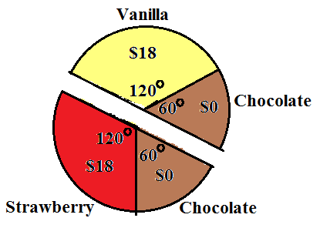

Before Gloria can choose a piece, she must find the value of each of Fred’s pieces in her value system.

**Figure 8.3.3: How Gloria Sees the Cake**

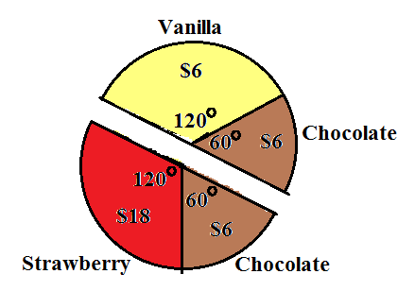

Gloria should choose the strawberry and chocolate piece since it has the highest value to her.

Now Fred and Gloria independently divide their pieces into three pieces of equal value in their respective value systems. Remember that each flavor of cake takes up 120◦. Since Fred sees the chocolate as having no value, he needs to divide the 120◦ of vanilla into three equal pieces of 40◦, each worth $6. One of the pieces will also include the 60◦ of chocolate. Gloria’s piece is worth a total of $24 so she needs to divide it into three pieces each worth $8. Start with the Strawberry part.  She cuts two pieces of strawberry that have an angle of 53.3◦. The remaining amount of strawberry is  Combining the small strawberry piece with the chocolate piece gives a larger piece with an angle of 73.4◦ and a value of  The pieces are numbered for convenience.

**Figure 8.3.4: The Subdivisions of Each Piece**

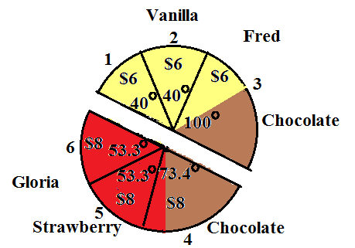

At this point, Harvey joins the game. He assigns a value to each piece according to his value system.

**Figure 8.3.5: How Harvey Sees the Pieces**

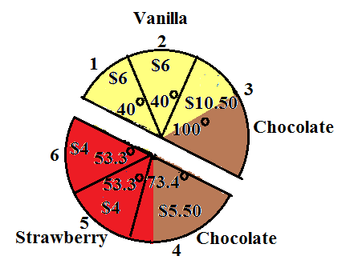

Pieces 1 & 2: 

Piece 3: 

Piece 4: 

Pieces 5 & 6: 

Harvey should pick the piece from each divider that he sees as having the greatest value. Fred and Gloria each keep the two pieces from their parts that Harvey does not pick. That gives each of the players two of the six pieces.

Now let’s look at the final division. Harvey gets pieces 3 and 4 for a total value of $16.00, more than a fair share to him. Gloria gets pieces 5 and 6 for a total value of $16, more than a fair share to her. The original divider Fred gets pieces 1 and 2 for a total value of $12, exactly a fair share to him.

**Last Diminisher Method:**

The Last Diminisher method can be used to divide a continuous object among many players. The concept is fairly simple. A player cuts a piece of the object. Each of the other players gets to decide if the piece is a fair share or too big. Any player that thinks the piece is too big can cut it smaller (diminish it). The key to the method is that the last person to cut/diminish a piece has to keep it.

**Summary of the Last Diminisher method:**

1. The players use a random method to choose an order. The players continue in the same order throughout the game. Call the n players, in order, P1, P2, P3, …, Pn.
2. Player 1 cuts a piece he/she considers a fair share. In order, each of the remaining players either passes (says the piece is a fair share and P1 can have it) or diminishes the piece. The last player to diminish the piece keeps the piece and leaves the game. If no one diminishes the piece, P1 keeps the piece and leaves the game.
3. The lowest numbered player still in the game cuts a piece of the object. Each of the remaining players can either pass or diminish the piece. The last player to cut/diminish the piece keeps it and leaves the game.
4. Repeat step three until only two players remain. These players use the Divider/Chooser method to finish the game.

**Example 8.3.2: Last Diminisher Method, #1**

Suppose six players want to divide a piece of land using the Last Diminisher method. They draw cards to choose an order. Assume the players in order are denoted P1, P2, P3, P4, P5, and P6.

In round one, P1 cuts a piece by drawing lines on a map of the land. Assume players P2 through P6 pass on the piece. Since P1 is the last player to cut or diminish the piece, P1 keeps the piece and leaves the game.

In round two, players P2 through P6 remain in the game. P2 is the lowest numbered player so P2 cuts a piece of the land. Assume that P3 and P4 pass on the piece. P5 thinks that the piece is more than a fair share so P5 diminishes the piece by redrawing the lines on the map to make the piece smaller. Assume P6 passes. Since P5 is the last player to diminish the piece, P5 keeps the piece and leaves the game.

In round three, players P2, P3, P4, and P6 remain in the game. P2 is still the lowest numbered player so P2 cuts a piece of the land. This time assume that P3 diminishes, P4 passes and P6 diminishes the piece. P6 keeps the piece and leaves the game.

In round four, players P2, P3, and P4 remain in the game. Once again P2 cuts a piece. Assume both P3 and P4 pass on the piece. P2 keeps the piece and leaves the game.

For round five, since only P3 and P4 are left, they do Divider/Chooser on the remaining land. P3 cuts and P4 chooses.

**Example 8.3.3: Last Diminisher Method, #2**

Eight players want to divide a piece of land using the Last Diminisher method. They draw straws to determine an order. Assume the players in order are denoted by P1, P2, P3, P4, P5, P6, P7, and P8. P3 and P5 are the only diminishers in round one. No one diminishes in rounds two, three and six. P8 is the only diminisher in round four. Both P4 and P6 diminish in round five. Describe the fair division round by round.

Round one: P1 cuts a piece, P2 passes, P3 diminishes, P4 passes, P5 diminishes, P6, P7, and P8 pass. P5 is the last diminisher so P5 keeps the piece and leaves the game.

Round two: P1 cuts a piece and everyone else passes so P1 keeps the piece and leaves the game.

Round three: P2 is now the lowest numbered player so P2 cuts a piece. Everyone else passes so P2 keeps the piece and leaves the game.

Round four: P3 is now the lowest numbered player so P3 cuts a piece. P4, P6, and P7 pass. P8 diminishes the piece making P8 the last diminisher so P8 keeps the piece and leaves the game.

Round five: P3 is still the lowest numbered player so P3 cuts a piece. P4 and P6 both diminish the piece but P7 passes. P6 is the last diminisher so P6 keeps the piece and leaves the game.

Round six: P3 cuts a piece again and everyone else passes, so P3 keeps the piece and leaves the game.

Round seven: P4 and P7 are the only players left so they use the Divider/Chooser method to divide the remaining land. P4 divides and P7 chooses.

**Section 8.4: Discrete Methods: Sealed Bids and Markers**

There are two more fair division methods that deal with discrete objects. It two heirs have to split a house they cannot just cut the house in half. Instead we have to figure out a way to keep the house intact and still have both heirs feel like they received a fair share. The method of sealed bids is used for dividing up a small number of objects not necessarily similar in value. If there are many objects similar in value, like a jewelry collection, the method of markers can be used to find a fair division.

**Method of Sealed Bids**

The method of sealed bids can be used to split up an estate among a small number of heirs. A nice feature of this method is that every player in the game ends up with more than a fair share (in their own eyes). The method can also be used when business partners wish to dissolve a partnership in an equitable way or roommates want to divide up a large list of chores.

We make the following assumptions in the method of sealed bids.

1. The players are the only ones involved in the game and are willing to accept the outcome.
2. The players have no prior knowledge of the other players’ preferences so they do not try to manipulate the game. If this assumption is not met the game might not produce a fair division.
3. The players are not emotionally/irrationally attached to any of the items. The players will settle for any of the items or cash as long as it is a fair share. For example, no one would say “I want the house and I will do anything to get it.”

The easiest way to explain the method is to work through an example. An easy way to keep the steps neat and organized is to do the steps in one big table, working from the top to the bottom.

**Example 8.4.1: Method of Sealed Bids, #1**

Three heirs, Alice, Betty and Charles inherit an estate consisting of a house, a painting and a tractor. They decide to use the method of sealed bids to divide the estate among themselves.

1. The players each submit a list of bids for the items. The bid is the value that a player would assign to the item. The bids are done privately and independently. The bids are usually listed in a table.

**Table 8.4.1: Initial Bids**

|  |  |  |  |
| --- | --- | --- | --- |
|  | Alice | Betty | Charles |
| House | $280,000 | $275,000 | $300,000 |
| Painting | $75,000 | $70,000 | $72,000 |
| Tractor | $56,000 | $60,000 | $63,000 |

1. For each item, the player with the highest bid wins the item. The winning bids are highlighted in the table.

**Table 8.4.2: Winning Bids**

|  |  |  |  |
| --- | --- | --- | --- |
|  | Alice | Betty | Charles |
| House | $280,000 | $275,000 | $300,000 |
| Painting | $75,000 | $70,000 | $72,000 |
| Tractor | $56,000 | $60,000 | $63,000 |

1. For each player find the sum of his/her bids. This amount is what the player thinks the whole estate is worth. For three players, each player is entitled to one third of the estate. Divide each sum by three to get a fair share for each player. Remember that each player sees the values differently so the fair shares will not be the same.

**Table 8.4.3: Total Bids and Fair Shares**

|  |  |  |  |
| --- | --- | --- | --- |
|  | Alice | Betty | Charles |
| House | $280,000 | $275,000 | $300,000 |
| Painting | $75,000 | $70,000 | $72,000 |
| Tractor | $56,000 | $60,000 | $63,000 |
| Total Bids | $411,000 | $405,000 | $435,000 |
| Fair Share | $137,000 | $135,000 | $145,000 |

1. Each player either gets more than his/her fair or less than his/her fair share when the items are awarded. Find the difference between the fair share and the items awarded for each player. If a player was awarded more than his/her fair share, the player owes the difference to the estate. If a player was awarded less than his/her fair share, the estate owes the player the difference.

Alice: $137,000 - $75,000 = $62,000. The estate owes Alice $62,000.

Betty: $135,000 - $0 = $135,000. The estate owes Betty $135,000.

Charles: $145,000 – ($300,000 + $63,000) = -$218,000. Charles owes the estate $218,000.

**Table 8.4.4: Owed to Estate and Estate Owes**

|  |  |  |  |
| --- | --- | --- | --- |
|  | Alice | Betty | Charles |
| House | $280,000 | $275,000 | $300,000 |
| Painting | $75,000 | $70,000 | $72,000 |
| Tractor | $56,000 | $60,000 | $63,000 |
| Total Bids | $411,000 | $405,000 | $435,000 |
| Fair Share | $137,000 | $135,000 | $145,000 |
| Owed to Estate |  |  | $218,000 |
| Estate Owes | $62,000 | $135,000 |  |

1. At this point in the game, there is always some extra money in the estate called the surplus. To find the surplus, we find the difference between all the money owed to the estate and all the money the estate owes.

$218,000 – ($62,000 + $135,000) = $21,000.

Divide this surplus evenly between the three players.

Share of surplus = 

**Table 8.4.5: Share of Surplus**

|  |  |  |  |
| --- | --- | --- | --- |
|  | Alice | Betty | Charles |
| House | $280,000 | $275,000 | $300,000 |
| Painting | $75,000 | $70,000 | $72,000 |
| Tractor | $56,000 | $60,000 | $63,000 |
| Total Bids | $411,000 | $405,000 | $435,000 |
| Fair Share | $137,000 | $135,000 | $145,000 |
| Owed to Estate |  |  | $218,000 |
| Estate Owes | $62,000 | $135,000 |  |
| Share of Surplus | $7,000 | $7,000 | $7,000 |

1. Finish the problem by combining the share of the surplus to either the amount owed to the estate or the amount the estate owes. Include the items awarded in the final share as well as any money.

Alice: $62,000 + $7,000 = $69,000

Betty: $135,000 + $7,000 = $142,000

Charles: -$218,000 + $7,000 = -$211,000

**Table 8.4.6: Final Share**

|  |  |  |  |
| --- | --- | --- | --- |
|  | Alice | Betty | Charles |
| House | $280,000 | $275,000 | $300,000 |
| Painting | $75,000 | $70,000 | $72,000 |
| Tractor | $56,000 | $60,000 | $63,000 |
| Total Bids | $411,000 | $405,000 | $435,000 |
| Fair Share | $137,000 | $135,000 | $145,000 |
| Owed to Estate |  |  | $218,000 |
| Estate Owes | $62,000 | $135,000 |  |
| Share of Surplus | $7,000 | $7,000 | $7,000 |
| Final Share | Gets painting and  $69,000 cash | Gets $142,000 cash | Gets house and tractor and pays $211,000 |

Alice gets the painting and $69,000 cash. Betty gets $142,000 cash. Charles gets the house and the tractor and pays $211,000 to the estate.

Now, we find the value of the final settlement for each of the three heirs in this example. Remember that each player has their own value system in this game so fair shares are not the same amount.

Alice: Painting worth $75,000 and $69,000 cash for a total of $144,000. This is $7,000 more than her fair share of $137,000.

Betty: $142,000 cash. This is $7,000 more than her fair share of $135,000.

Charles: House worth $300,000, tractor worth $63,000 and pays $211,000 for a total share of $152,000. This is $7,000 more that his fair share of $145,000.

At the end of the game, each player ends up with more than a fair share. It always works out this way as long as the assumptions are satisfied.

**Summary of the Method of Sealed Bids:**

1. Each player privately and independently bids on each item. A bid is the amount the player thinks the item is worth.
2. For each item, the player with the highest bid wins the item.
3. For each player find the sum of the bids and divide this sum by the number of players to find the fair share for that player.
4. Find the difference (fair share) – (total of items awarded) for each player. If the difference is negative, the player owes the estate that amount of money. If the difference is positive, the estate owes the player that amount of money.
5. Find the surplus by finding the difference (sum of money owed to the estate) – (sum of money the estate owes). Divide the surplus by the number of players to find the fair share of surplus.
6. Find the final settlement by adding the share of surplus to either the amount owed to the estate or the amount the estate owes. Include any items awarded and any cash owed in the final settlement. The sum of all the cash in the final settlement should be $0.

**Example 8.4.2: Method of Sealed Bids, #2**

Doug, Edward, Frank and George have inherited some furniture from their great-grandmother’s estate and wish to divide the furniture equally among themselves. Use the method of sealed bids to find a fair division of the furniture.

*Note: We start with one table and add lines to the bottom as we go through the steps.*

1. List the bids in table form.

**Table 8.4.7: Initial Bids**

|  |  |  |  |  |
| --- | --- | --- | --- | --- |
|  | Doug | Edward | Frank | George |
| Dresser | $280.00 | $275.00 | $250.00 | $300.00 |
| Desk | $480.00 | $500.00 | $450.00 | $475.00 |
| Wardrobe | $775.00 | $800.00 | $850.00 | $800.00 |
| Dining Set | $1,000.00 | $800.00 | $900.00 | $950.00 |
| Poster Bed | $500.00 | $650.00 | $600.00 | $525.00 |

1. Award each item to the highest bidder.

**Table 8.4.8: Winning Bids**

|  |  |  |  |  |
| --- | --- | --- | --- | --- |
|  | Doug | Edward | Frank | George |
| Dresser | $280.00 | $275.00 | $250.00 | $300.00 |
| Desk | $480.00 | $500.00 | $450.00 | $475.00 |
| Wardrobe | $775.00 | $800.00 | $850.00 | $800.00 |
| Dining Set | $1,000.00 | $800.00 | $900.00 | $950.00 |
| Poster Bed | $500.00 | $650.00 | $600.00 | $525.00 |

1. Find the fair share for each player.

Doug:





Edward:





Calculate similarly for Frank and George.

**Table 8.4.9: Total Bids and Fair Shares**

|  |  |  |  |  |
| --- | --- | --- | --- | --- |
|  | Doug | Edward | Frank | George |
| Dresser | $280.00 | $275.00 | $250.00 | $300.00 |
| Desk | $480.00 | $500.00 | $450.00 | $475.00 |
| Wardrobe | $775.00 | $800.00 | $850.00 | $800.00 |
| Dining Set | $1,000.00 | $800.00 | $900.00 | $950.00 |
| Poster Bed | $500.00 | $650.00 | $600.00 | $525.00 |
| Total Bids | $3,035.00 | $3,025.00 | $3,050.00 | $3,050.00 |
| Fair Share | $758.75 | $756.25 | $762.50 | $762.50 |

1. Find the amount owed to the estate or the amount the estate owes.

Doug: 

Doug owes the estate $241.25.

Calculate similarly for Edward and Frank.

George: 

The estate owes George $462.50.

**Table 8.4.10: Owes to Estate and Estate Owes**

|  |  |  |  |  |
| --- | --- | --- | --- | --- |
|  | Doug | Edward | Frank | George |
| Dresser | $280.00 | $275.00 | $250.00 | $300.00 |
| Desk | $480.00 | $500.00 | $450.00 | $475.00 |
| Wardrobe | $775.00 | $800.00 | $850.00 | $800.00 |
| Dining Set | $1,000.00 | $800.00 | $900.00 | $950.00 |
| Poster Bed | $500.00 | $650.00 | $600.00 | $525.00 |
| Total Bids | $3,035.00 | $3,025.00 | $3,050.00 | $3,050.00 |
| Fair Share | $758.75 | $756.25 | $762.50 | $762.50 |
| Owes to Estate | $241.25 | $393.75 | $87.50 |  |
| Estate Owes |  |  |  | $462.50 |

1. Find the share of surplus for each player.





**Table 8.4.11: Share of Surplus**

|  |  |  |  |  |
| --- | --- | --- | --- | --- |
|  | Doug | Edward | Frank | George |
| Dresser | $280.00 | $275.00 | $250.00 | $300.00 |
| Desk | $480.00 | $500.00 | $450.00 | $475.00 |
| Wardrobe | $775.00 | $800.00 | $850.00 | $800.00 |
| Dining Set | $1,000.00 | $800.00 | $900.00 | $950.00 |
| Poster Bed | $500.00 | $650.00 | $600.00 | $525.00 |
| Total Bids | $3,035.00 | $3,025.00 | $3,050.00 | $3,050.00 |
| Fair Share | $758.75 | $756.25 | $762.50 | $762.50 |
| Owes to Estate | $241.25 | $393.75 | $87.50 |  |
| Estate Owes |  |  |  | $462.50 |
| Share of Surplus | $65.00 | $65.00 | $65.00 | $65.00 |

1. Find the final share for each player.

Doug: 

Calculate similarly for Edward and Frank.

George: 

**Table 8.4.12: Final Shares**

|  |  |  |  |  |
| --- | --- | --- | --- | --- |
|  | Doug | Edward | Frank | George |
| Dresser | $280.00 | $275.00 | $250.00 | $300.00 |
| Desk | $480.00 | $500.00 | $450.00 | $475.00 |
| Wardrobe | $775.00 | $800.00 | $850.00 | $800.00 |
| Dining Set | $1,000.00 | $800.00 | $900.00 | $950.00 |
| Poster Bed | $500.00 | $650.00 | $600.00 | $525.00 |
| Total Bids | $3,035.00 | $3,025.00 | $3,050.00 | $3,050.00 |
| Fair Share | $758.75 | $756.25 | $762.50 | $762.50 |
| Owes to Estate | $241.25 | $393.75 | $87.50 |  |
| Estate Owes |  |  |  | $462.50 |
| Share of Surplus | $65.00 | $65.00 | $65.00 | $65.00 |
| Final Share | Dining set and pays $176.25 | Desk and poster bed and pays $328.75 | Wardrobe and pays $22.50 | Dresser and gets $527.50 |

Doug gets the dining set and pays $176.25. Edward gets the desk and poster bed and pays $328.75. Frank gets the wardrobe and pays $22.50. George gets the dresser and $527.50 in cash.

Note that the sum of all the money in the final shares is $0 as it should be. Also note that each player’s final share is worth $65.00 more than the fair share in his eyes.

**Example 8.4.3: Method of Sealed Bids in Dissolving a Partnership**

Jack, Kelly and Lisa are partners in a local coffee shop. The partners wish to dissolve the partnership to pursue other interests. Use the method of sealed bids to find a fair division of the business. Jack bids $450,000, Kelly bids $420,000 and Lisa bids $480,000 for the business.

Make a table similar to the table for dividing up an estate and follow the same set of steps to solve this problem.

**Table 8.4.13: Method of Sealed Bids for Dissolving a Partnership**

|  |  |  |  |
| --- | --- | --- | --- |
|  | Jack | Kelly | Lisa |
| Business | $450,000 | $420,000 | $480,000 |
| Total Bids | $450,000 | $420,000 | $480,000 |
| Fair Share | $150,000 | $140,000 | $160,000 |
| Owes to Business |  |  | $320,000 |
| Business Owes | $150,000 | $140,000 |  |
| Share of Surplus | $10,000 | $10,000 | $10,000 |
| Final Share | $160,000 cash | $150,000 cash | Business and pays $310,000 |

Lisa gets the business and pays Jack $160,000 and Kelly $150,000.

**Method of Markers**

The method of markers is used to divide up a collection of many objects of roughly the same value. The heirs could use the method of markers to divide up their grandmother’s jewelry collection. The basic idea of the method is to arrange the objects in a line. Then, each player puts markers between the objects dividing the line of objects into distinct parts. Each part is a fair share to that particular player. Based on the placement of the markers, the objects are allotted to the players. If there are  players, each player places  markers among the objects. We will use notation A1 to represent the first marker for player A, A2 to represent the second marker for player A, and so on.

Many times when the players have done all the steps in the method of markers there are some objects left over. If many objects remain, the players can line them up and do the method of markers again. If only a few objects remain, a common approach is to randomly choose an order for the players, then let each player pick an object until all the objects are gone.

It is interesting to see that one player may only receive one or two objects while another player may receive four or five objects. The number of objects allotted depends on each player’s value system. First we will look at the allocation of the pieces after the markers have been placed. Once we understand that, we will look at placing the markers in the correct places for each player.

**Example 8.4.4: Method of Markers, #1**

Three players Albert (A), Bertrand (B), and Charles (C), wish to divide a collection of 15 objects using the method of markers. Determine the final allocation of objects to each player. Since there are three players, each player uses two markers.

Let’s start by looking at the line of objects and Albert’s markers.

**Figure 8.4.14: Markers for Albert**

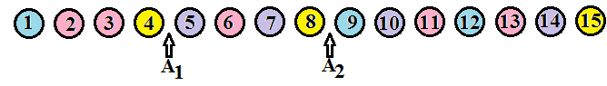

The markers divide the line of objects into three pieces. Each piece of the line is a fair share in Albert’s value system. He would be satisfied with any of the three pieces in the final allocation. For now, do not worry about how Albert determined where to place the markers. We will look at that in Example 8.4.6.

**Figure 8.4.15: Pieces (Fair Shares) for Albert**

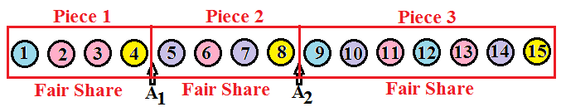

Now let’s add the markers for Bertrand and Charles.

**Figure 8.4.16: Markers for Albert, Bertrand, and Charles**

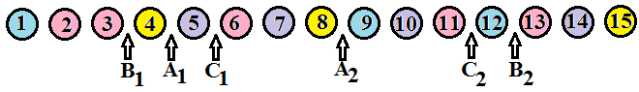

Step 1: As you examine the objects from left to right, find the first marker, B1. Give Bertrand all the objects from the beginning of the line to the marker B1. Bertrand removes the rest of his markers and leaves the game for now.

**Figure 8.4.17: Allocate the First Fair Share**

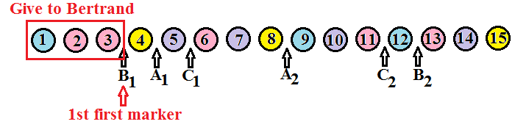

**Figure 8.4.18: Remove the Bertrand’s Fair Share and His Remaining Markers**

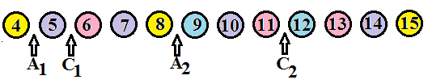

Step 2: Now, continuing from left to right, find the first marker out of the second group of markers (A2 and C2). The first marker from this group we come across is A2. Give Albert all the objects from his first marker A1 to his second marker A2. Remember that a fair share is from one marker to the next. Object #4 is not part of Albert’s fair share since it is before his first marker. Albert removes the rest of his markers and leaves the game for now.

**Figure 8.4.19: Allocate the Second Fair Share**

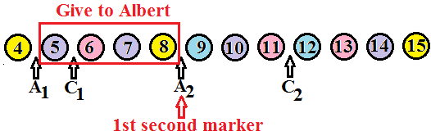

**Figure 8.4.20: Remove Albert’s Fair Share and His Remaining Markers**

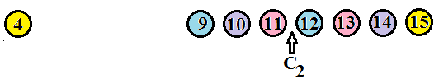

Step 3: Charles is the only player left in the game. He considers everything from his second marker to the end of the line to be a fair share so give it to him. Any objects not allocated at this point are left over.

**Figure 8.4.21: Allocate the Last Fair Share**

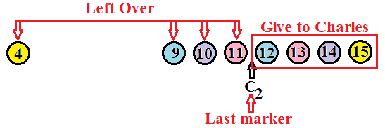

Step 4: Typically some objects are left over at this point. Objects numbered 4, 9, 10 and 11 are left over in this game. The three players could draw straws to determine an order. Then each player in order would choose an object until all the object are allocated.

*Note: Normally when we do the method of markers, we only draw the figure once.*

**Figure 8.4.22: Combined Figure for All Three Shares**

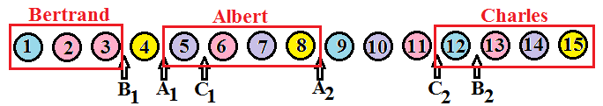

**Summary of the Method of Markers for n players:**

1. Arrange the objects in a line. Each of the n players places n-1 markers among the objects.
2. Find the 1st first marker, say A1. Give player A all the objects from the beginning of the line to the 1st first marker. Player A removes his/her remaining markers and leaves the game for now.
3. Find the 1st second marker, say B2. Give player B all the objects from the 1st second marker back to B’s previous marker B1. In other words, all the objects from B1 to B2. Player B removes his/her remaining markers and leaves the game for now.
4. Find the 1st third marker, say C3. Give player C all the objects from the 1st third marker back to C’s previous marker C2. In other words, all the objects from C2 to C3. Player C removes his/her remaining markers and leaves the game for now.
5. Continue this pattern until one player remains. Give the last player all the objects from his/her last marker to the end of the line of objects.
6. Divide up the remaining objects. If many objects remain, do the method of markers again. If only a few objects remain, randomly choose an order then let each player choose an object in order until all the objects are gone.

**Example 8.4.5: Method of Markers, #2**

Four cousins, Amy, Becky, Connie and Debbie wish to use the method of markers to divide a collection of jewels. The jewels are lined up and the cousins place their markers as shown below in Figure 8.4.23. What is the final allocation of the jewels?

**Figure 8.4.23: Jewels and Markers for Four Cousins**

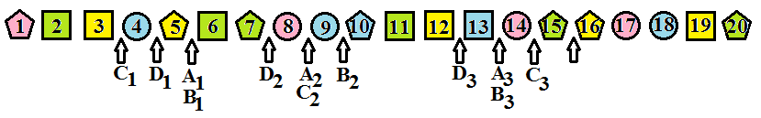  
  
The 1st first marker is C1 so give Connie all the jewels from the beginning of the line to her first marker. Connie removes her remaining markers and leaves the game for now.

**Figure 8.4.24: Allocate the First Fair Share**

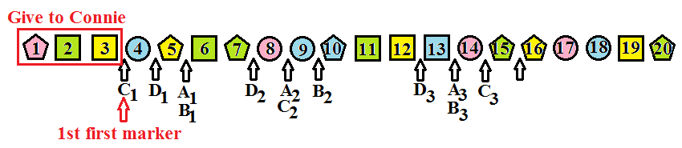

The 1st second marker is D2 so give Debbie all the jewels between markers D1 and D2. Debbie removes her remaining markers and leaves the game for now.

**Figure 8.4.25: Allocate the Second Fair Share**

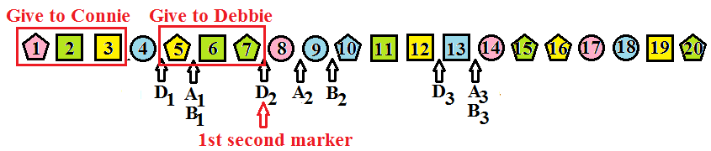

The 1st third marker is a tie between A3 and B3 so randomly choose one. One possibility is to have Amy and Becky toss a coin and the winner gets the next fair share. Assume Becky wins the coin toss. Give Becky all the jewels between markers B2 and B3. Becky removes her remaining markers and leaves the game for now.

**Figure 8.4.26: Allocate the Third Fair Share**

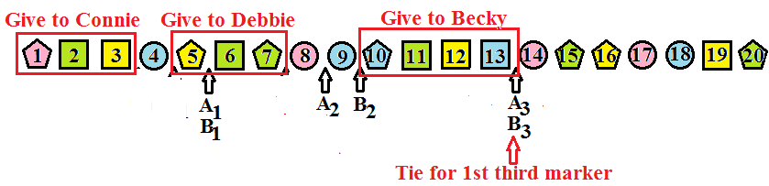

Amy is the last player in the game. Give Amy all the jewels from her last marker to the end of the line.

**Figure 8.4.27: Allocate the Last Fair Share**

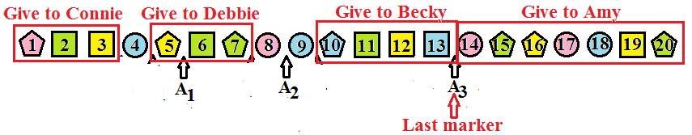

Jewels numbered 4, 8, and 9 are left over. The players can draw straws to determine an order. Each player, in order, chooses a jewel until all the jewels have been allocated.

**Example 8.4.6: Determining Where to Place the Markers**

Four roommates want to split up a collection of fruit consisting of 8 oranges (O), 8 bananas (B), 4 pears (P), and 4 apples (A). The fruit are lined up as shown below in Figure 8.4.28.

**Figure 8.4.28: Line of Fruit**



To determine where to place the markers, each player assigns a value to each type of fruit. Jack loves oranges, likes apples and pears equally, but dislikes bananas. He assigns a value of $1 to each apple and each pear, a value of $2 to each orange, and a value of $0 to each banana. In Jack’s value system, the collection of fruit is worth $24. Jack’s fair share is $6. He needs to place his markers so that the fruit is divided into groups worth $6. It can be helpful to work from both ends of the line. Jack has no choice about the placement of his first and third markers. Because he sees the bananas as worth $0 he has three possible places for his second marker. These possibilities are shown below in Figure 8.4.29 as dotted lines.

**Figure 8.4.29: How Jack Values the Fruit**

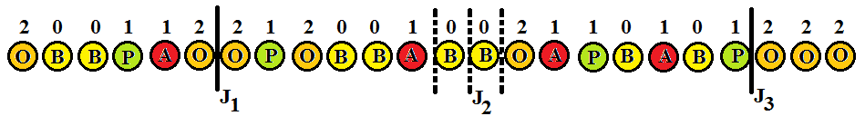

Kent dislikes apples and oranges, like bananas and really loves pears. He assigns a value of $0 to each apple or orange, a value of $1 to each banana, and a value of $3 to each pear. In Kent’s value system, the collection of fruit is worth $20. Since there are four players, Kent’s fair share is $5. He needs to place his markers so that the fruit is divided into groups worth $5. Jack has no choice about the placement of his third marker. He has a few possibilities for his first two markers. The possibilities are shown below in Figure 8.4.30 as dotted lines.

**Figure 8.4.30: How Kent Sees the Fruit.**

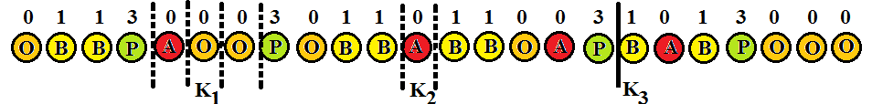

The other two roommates would follow the same process to place their markers. Once all the markers are placed, the allocation by the method of markers begins.

Imagine if the order of the fruit in Example 8.4.6 was rearranged. It might not be possible for Kent to divide up the line of fruits into groups worth $5. He might have to use a group worth $6 next to a group worth $4. This is a good time to remember that none of our fair division methods are perfect. They work well most of the time but sometimes we just have to make do. If Kent was allocated a group of fruit worth only $4 he might get some of the missing value back when the left over fruits are allocated.

**Chapter 8 Homework**

1. Three players are dividing a business. The assets are divided into three shares, S1, S2, and S3. The following table shows how each player sees each share. For each player, list the shares that the player considers a fair share.

|  |  |  |  |
| --- | --- | --- | --- |
|  | S1 | S2 | S3 |
| Doug | 40% | 30% | 30% |
| Eddie | 33 1/3% | 33 1/3% | 33 1/3% |
| Fred | 35% | 30% | 35% |

1. Four cousins are dividing a pizza. The pizza has been divided into four pieces, S1, S2, S3, and S4. The following table shows how each cousin sees each piece. For each cousin, list the pieces that the cousin considers a fair share.

|  |  |  |  |  |
| --- | --- | --- | --- | --- |
|  | S1 | S2 | S3 | S4 |
| Anne | 0% | 0% | 50% | 50% |
| Bob | 30% | 30% | 30% | 10% |
| Cathy | 20% | 30% | 20% | 30% |
| Don | 25% | 25% | 25% | 25% |

1. A three-flavored cake is one-third chocolate, one-third vanilla, and one-third strawberry. If the chocolate part is worth $4, the vanilla part is worth $6 and the strawberry part is worth $12 to Francis, find the value of each of the following slices.

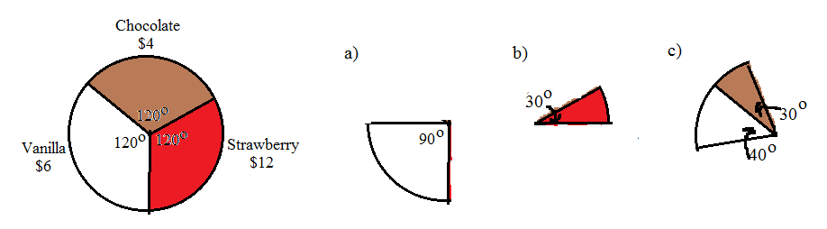

1. A three-flavored cake is one-third chocolate, one-third vanilla, and one-third strawberry. If the chocolate part is worth $6, the vanilla part is worth $8 and the strawberry part is worth $10 to George, find the value of each of the following slices.

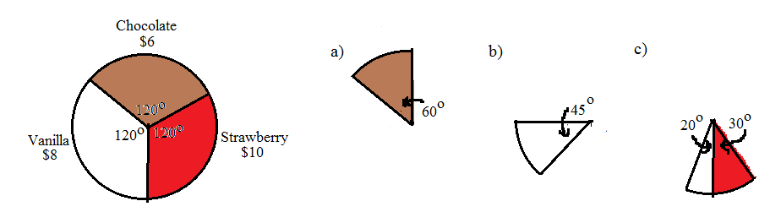

1. A 12-inch sandwich worth $6 is half turkey and half meatball. To Jack, the turkey half is worth $4 and the meatball half is worth $2. Find the value of the following slices of the sandwich.

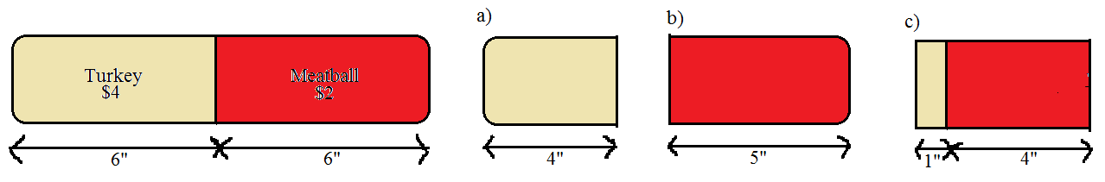

1. A 12-inch sandwich worth $9 is half turkey and half meatball. To Jack, the turkey half is worth $3 and the meatball half is worth $6. Find the value of the following slices of the sandwich.

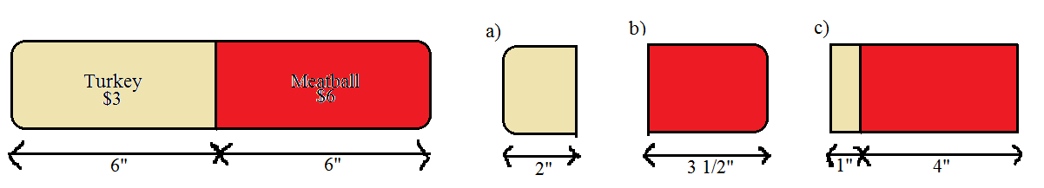

1. Alice wants to divide a half-strawberry half-vanilla cake worth $12 into two pieces of equal value. She likes strawberry three times as much as vanilla. How should she cut the cake so that each piece is a fair share to her?

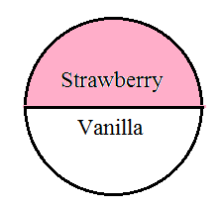

1. Sam has a pizza that is one-third pepperoni, one-third mushrooms, and one-third sausage. He likes both pepperoni and mushrooms twice as much as sausage. He wants to split the pizza into two pieces to share with his roommate. How should Sam cut the pizza so that each piece is a fair share to him?

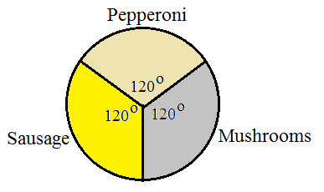

1. Luke wants to split a twelve-inch half turkey and half veggie sub sandwich worth $12 with a friend. Luke likes turkey twice as much as veggies. How should he cut the sandwich so that each piece is a fair share to him?

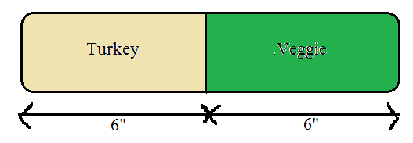

1. Alice and Betty want to divide a half-strawberry half-vanilla cake worth $12 by the divider/chooser method. Alice likes strawberry three times as much as vanilla and Betty likes vanilla twice as much as strawberry. A coin is tossed and Alice is the divider.
   1. How should Alice cut the cake?
   2. Which piece should Betty choose and what is its value to her?



1. Sam and Ted have a pizza that is one-third pepperoni, one-third mushrooms, and one-third sausage. Sam likes pepperoni and sausage equally well but does not like mushrooms. Ted likes pepperoni twice as much as sausage and likes mushrooms twice as much as pepperoni. They want to split the pizza by the divider/chooser method. After drawing straws, Sam is the divider.
   1. How should Sam cut the pizza?
   2. Which piece should Ted choose and what is its value to him?



1. Luke and Mark want to use the divider/chooser method to split a twelve-inch half turkey and half veggie sub sandwich worth $12. Luke likes turkey three times as much as veggies and Mark like veggies twice as much as turkey. They draw cards and Mark is the divider.
   1. How should Mark cut the sandwich?
   2. Which piece should Luke choose and what is its value to him?



1. Two brothers want to divide up a piece of land their grandfather left them. The piece of land, valued at $300,000 is made up of two distinct parts as shown in the following figure. Joseph likes the woods twice as much as the fields. Kevin likes the fields but does not like the woods at all. The brothers decide to use the divider/chooser method to divide the land. They toss a coin and Joseph is the divider.
   1. How should Joseph divide the land if he makes one horizontal cut on the map: Which piece of land should Kevin choose: What is its value to him?
   2. How should Joseph divide the land if he makes one vertical cut on the map: Which piece of land should Kevin choose: What is its value to him?
   3. If Joseph can make more than one cut (i.e. cut out a rectangle or a triangle) how should he cut the piece of land: Hint: there is more than one answer.

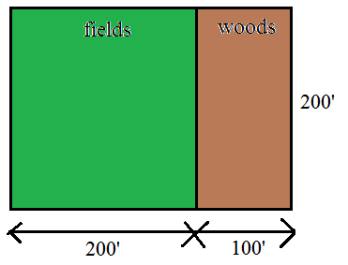

1. Amy, Becky, Charles and Doug want to use the lone divider method to split a piece of land they inherited from their father. They draw cards to determine that Doug is the divider. After Doug divides the land, Amy bids {S2, S3}, Becky bids {S1, S2}, and Charles bids {S3}. Describe the fair division.
2. Edward, Frank, George, and Harold want to use the lone divider method to split a piece of land they inherited from their Grandfather. They draw cards to determine that George is the divider. After George divides the land, Edward bids {S3, S4}, Frank bids {S2}, and Harold bids {S3, S4}. Describe the fair division.
3. Inez, Jackie, Kelly, and Louise want to use the lone divider method to split a piece of land they inherited from their father. They draw cards to determine that Jackie is the divider.
   1. If Inez bids {S2}, Kelly bids {S1, S2}, and Louise bids {S2, S4} describe the fair division.
   2. At the last minute Louise changes her bid to {S2}. If Inez and Kelly do not change their bids, describe the fair division.
4. Frank, Greg, and Harriet want to divide a cake worth $24 that is half chocolate and half strawberry. Frank likes all cake equally well. Greg likes chocolate twice as much as strawberry and Harriet like strawberry three times as much as chocolate. They decide to use the lone chooser method and draw cards to determine that Greg will cut the cake first and Harriet will be the chooser.
   1. How should Greg cut the cake?
   2. Which piece will Frank choose and what is its value to him?
   3. How will Greg subdivide his piece of the cake?
   4. How will Frank subdivide his piece of the cake?
   5. Which pieces of cake will Harriet choose?
   6. Describe the final division of the cake. Which pieces does each player receive and what are their values?

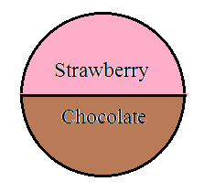

1. Paul, Rachel and Sally want to divide a four-topping pizza using the lone chooser method. The draw straws to determine that Rachel is the chooser and Paul will make the first cut. Paul likes pepperoni twice as much as mushrooms, likes sausage three times as much as mushrooms and does not like pineapple. Rachel likes mushrooms and pineapple equally well but does not like pepperoni or sausage. Sally likes all pizza equally well.
   1. How should Paul cut the pizza?
   2. Which piece should Sally choose and what is its value to her?
   3. How will Paul subdivide his piece of pizza?
   4. How will Sally subdivide her piece of pizza?
   5. Which pieces of pizza will Rachel choose?
   6. Describe the final division of the pizza. Which pieces does each player receive and what are their values?

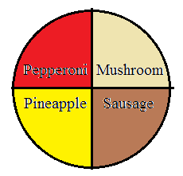

1. Eight heirs inherit a large piece of property. They decide to use the last diminisher method to divide the property. They draw straws to choose an order. Assume the order of the players is P1, P2, P3, P4, P5, P6, P7, and P8. In round one, P3, P4 and P7 are the only diminishers. In round two, no one diminishes the piece. In round three, P3 and P4 are the only diminishers. No one diminishes the piece in rounds four and five. Every player diminishes the piece in round 6.
   1. Who keeps the piece at the end of round one?
   2. Who cuts the piece at the beginning of round three?
   3. In round six, who cuts the piece and who keeps the piece?
   4. Which players are left after round six and how do they finish the division?
2. Seven heirs inherit a large piece of property. They decide to use the last diminisher method to divide the property. They draw straws to choose an order. Assume the order of the players is P1, P2, P3, P4, P5, P6, and P7. In round one, P3, P4 and P7 are the only diminishers. In round two, every player diminishes the piece. In round three, P3 and P4 are the only diminishers. No one diminishes the piece in rounds four or five. Every player diminishes the piece in round 6.
   1. Who keeps the piece at the end of round two?
   2. In round three, who cuts the piece and who keeps the piece?
   3. Who cuts the piece at the beginning of round five?
   4. Which players are left after round five and how do they finish the division?
3. Three heirs are dividing an estate consisting of a house, a lakeside cabin, and a small business using the method of sealed bids. The bids are listed in the following table.

|  |  |  |  |
| --- | --- | --- | --- |
|  | Mary | Nancy | Olivia |
| House | $350,000 | $380,000 | $362,000 |
| Cabin | $280,000 | $257,000 | $270,000 |
| Business | $537,000 | $500,000 | $520,000 |

Describe the final settlement including who gets each item and how much money they pay or receive.

1. Five heirs are dividing an estate using the method of sealed bids. The bids are listed in the following table.

|  |  |  |  |  |  |
| --- | --- | --- | --- | --- | --- |
|  | A | B | C | D | E |
| Item 1 | $352 | $295 | $395 | $368 | $324 |
| Item 2 | $98 | $102 | $98 | $95 | $105 |
| Item 3 | $460 | $449 | $510 | $501 | $476 |
| Item 4 | $852 | $825 | $832 | $817 | $843 |
| Item 5 | $513 | $501 | $505 | $505 | $491 |
| Item 6 | $725 | $738 | $750 | $744 | $761 |

Describe the final settlement including who gets each item and how much money they pay or receive.

1. Albert, Brett and Carl own a hot dog stand together. Unfortunately, circumstances are forcing them to dissolve the partnership. They decide to use the method of sealed bids with the understanding that one of them will get the hot dog stand and the other two will get cash. Albert bids $81,000, Brett bids $78,000, and Carl bids $87,000. Who gets the hot dog stand and how much does he pay each of the other two partners?
2. The method of sealed bids can be used to divide up negative items like a list of chores that must be done. The main difference in the method is that the item or chore is given to the lowest bidder rather than the highest. You also need to be careful in the “owes to estate”/”estate owes” step. Three roommates need to divide up four chores in order to get their security deposit back. They use the method of sealed bids to divide the chores. The bids are summarized in the following table.

|  |  |  |  |
| --- | --- | --- | --- |
|  | Harry | Ingrid | Jeff |
| Clean Bathrooms | $65 | $70 | $55 |
| Patch and Paint Wall | $100 | $85 | $95 |
| Scrub Baseboards | $60 | $50 | $45 |
| Wash Windows | $75 | $80 | $90 |

Describe the final outcome of the division. State which chores each roommate does and how much money each roommate gets or pays.

1. Albert, Bernard, and Charles want to divide up a collection of 17 small objects using the method of markers. The objects are laid out in a straight line and the players place their markers as shown in the following figure. Describe the final division, including which objects each player gets and how they deal with any leftover objects.

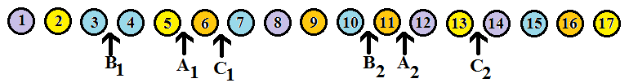

1. Alex, Bobby, Carrie, and Doug want to divide a collection of 25 small objects using the method of markers. The objects are laid out in a straight line and the players place their markers as shown in the following figure. Describe the final division, including which objects each player gets and how they deal with any leftover objects.

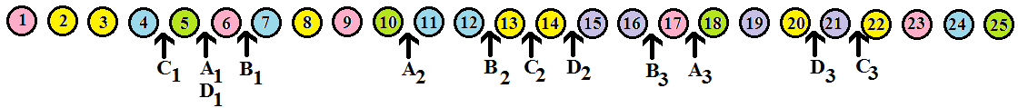

1. Jack, Kelly, and Larry want to divide a collection of 25 small objects using the method of markers. The objects are laid out in a straight line as shown in the following figure. Jack values each red object at $2, each blue object at $1, each green object at $0.50, and each yellow object at $0. Kelly values each red object at $0, each blue object at $1.50, each green object at $1, and each yellow object at $2. Larry values each red object at $1.50, each blue object at $1.50, each green object at $2, and each yellow object at $0.50. Determine where each player should place his markers. Draw the figure placing each player’s markers in the correct places. Do not determine the division of objects.

*Note: The numbers do not come out evenly so you might have to round off a bit.*

