2017-2018 Academic Program Review

In section I, provide a brief description of the program for someone who may not have direct interactions with the program. A more detailed explanation of the program will be included throughout the review document.

1. **Overview**
   1. **Narrative**
      * ***State the purpose of the program and its contributions to the community.***
      * The Physical and Biological Science (P&BS) program at CCC provides a sequence of courses for those students seeking general education science credits as part of their degree, certificate, or transfer to another institution. Our department vision statement states “the science department at CCC wants our students to have the ability to evaluate experimental predictions and outcomes, conceptual claims, problem solutions and models.” Our department mission statement is “to provide quality education to the students we serve as well as furthering the overall mission of the college.” Our intent is to provide a robust scientific aptitude in our students. We strive to create a skilled and qualified workforce equipped to face the scientific challenges of the 21st century as per the local and national needs. Our program provides quality, affordable science education and to cope with rapid changes in skill requirements in the workplace.
      * The P&BS program is diverse in terms of the component disciplines, such as Astronomy, Biology, Chemistry, Geology, and Physics. Some of these disciplines have introductory courses for non-majors to experience the field, such as Introduction to Human Anatomy & Physiology (BIO 160), Fundamental Chemistry (CHM 130), Physical Geology (GLG 101), or Introduction to Astronomy (PHY 180). These courses also fit the General Education Lab Science requirements for CCC students and our transfer institutions. More specialized elective courses permit students and the community to learn more about local science.
      * Many of the disciplines within the P&BS program offer courses that build towards specific degrees and certificates within CCC, such as the Associate of Applied Science Degree in Nursing and Associate of Science in General Studies (see Appendix 2 for the full list of degrees and certificates). Unity of Life (BIO 181/182), General Chemistry (CHM 151/152), and University Physics (PHY 161/262) are examples of courses that our students take who are planning to transfer to a four-year institution (see Appendix 1 for the full list of courses offered).
      * ***Define what sets this program apart from other programs in the college.***
      * Physical and Biological Science courses are required in 8 degrees and certificates (see Appendix 2). Many degree-seeking students requiring an AGEC or those pursuing an AGEC certificate will take our courses.
      * Many of our courses contain lab hours where students perform hands-on activities. These activities allow students to utilize special equipment, models, and lab facilities to understand scientific concepts and test hypotheses.
      * Northern Arizona is host to considerable geological and astronomical opportunities for learning. Local areas like Sunset Crater, the Grand Canyon, and Oak Creek Canyon afford us incredible opportunity for hands-on learning of different geological concepts. Being an official Dark Sky City, Flagstaff has a rich history of astronomical opportunities for learning. We have a large array of local experts in these fields (US Geological Society, Lowell Observatory) to assist us in presenting incredible activities and opportunities for our students to learn.
      * Northern Arizona University (NAU) is also located in Flagstaff. We have collaborated with their undergraduate and graduate programs to offer our students research scholarships and joint lab courses. Bridging Arizona Native American Students to Bachelor’s Degrees (Bridges) at Coconino Community College (CCC) is a two-semester program, with the opportunity of summer research work at Northern Arizona University, designed to offer tribal community college students the opportunity to get hands on laboratory experience and enhance their knowledge about the biomedical-related scientific fields. The program consists of individual projects and responsibilities in which the students will learn to collaborate with a faculty mentor and other students in a research setting. This two-semester program gives students the opportunity to develop their laboratory and scientific skill set while attending the community college.
      * We offer diverse courses within our various disciplines for students with different skill sets and different goals. Some of our courses serve as foundation classes for certain degrees and certificates, such as Microbiology (BIO 205) and Human Anatomy & Physiology (BIO 201/202) for allied health students (see Appendix 2). Some of our courses stand alone to expose students to the sciences. The Geology courses have no math prerequisites, therefore many students with math or science anxieties may find these courses more approachable when it comes to Gen-Ed science requirements.
      * We are faced with the general impression that science courses are difficult and full of memorization from many of our potential students. We have worked to make our classes approachable and achievable without sacrificing rigor. The Chemistry instructors are creating math modules to help their students keep up with the material. We have created hybrid versions of some of our courses, such as General Chemistry I (CHM 151), and Human Anatomy & Physiology I (BIO 201), to adapt to the busy life schedules of many of our students.
      * ***How does the program gather input and/or respond to community needs?***
      * We maintain dialogues with various groups in the community as to what would serve their needs. We created an Archaeoastronomy course (PHY 253) to demonstrate how different cultures were able to map the stars and learn from them.
      * We created an “Anatomy & Physiology for Engineers” non-credit course that we offered for several semesters to employees of W.L.Gore. Their engineers design vascular shunts and other life-saving devices and wanted to improve their foundational understanding of the human body and we were able to deliver a course on their Flagstaff campus.
      * Geology of the Grand Canyon (GLG 112) and Geology of the Colorado Plateau (GLG 232) offer transfer-credit science courses that capitalize on our proximity to an incredible wealth of hands-on learning. Natural History of the Southwest (BIO 109) and Wildflowers of Northern Arizona (BIO 112) are transfer-credit science courses that were created in response to local interest in these topics. We’ve offered them as non-credit courses at times, becoming successful enough to offer them as transfer-credit courses.
      * We have participated in the Festival of Science and Science in the Park for over ten years. We offer a “CCC Science Celebration” event as a capstone event for the the festival, which routinely draws several dozen members of the community to our Lone Tree campus. One of our science faculty has served on the Festival Board of Directors for over five years, helping to demonstrate the commitment of the CCC Physical & Biological Science Program to the county.
      * We have participated in the Flagstaff Community STEM Celebration Night at the Skydome. We routinely take a number of CCC science faculty and students to demonstrate concepts and share hands-on activities with learners of all ages at the event.
      * We offer a number of non-Gen. Ed. classes that take advantage of our location in northern Arizona, such as Wildflowers of Northern Arizona (BIO 112) and Geology of the Grand Canyon (GLG 112). We are investigating the idea of offering these in non-credit form for county residents who wish to benefit from these classes but don’t need college credit.
      * ***How long has the program existed?***
      * Physical science courses and biological science courses were part of the curriculum at the start of the college in 1991, creating the Science Program. We have offered degree- and certificate-pertinent courses during all semesters since the beginning of the college. It has grown over time, offering more classes each semester and more sections of each class (see Appendix 1). THe Science Program merged with the Math Program in 2000, with one department chair overseeing both programs jointly. The merged program was split into the Math Program and the Physical and Biological Sciences Program in 2014 when the administration removed department chairs from the administrative hierarchy.
      * ***When was the last program review?***
      * Program reviews previously occurred annually up through 2011 and were spearheaded by the department chair. Those reviews focused on the Biological Sciences. We have not performed a review of the entire Physical and Biological Sciences program before.
      * When Academic Affairs was reorganized in 2014, we were no longer tasked with updating annual program reviews. Instead, we focused on individual faculty reviews and the courses that each faculty member oversaw.
   2. **Program goals**
      * ***Define the program goals.***
      * The Physical and Biological Science program at CCC is dedicated to providing quality education to our students. We offer several lab science courses that satisfy General Education requirements. We offer courses that provide the foundational skills, knowledge, and coursework required to transfer to a 4-year institution.
      * We offer a variety of courses with different levels of accessibility and through different forms of delivery. We offer several stand-alone courses that contribute to learning about our local environment, such as Natural HIstory of the Southwest (BIO 109) and Geology of the Grand Canyon (GLG 112). We offer compounding courses that build upon one another as prerequisites for higher level degree programs like Nursing. These courses include Unity of Life I (BIO 181), Human Anatomy & Physiology I (BIO 201), and Microbiology (BIO 205).
      * ***Describe how the program goals are tied to the institutional mission statement.***
      * The CCC Mission Statement states “as a learning centered college, Coconino Community College enriches lives by embracing diversity and transforming the future through quality education.” We strive to offer a variety of courses that satisfy the needs of a diverse population with varying goals.
      * We offer a number of introductory courses with no prerequisite, such as Biology Concepts (BIO 100), Physical Geology (GLG 101), and Introduction to Astronomy (PHY 180), making them very accessible for incoming students and those with science or math anxieties. These courses are designed to teach students about basic science concepts, how they relate to the local environment, and apply to global issues and processes. These courses are also designed with transferability in mind or feed to higher level classes that can transfer.
      * We offer some courses to address local needs and local interests. Archaeoastronomy (PHY 253) was designed to show how pre-historical societies used celestial movements to anticipate ceremonial and survival activities. Geology of the Colorado Plateau (GLG 232) examines and observes the geology and geologic process of the Colorado Plateau and how it has affected its inhabitants.
      * We work with Disability Resources to make our lab exercises accessible to as many students as possible. We create lab practical exams that students can take in Disability Resources while still gaining the experiences of all of our students. We monitor our courses, lab resources, and online resources, to maintain accessibility for students with various forms of disability. This has included hands-on activities for visually-impaired students to perform microscopy labs in Human Anatomy & Physiology I (BIO 201), hands-on modeling activities for wheelchair-bound students who otherwise couldn’t easily reach some of the countertop equipment in Unity of Life I (BIO 181), and math modules for the chemistry courses to help all students be better prepared for and successful within the class.
      * The P&BS program participates annually with the Flagstaff Festival of Science to make science accessible to many of our county residents. The Festival is an annual 10-day event in the fall, incorporating dozens of activities across the county and offering participants an opportunity to experience first-hand the wonders of how science affects us. We have a booth at the Science in the Park with numerous hands-on activities. We host a CCC Science Night at the Lone Tree campus, inviting residents to see what we have to offer and to experience science for themselves. We have several tables at the Flagstaff Community STEM Celebration at the NAU Skydome, sharing what CCC has to offer in terms of learning about science with residents and visitors.
   3. **Decision making**
      * ***Describe how decisions are made within the program.***
      * The Physical and Biological Science program makes decisions through the consensus model. We review course schedules, assessment strategies, and plans for laboratory upgrades as a department in order to provide a unified voice for our program.
      * We collaborate with other programs on multi-disciplinary projects. We have worked with the Fine Arts Program on the Colorado Plateau Studies program. This program introduces to the students to the history, art, literature, physical and cultural geography of the Colorado Plateau, and contemporary issues of the region. The Environmental Studies Program examines the local biophysical environment, surveys the regional history and economics, and then assesses local environmental issues that may affect the health and well-being of the local environment. We have worked closely with the Nursing Program to make sure that we offer courses and labs that best serve students wishing to enter their program.
      * ***Describe the communication process within the program.***
      * We have monthly department meetings and frequent communications between the faculty and dean. With a small group of full-time employees (we’ve grown from 4 to 6 full-time faculty and retained 1 full-time staff), we are able to have regular discussions via email or impromptu meetings in the Lab Prep room. All full-time members of the department routinely attend all department meetings and contribute to the agenda.
      * We invite the Dean to our department meetings to share information. For semester course schedules, we designate one department representative to meet with the Academic Operations Coordinators and submit the proposed schedule for the next semester.
      * ***Define any outside agencies that inform decision making and their scope.***
      * We have been in routine communication with the science departments at NAU to determine that our transfer courses match theirs, to assist student transfer as best as possible. For example, we rearranged the presentation of course content within the Human Anatomy & Physiology (BIO 201/202) courses to align with their syllabi. This improved the flow of information presentation and made teaching easier for several of our part-time instructors (who are also graduate students and/or instructors at NAU). We design our courses to make sure as many of them as possible fulfill General Education lab science course requirements.
      * We send a representative to the annual ATF (articulation task force) meetings for biology, chemistry, and geology to confirm that our courses can transfer to all other 2-year and 4-year institutions in Arizona (see Appendix 2). We have revised course goals for various courses - such as Unity of Life I (BIO 181) and Human Pathophysiology (BIO 218) - to guarantee that our course goals match those of schools primarily transferred to by our students.
      * When available, we send representatives to the physics and engineering ATF meetings. We have been working to expand our offerings in these two disciplines and communication with the ATF meetings and with other institutions has helped us in the design of this growth.
      * We are creating a BioScience course (BIO 131) for the Coconino Association for Vocations, Industry and Technology (CAVIAT) program. CAVIAT is a joint technical education district, a school district that offers high school career and technical education programs to partner school districts.
   4. **A statement of the program’s accomplishments in support of the College’s current strategic plan**
      * ***Provide the goals from the strategic plan that the program contributes to.***
      * Here are the Strategic Goals for CCC for the period of 2012-2016 (See Appendix 7 for the full list).
      * Strategic goal 1: CCC will promote a learner centered environment and continue to incorporate innovative strategies to enable achievement of individual learning goals.
      * Strategic goal 2: CCC will build greater awareness of its services throughout the District and collaborate with community partners to promote the economic health and vitality of the County.
      * Strategic goal 3: CCC will continue to establish a high quality workplace which values its employees.
      * Strategic goal 4: CCC will improve the use of technology to enhance learning and services.
      * Strategic goal 5: CCC will develop and implement sustainable funding options and optimize the utilization of existing resources.
      * ***Provide evidence on how the program has been contributing to the strategic plan.***
      * Strategic goal 1:
      * We have met with local high schools regarding dual enrollment biology courses. As a consequence of these meetings we now offer several science courses for this population of students, such as BIO 181 (Unity of Life I), BIO 201 (Human Anatomy & Physiology I), and CHM 151 (General Chemistry I). - Goal 1.d.
      * Our Geology courses do not have a math prerequisite, which makes them approachable to students with math or science anxieties. Some of our Biology and Chemistry courses - such as BIO 100 and CHM 151 - have created remedial modules to assist students in these courses who may require extra practice in the foundational skills (goal 1.e.). - Goal 1.e.
      * We organized the sections for each class to optimize the timing of offerings for students (making sure that sections were offered in the mornings, afternoons, evenings and on different days). - Goal 1.f.
      * We have created several online and hybrid sections for various science courses (see Appendix 1). We are developing more online and hybrid sections of different science courses to allow flexibility in our students’ schedules. - Goal 1.h.
      * We have worked with Veteran Services and Student Services to make sure that our courses are approachable to students from all demographics. We have talked with local experts in Navajo and Hopi studies to ensure that our dissection specimens and animal models do not offend their cultures. - Goal 1.i.
      * Strategic goal 2:
      * We worked with the former department of Community and Corporate Learning to develop an “A&P for Engineers” non-credit course for vascular engineers at W.L.Gore. The course was successfully received and continued until 2015 spring when we agreed to a hiatus (we had currently trained almost all of their available engineers). - Goal 2.a.
      * Our faculty regularly work with local agencies regarding field trips, community projects, and hands-on learning activities for students. This keeps us current on what is available in the area to our employees, our classes, and our students. - Goal 2.b.
      * We had created a shared faculty position with NAU. Eventually, both institutions converted this into two separate positions, one per each institution, but it did give us an opportunity to investigate options for providing more course and employment offerings. - Goal 2.b.
      * The Physical and Biological Science department has participated in the Festival of Science and Science in the Park for over ten years. We offer a “CCC Science Celebration” event during the festival that has been well attended by the community. The department will continue to participate in these events. We have participated in the Flagstaff Community STEM Celebration Night at the Skydome. Additionally, our faculty regularly work with agencies, presenting what CCC has to offer to all residents of the county. - Goal 2.c.
      * Strategic goal 3:
      * We have recognized a CCC Science Student of the Year for each year as part of the Student Services Student Awards Ceremony. - Goal. 3.a.
      * The hiring of a full-time Geology faculty member in 2016 aids student learning (designated office hours) and creates a “lead instructor” position to work on curriculum development, new initiatives and community outreach, and to act as a mentor/liaison for part-time GLG faculty. - Goal. 3.b.
      * We hired a fourth full-time Biology faculty member in 2016 to improve our ability to provide full-time faculty assistance to students, enhance our development of online and hybrid science course offerings, and expand our collaborations with NAU. - Goal. 3.b.
      * Strategic goal 4:
      * We have created an online section of BIO 100 (Biology Concepts) and are working on an online section of BIO 181 (Unity of Life I). We have created hybrid sections of BIO 181 (Unity of Life I), BIO 202 (Human Anatomy & Physiology II), CHM 130 (Fundamental Chemistry), and CHM 151 (General Chemistry I). These sections will allow us to reach more students who may otherwise not be able to take in-person classes with us while also freeing up physical lab space for other sections (see Appendix 1). - Goal 4.a.
      * We developed an iTV (interactive TV) section of BIO 182 (Unity of Life II) in 2014 spring, teaching to students in both the Lone Tree campus at Flagstaff and the Page campus at the same time. Normally, enrollment would be too low at the Page campus for a stand-alone section of this course. - Goal 4.c.
      * The Physical and Biological Sciences program has purchased multiple computer projectors, printers, laptops and other technologies to be used for many of the classes with the program. - Goal 4.d.
      * We have purchased a classroom set of iPad computers and developed several activities within the BIO 201 and BIO 202 (Human Anatomy & Physiology) classes to use these to improve student mastery of microscopy skills. We are developing activities in other science courses, such as BIO 181 (Unity of Life I) to use these computers. We use laptop computers in various Biology and Chemistry classes to gather real-time data from experiments and analyze that data while still in the lab period. - Goal 4.e.
      * Strategic goal 5:
      * We have been vigilant regarding spending practices and improving internal efficiencies. A standardized fee scale was developed and implemented for all science classes. To optimize room utilization, a time block schedule was created and implemented. Each semester, the Science Lab Coordinator would present the status of the various budgets within the program and work with the faculty to keep expenses within budget while still offering the best classes that we can. - Goal 5.c.
      * The Science Lab Coordinator served on the Facilities Committee to keep apprised of any regulations necessary for proper lab safety and compliance. - Goal 5.d.
      * We are developing a dedicated Geology lab and a dedicated Engineering/Physics lab. We are designing appropriate storage space and lab activity space to enhance these offerings. - Goal 5.d.

In the following sections II-IV, provide a detailed description and provide evidence and data to support the claims.

1. **Teaching and Learning**
2. **Program requirements and course offerings**
   * 1. **Degrees and Certificates**
        + ***Discuss any changes to the degree and certificate outcomes within the program.* (A curriculum map with the degrees and certifications will be provided by the assessment team to be included in the Appendix.)**
        + ***Discuss any opportunities and impacts to the program from changes to degrees and certificates at the college.***

The majority of P&BS courses at CCC are taken by students pursuing a career in allied health or nursing, or by those who are seeking a general studies degree with plans to transfer to a four year university (Figure A). Less than five percent of P&BS students have not declared a major. There have not been any significant changes to the degrees or certifications sought by students enrolled in P&BS courses. A curriculum map with degrees and certifications is provided in Appendix 2.

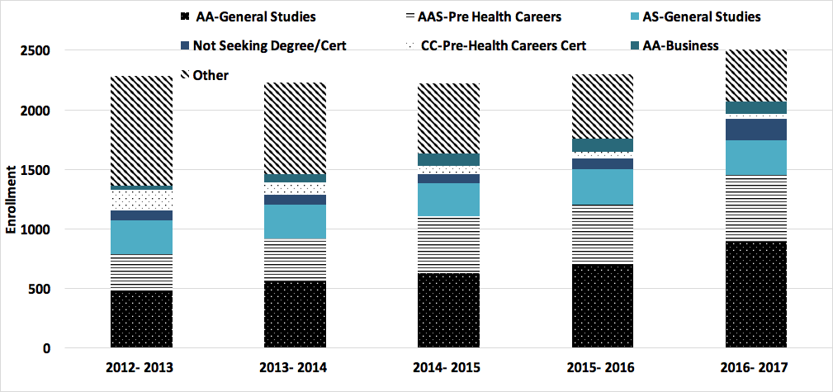

*Figure A. Over 75% of students enrolled in P&BS courses from Fall 2012 through Spring 2017 have declared one of the following three majors: Associates of Art in General Studies, Applied Associate of Science in Pre Health Career, or Associate of Science Degree.*

General P&BS requirements. At CCC there are numerous Associates of Art (AA) and Applied Associate of Science (AAS) degrees and certificates (Arizona General Education Curriculum (AGEC-A,-S,B), Pre Health Careers, etc. ) which require students to complete one or more P&BS General Education (Gen. Ed.) courses. During the five years covered by this review CCC consistently offered 25 courses which met the Gen. Ed. education standards (Figure B). A full list of all course descriptions and offering can be found in Appendix 2.

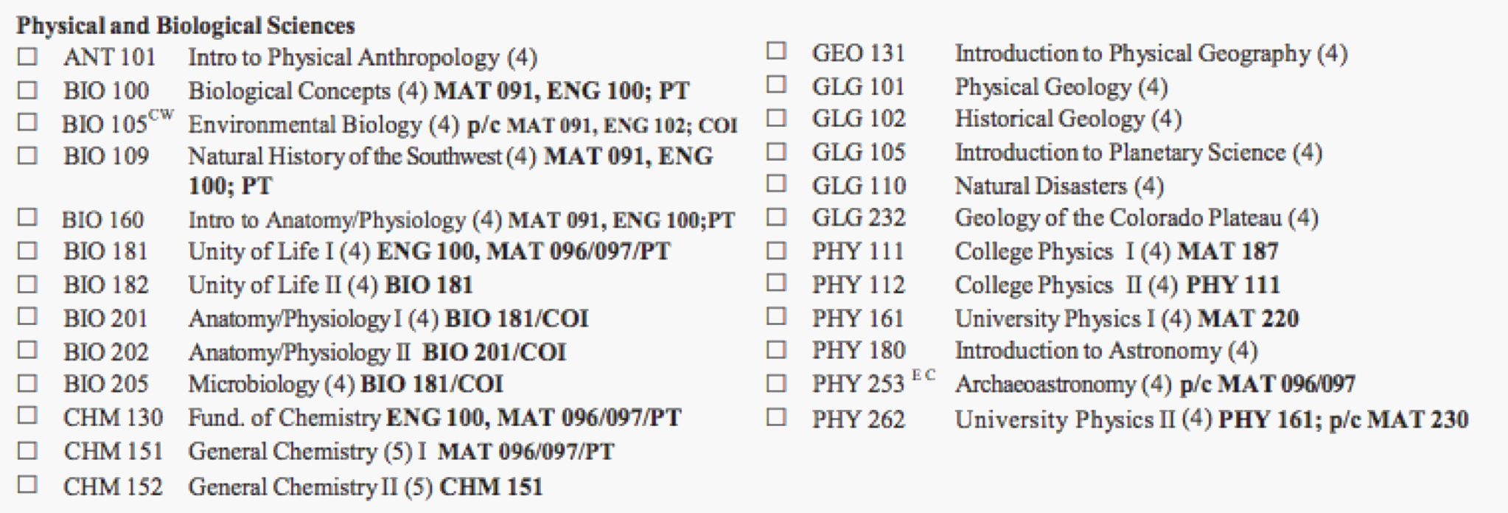

*Figure B. There are 25 general education courses consistently offered at Coconino Community College.*

Specific P&BS requirements:There are six degrees offered by CCC which require specific P&BS coursework. These degrees include the following four AA degrees and two AAS degrees (required courses are shown in parenthesis): Anthropology (ANT 101), Environmental Studies (BIO 105), Colorado Plateau Studies (CPS) (BIO 109, GLG 101), Construction Technology Management (PHY111, PHY11), Pre-Health (BIO 181, BIO 201, BIO 202, BIO 205, BIO 218) and Nursing (BIO 202, BIO 205, BIO 218, CHM 130). It is notable that BIO 181 and BIO 201 are prerequisites for BIO 202, and thus are “hidden prerequisites” which must be successfully completed in order for a student to obtain an AAS in Nursing. Additional course specific requirements apply to several certificates (see Appendix 2).

* + 1. **Course Offerings**
       - ***Discuss course offerings, types of courses, modalities, scheduling of courses and frequency of offerings.* (A list of course offerings will be provided by the assessment team to be included in the Appendix.)**

There are 32 courses offered within the Physical and BIological Sciences (13 BIO, 4 CHM, 7 GLG, 6 PHY). All courses (except BIO 218) contain a lecture and a laboratory component (4-5 credit hours per course) and all in-person courses are offered in a combined lecture and laboratory space. Students experience a great deal of personal interaction with faculty in every course, with an average faculty to student ratio of 1:25. In-person laboratory courses follow the block style: classes meet twice per week for 2½ or 3 hour sessions instead of traditional separate Lecture and Lab times. Hybrid laboratory courses generally meet for laboratory in-person once per week and online laboratory courses require students to perform and document experiments offsite. We are continuing to expand the frequency and scope of courses offered in online and hybrid formats in response to student demand (Figure E).

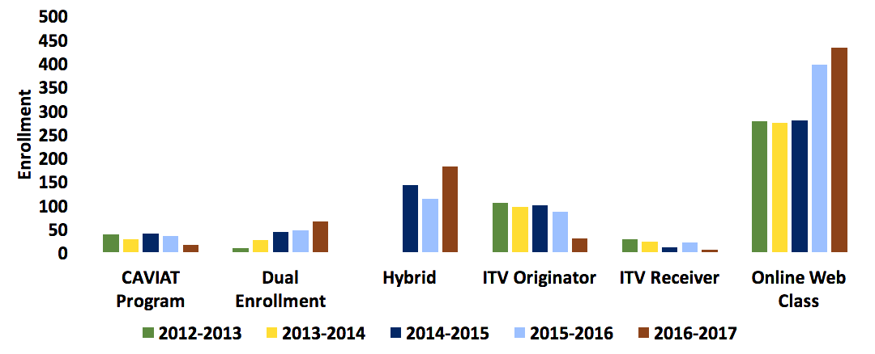

*Figure E. CCC offers dual enrollment courses at local high schools, and ITV and online courses offer remote students access to quality education. Hybrid courses usually meet once per week for half of the time allotted to face to face courses and emphasize laboratory exercises.*

Biology: The CCC catalog features 13 biology courses, 9 of which meet the general education requirements and have been offered on a regular basis. A new offering in 2016-2017 was BIO 298; it is an innovative six-credit course offered to dual enrollment students in which they work in a professional scientific laboratory and share experimental results at local conferences. The variety of biology offerings includes introductory courses for both majors and non-majors, courses tailored to students entering the health professions, courses that highlight the regional biology of the Southwest, and specialized biotechnology topics. While some courses are currently offered strictly in the in-person format, others are delivered via hybrid and/or online modalities. In-person biology courses span the full range of campus open hours. For courses with multiple sections per semester, effort is made to maximize accessibility to students by varying the scheduling among sections. See Appendix 2 for a complete list of biology course offerings. We expect to offer BIO 100, BIO 181, BIO 181, BIO 201, BIO 202 and BIO 2

Chemistry: CCC offers three Chemistry classes in an in-person format (CHM 130, 151, 152). Chemistry 130 is a fundamental Chemistry class and is primarily taken by students fulfilling the prerequisites for the CCC Nursing program. As part of a financial austerity plan in December 2013 the CCC nursing program capacity was reduced from 40 to 20 students annually and negatively impacted subsequent enrollment in CHM 130. Plans are in place to increase the CCC nursing program in Fall 2017 to a cohort of 30 students and we expect to see a consequent rebound in CHM 131 enrollment. It is worth noting that the BIO prerequisite courses for CCC nursing were not impacted by the change to the nursing program because they are common prerequisites for most nursing programs. The CCC nursing program is one of the only nursing programs in our region that requires Chemistry as a prerequisite. Chemistry 151 and 152 are transferable Chemistry classes. These two classes are taken mainly by students pursuing an AAS or by those interested in transferring to four-year college or university in pursuit of an advanced degree ( e.g. a degree in Physical Therapy, Medicine, Scientific Research,etc.) and we have seen a significant and consistent increase in enrollment.

Geology: The six laboratory based geology courses at CCC are offered consistently (see Appendix 1).Physical Geology (GLG 102) and Geology of the Colorado Plateau (GLG 232) were historically taught at the same time in the same room. Starting Fall 2016, GLG 102 has been taught separately, while G 232 has not been offered and is being evaluated for future offerings and under curriculum review. Most classes meet Mondays – Thursdays; at least one Gen. Ed. geology course is offered in the evening. All course offerings have been at the Lone Tree campus; starting summer 2014, one section of GLG 101 was offered online. An additional section of GLG 110 will be offered fall and spring a the 4th Street campus starting Fall 2017. GEO 110

Physics: CCC offers a two-semester sequence of algebra-based physics (PHY 111 and PHY 112) and calculus-based physics (PHY 161 and PHY 262). The algebra-based physics courses are primarily taken by students pursuing a career in allied health fields such as nursing, and are offered annually in person at CCC and through dual enrollment. The calculus-based physics courses are primarily taken by students interested in transferring to a four-year college and pursuing a degree at a Bachelors or higher level; these courses are offered annually in an in-person format. Physics 180 is a laboratory-based introductory astronomy course and is offered during the Fall and Spring semesters, both in-person and through dual enrollment. See Appendix 1 for details.

* + 1. **Enrollment and student success information for the previous five years**
       - ***Elaborate on any patterns or outlying data contained within provided tables.* (Data tables will be provided by the assessment team to be included in the Appendix. The first set of data tables will contain a breakdown by course of student success rates overall, by campus, by instructional method, and by session. The second set of data tables will contain an overview of the number of courses, sections, enrollments, and potential tuition earned for the previous five years.)**
       - ***Discuss other data collected by the program if desired.***

Student enrollment in P&BS courses at CCC increased steadily from 2,475 in Fall 2012 to 2,887 in Spring 2017 (Fig. C and D). The majority (97.3%) of in-person courses were offered at the Lone Tree Campus followed by those at the Page instructional site (2.3%). 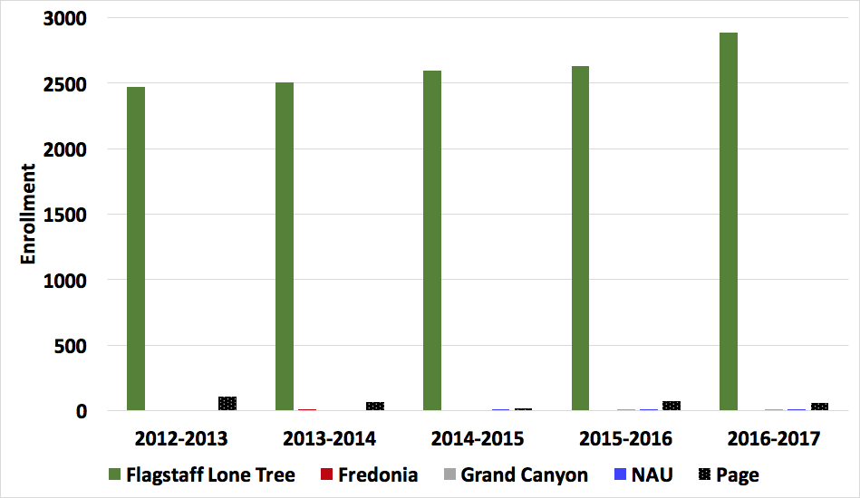

*Figure C. Student enrollment in P&BS courses at CCC increased steadily from 2,475 in Fall 2012 to 2,887 in Spring 2017.*

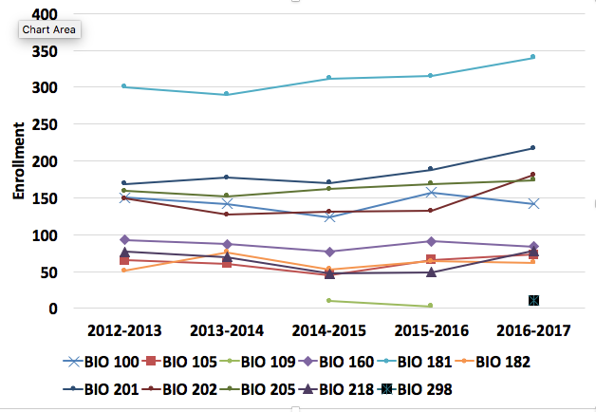

*Figure D.0. Biology Enrollment by course (counted at day 45) from Fall 2012 through Spring 2017.*

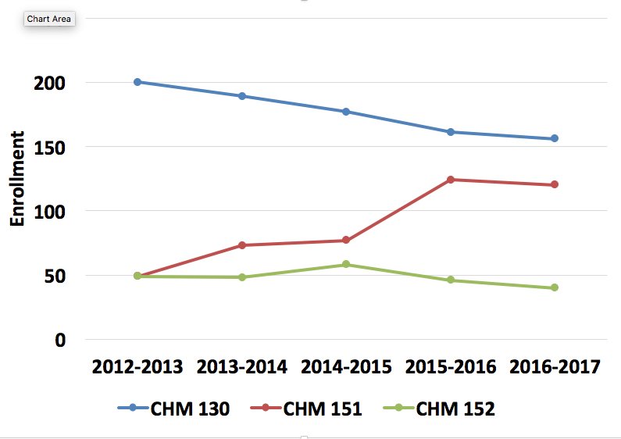

*Figure D.1. Chemistry Enrollment by course (counted at day 45) from Fall 2012 through Spring 2017.*

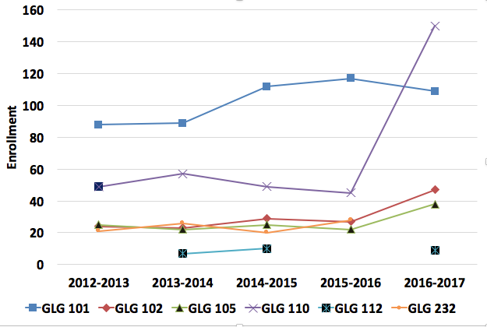

*Figure D.2 Geology Enrollment by course (counted at day 45) from Fall 2012 through Spring 2017.*

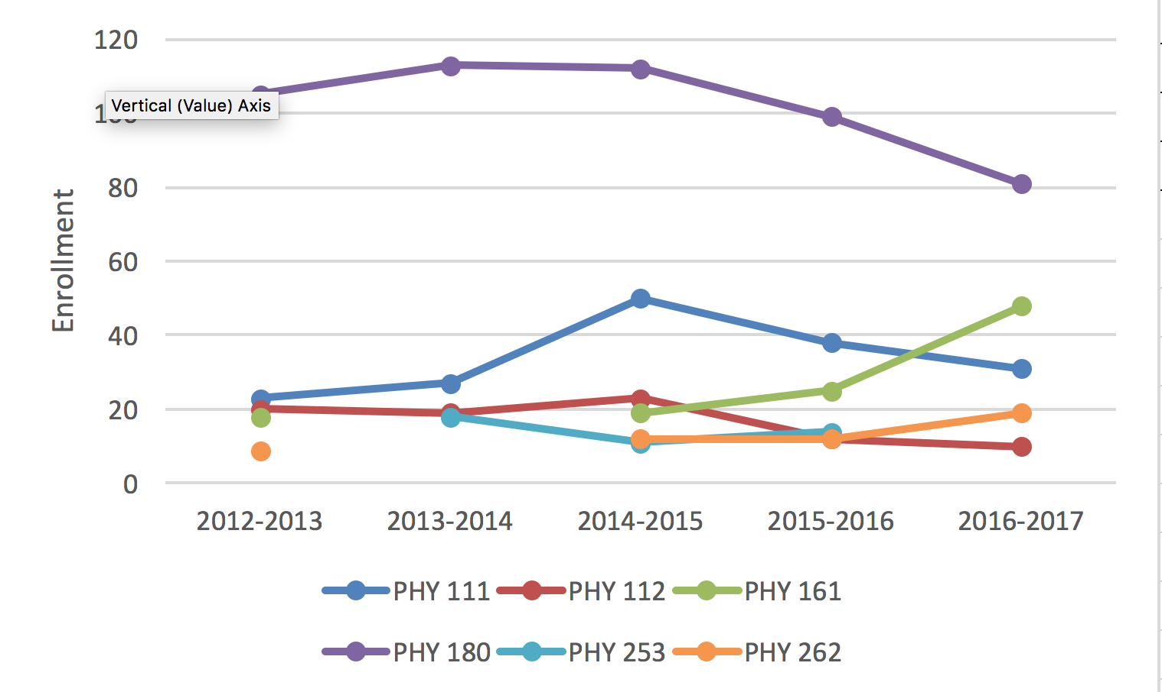

*Figure D. Physics Enrollment by course (counted at day 45) from Fall 2012 through Spring 2017.*

High school students make up 4.6% of enrollment in P&BS courses. CAVIAT high school students attend classes on CCC campus and dual enrollment students attend CCC courses at their high school. Both groups have higher success rates compared to other CCC students taking equivalent courses (see Appendix 2).

The dominant modality is in-person for P&BS courses and the in-person laboratory component of courses such as CHM 151 and 152 is likely to be maintained. However, there is an increasing percentage of P&BS courses offered online or in a hybrid format (Fig. E) and we expect to offer more P&BS courses in these modalities in the near future. Enrollment in P&BS courses consistently accounts for approximately 20% of total CCC enrollment.

Fall and Spring semesters are traditionally 16 weeks. We have offered several 5-week, 8-week and 10-week courses in the summer. There are plans to increase the variety of course duration, especially in online formats (for example 10-week and 12-week BIO 181 courses in the Fall and Spring semesters). These courses offer students more scheduling options and allow for the addition of courses in high demand after the traditional start date. Enrollment is highest the Fall and Spring semesters, 46.5% and 43.7% respectively, with Summer enrollment accounting for the remaining 9.7%.

We are proud to have a mean student success rate across all P&BS courses of 78%( Figure F.0). The success rate by course is summarized in Figure F.1. Additional data is found in Appendix 2. Dual enrollment success rates are exceptionally high and we believe it is a reflection of the caliber of student who has excelled in their high school curriculum to such an extent that he or she is selected for such coursework and of the quality of instructor who works to offer this opportunity to students. Rigor and oversight of dual enrollment coursework is detailed in the Dual Enrollment Handbook (Appendix X).

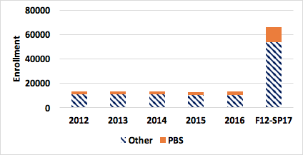

*Figure F. Physical and Biological Science (P&BS) courses accounted for 18.5% of credit-seeking student enrollment from Fall 2012 through Spring 2017 ( a range of 17.3 % to 21 %).*

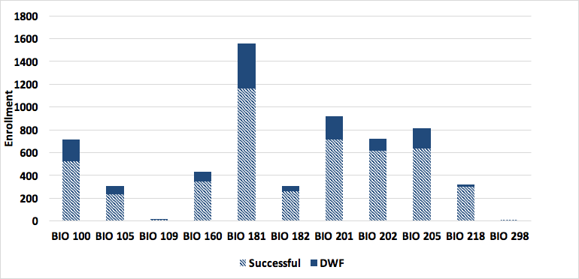

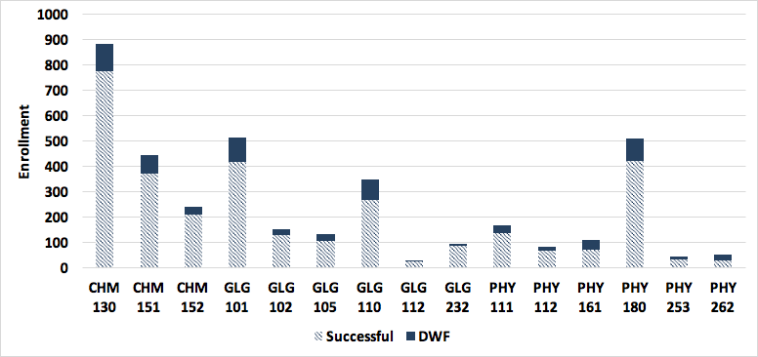

*Figure G. Student success rates by course and discipline for Biology (BIO), Chemistry (CHM), Geology (GLG), and Physics (PHY). Student success is defined here as completing the course with a C or higher and data shown spans Fall 2012 through Spring 2017. The mean student success rate over all P&BS courses was 78.7%.*

1. **Licensure/certifications of students**
   * ***Discuss what licensures/certifications students may be able to obtain upon completion of the program.***
   * ***Outline the requirements for each licensure/certification.***
   * ***Describe how the program contributes to the student’s ability to achieve the current licensures/certifications.***
   * ***Discuss any impediments to the student obtaining the licensures/certifications.***

The P&BS courses at CCC contribute primarily to requirements for students seeking AGEC

degrees, fulfilling prerequisites for allied health fields, or transfer to a university in pursuit of an advanced degree (see section II a.i for details).

1. **Curriculum**
2. **Course outline reviews and updates**
   * + - ***Define how often course outlines are reviewed and updated.***

The current P&BS course outlines are provided in Appendix 2.i. Course outlines are reviewed and updated periodically by full time faculty and all changes are reviewed by the CCC curriculum committee prior to adoption. All changes to General Education course outlines are also reviewed by the General Education committee. For foundation-level courses, potential changes to course outlines are discussed among science department members during our regular meetings. In order to increase consistency among courses and provide part-time faculty with additional guidance, we are in the process of creating course guidelines for each course in which parameters for grading, assessments, and field trips are described. To ensure compliance with the American Disabilities Act, State Authorization Reciprocity Agreement, and accrediting bodies such as the Higher Learning Commision we are planning to work with members of the distance learning team to create course templates in our Learning Management System in Canvas.

* + - * ***Discuss changes made to the course outcomes since the last program review.***
      * ***Discuss the effects these changes have had on the program.***

1. **Other curriculum changes** 
   * + - ***Describe any curricular changes since the last program review such as program outcome changes, pedagogy, software updates, different delivery methods, or different time offerings.***

Curricular changes include an increase in the number of course offerings in hybrid and online format (see Section II ii (Figure E)). Future college-level policy changes will focus on standardizing format, evaluating the quality of online courses, and ensuring ADA compliance. Members of the faculty have completed online training with the nonprofit quality assurance organization Quality Matters. Compliance with the State Authorization Reciprocity Agreement will also ensure that all courses meet comparable national standards for interstate offering of postsecondary distance education and programs. Plans are inplace to increase the frequency of non-semester length course offerings (5-wk, 8-wk and 12-wk) throughout the academic year.

* + - * ***Note any impending course changes.***

The department is exploring options to better serve remote students at the Page Instructional Site. This

will likely include regular commuting of select faculty to the Page campus for new hybrid courses (BIO 181, BIO

201, CHM 130).

* ***Discuss the effects these changes have had on the program.***

Faculty recently (2016-2017) mapped P&BS course outcomes to general education outcomes (Appendix #). This mapping process has helped us to see the potential benefit of creating general education outcomes specific to the physical and biological sciences. We plan to create these P&BS general education outcomes in 2018 and assess the outcomes in fundamental P&BS courses. Additionally, the general education mapping process has enabled our department to identify courses which would benefit from more frequent review. We are planning to review course outlines, textbook selection, and course guidelines according to a formalized cycle that is instep with our program review.

1. **Articulation**
   * ***Describe the program’s participation in Articulation Tasks Forces.***

CCC has demonstrated a strong presence at annual Arizona Articulation Task Forces (ATFs) meetings and via email discussions regarding pedagogy, assessment methodology and rigor. Our P&BS faculty help implement and update the Arizona Transfer System in order to ensure that community college students obtain the maximum earned college credit when transferring to public universities. When the college did not have a full time faculty member in the disciple (e.g geology), a part-time faculty member or a faculty member in a related field would attend the annual as a voting member. We held the Biology ATF at CCC in 2013 as part of a two-day event that highlighted best-teaching practices within the discipline. We also hosted the Geology ATF in 2014 and plan to offer a Chemistry ATF in Flagstaff in the future.

* + ***Discuss changes in transferable courses.***

There have been a few changes in transferable courses. In Geology, GLG 102 and GLG 232 are no longer be taught at the same time (initiated SP 16) and will be taught as separate offerings. Starting Fall 2017 – GLG 102 will have a pre-requisite of GLG 101 or instructor permission. This creates a first year sequence in Geology, similar to the other sciences. GLG 102 is taught at NAU, Yavapai College, and others as the second half of a one year geology sequence (with 101).

* + ***Provide elaboration on any courses that are only transferable as electives or non-transferable.* (A transfer table of the courses will be provided by the assessment team to be included in the Appendix.)**

At CCC there are currently few P&BS non-transferable courses. These include internships and special topic courses within each disciplines. These courses have little to no enrollment over the past five years. Field-based classes such as BIO 112 (Wildflowers of Northern Arizona) and GLG 112 (Geology of the Grand Canyon) are not directly transferable to public universities but they afford students the incredible opportunity for intensive fieldwork and first-hand experience of the material.

1. **Is the program accredited by a programmatic accrediting agency? If so, name the agency and include the status of the most recent accreditation.**

The P&BS program at CCC is not accredited by any programmatic accrediting agency. Coconino Community college is accredited by the regional accrediting agency- the Higher Learning Commision. Reaffirmation was awarded in 2011-2012 and the next reaffirmation will be in 2021-2022.

1. **Teaching loads**
   * ***Provide a description of the responsibilities and loads of the full-time faculty.***

The teaching load of full-time faculty at CCC is 15-23 credit/semester and the teaching load of part-time faculty is 4-8 credit/semester. Full-time faculty are active on committees and in the community (See Appendix 5 for details). The ratio of courses taught by full time faculty to part time faculty has increased significantly as a result of these recent hires (see Appendix 5vi). The job descriptions for full and part-time faculty are provided in Appendix 5 vi.

Biology: Three full-time Biology faculty have taught several of the classes at the LoneTree campus. We have employed several part-time faculty to teach many of the sections. We employed a full-time Biology faculty member at the Page campus, but this position was terminated in 2014 when the Page campus was reorganized as an instructional site. We have added a fourth full-time Biology faculty to our department in 2016. This addition has resulted in an expansion of our online and hybrid offerings and offers the opportunity for a biology faculty member to travel to the Page instructional site for hybrid courses such as BIO 181 and BIO 201. The new biology faculty members are active board members of local STEM and community organizations (STEM city, Flagstaff Festival of Science, NAZPHI, Arizona Native Plant Society, add additional affiliations for Aaron) and are working to expand undergraduate research opportunities and partnerships with Northern Arizona University. With a full-time biology faculty member acting as the advisor for the Science Club, community involvement has greatly increased; events have grown to include regular judging of K-6 science fair projects, facilitating “engineering day” for middle school students on field trips to CCC, volunteering to help local nonprofits (Wonder Factory, Willow Bend), and building raised bed pollinator gardens.

Chemistry: There is one full-time chemistry faculty and one-part time faculty who exclusively teaches online. Our current Science lab coordinator also acts as a part-time Chemistry faculty. Two of our part-time faculty who taught in CCC for a long time found to be ineligible as per new HLC guideline. Appendix # enclosed herewith depicts the number of full-time and part-time faculty employed, respective teaching load as per credit hours and individual classes.

Geology: From Fall 2012 through Spring 2016 semester, Geology courses had been taught exclusively by 4 to 5 part-time faculty. See Appendix D for names, credentials, and loads. Starting Fall 2016 semester, there is now one full time Geology Faculty member and at least two part-time faculty. All GLG course offerings have been at the Lone Tree campus; starting 2014, one section of GLG 101 was offered online annually as a summer offering. Starting Fall 2017, hybrid and on-line versions of GLG 110 will be developed. An additional section of GLG 110 will be offered fall and spring a the 4th Street campus starting Fall 2017. Hands-on learning experience has been enhanced by the addition of several new field trips in GLG courses in 2016.

Physics: Physics course revisions (Section II.c.i) ATF participation (Section 3.d) and part-time faculty mentorship has been the responsibility part-time faculty or the previous department chair. We believe that the addition of a full-time physics position would lead to an increase in the enrollment, retention and success of physics students. It is well known that physics is a challenge for many students and DFW rates in the calculus-based courses (PHY 161, PHY 162) are higher than any other P&BS courses (Figure G). We feel that the addition of a full-time physics faculty position is necessary to enable students to succeed in these courses. Although we have had excellent part-time physics faculty, part-time faculty are not required to hold office hours, attend ATFs, revise curriculum, and develop student success strategies that may include implementation of supplemental instruction or targeted tutoring.

* + ***Discuss the delivery methods of the courses.***

As discussed in II a. iii., the addition of a new full-time geology faculty positions has increased course offerings and enrollment in geology dramatically and has helped expand the science lab facilities (section III). The addition of a new full-time biology faculty has increased the frequency of online and hybrid biology class offerings and there are plans to introduce new online and hybrid courses (BIO 181,BIO 182, BIO 201, BIO 202, BIO 105) in biology. Online courses will be offered in traditional 16 week format as as well as five, eight and twelve-week formats).

* + ***Discuss any release time of the full-time faculty.* (Charts and tables detailing the number of courses and sections taught by full-time and part-time faculty will be provided by the assessment team to be included in the Appendix.)**

Although faculty are active on committees, boards and community outreach faculty do not receive release time for these commitments. Great efforts have been made at CCC in recent years to increase the number of full-time faculty positions and thus the number of faculty available to take an active role all areas of the college and to further student support. In Fall 2016 the Physical and Biological Science department gained one additional full-time biology faculty position and created for the first time a full-time geology faculty position. The percentage of P&BS courses taught by full time faculty increased from 38% in 2012 to 48% in 2017 (see Appendix 5 v.i for ratios by discipline). These additional full time positions have enabled more frequent revisions of course curriculum, greater involvement in designing and implementing assessments across all sections and strengthening CCC ties to the region as we broaden the scope of our community outreach programs. Faculty may apply for a sabbatical lasting one or two semesters.

1. **Faculty credentials**
   * ***Describe minimum credentials needed to teach in the program.***
   * ***Discuss any specializations or achievements of the current faculty.***

Basic Credentials for teaching P&BS courses are based on those set by the Higher Learning Commission:

“Faculty teaching general education courses, or other non-occupational courses, hold a master’s degree or higher in the discipline or subfield. If a faculty member holds a master’s degree or higher in a discipline or subfield other than that in which he or she is teaching, that faculty member should have completed a minimum of 18 graduate credit hours in the discipline or subfield in which they teach.”

In 2016 all faculty credentials at CCC were thoroughly reviewed and evaluated with respect to current HLC requirements. Only faculty meeting HLC requirements are currently teaching for CCC (for full details see Appendix X for Policy 310-00 and Procedure 310-01). In Geology, based on information provided by IR, faculty had graduate degrees in Geology or Earth Science. The credentialing for dual enrollment instructors is similar to CCC faculty and is provided in Appendix X.

1. Student Learning Assessment
   * ***Provide detailed descriptions on types of assessment used to measure student learning.***
   * ***Describe any course level assessments that were conducted and the results since the last program review.***
   * ***Report any shared assessments within the program and data gathered from those assessments.***
   * ***Record any observations or trends found within the student learning assessment data.***

College Wide assessment of general education outcomes is a high priority at CCC. In response to feedback from HLC, the college initiated a large scale effort to better generate and utilize student assessment data. The overwhelming majority of P&BS courses are general education courses and all general education courses at CCC were mapped to general education outcomes in 2016 (see Appendix 3.iv). The initial assessment across all general education courses focused on the category of Critical Thinking, with future assessments planned to target the remaining general education outcomes. All instructors were tasked with creating a course-specific assessment that evaluated critical thinking. Assessment details and student success rates were reported and used to gain insight into program wide performance (see results in Appendix 3.i.v).

Biology: From Fall 2012- Spring 2017, course level assessments have been made for high-enrollment biology courses such as BIO 181, BIO 201, and BIO 202. Common final exam questions aligned with course outcomes were administered by all faculty teaching these courses. Results were compiled and analyzed by biology faculty each semester and the results were used to inform and direct pedagogy to improve student success. In BIO 181 a common lab report was also assessed in each section. An anonymous sample of the results from a random section of BIO 181 is provided in Appendix 3iv.. Common Pre and Post tests are planned for all sections of BIO 181 and BIO 100 in Fall 2017.

Geology: During the first 4 years of this 5 year period under review (Fall 2012 to Fall 2016), there is no recoverable historical record of assessment. Prior to that period GLG courses were part of broader assessment activities focused on the General Studies and Environmental Studies A.S. degrees. Assessment was targeted at CCC’s General Education Outcomes and Science Assessment Outcomes. In Fall 2016, course outcomes and General Education outcomes were linked for each GLG course. Starting Fall 2016, Critical Thinking was assessed in GLG courses taught by the full time faculty member. Subsequent semesters will add sections taught by part-time faculty. After the 2016-2017 academic year, a review and improvement of the course outcomes will occur (several have over 15 outcomes).

Dual Enrollment: Courses taught by dual enrollment instructors at high schools are assessed according to the procedure in the Dual Enrollment Handbook and must pass a credentialing process similar to faculty at CCC (Appendix X). All instructors sign an agreement which states that they will meet the standards in Course Content, Assessment and Course Outcomes detailed in the official Course Outline. They must also submit a copy of their syllabus which reviewed by CCC Deans and Faculty and must explicitly state compliance with CCC standards.

1. **Facilities and Resources**
   1. ***Specify any designated space that is primarily for the program’s use since the last program review.***
      * Laboratory rooms 507, 513, 514, and 515 are dual use rooms, where lecture and lab course components are delivered in the same place, at the same meeting time, and by the same instructor. This allows students to fulfill both components of a lab science course with the convenience of a simpler schedule. It also allows the instructor a unique opportunity to convey connections between lecture and lab content.
      * Lab 507 is primarily outfitted for Anatomy & Physiology classes (BIO 160, 201, and 202). Lab 513 houses equipment and materials for a number of Biology courses, such as Microbiology (BIO 205) and Biology Concepts (BIO 100). Lab 514 houses most of the equipment for Unity of Life (BIO 181 and 182). Lab 515 is primarily outfitted for the Chemistry classes (CHM 130, 151, and 152). Occasionally, other classes are taught in these rooms if the space is needed.
      * Astronomy, Geology, and some of the Biology and Physics courses were taught in traditional classrooms. Room 517 served as our interim geology and astronomy lab room, storing geology samples, magnifying lenses, and acid bottles in cabinets. Telescopes for the Astronomy classes were stored in closet 531.
      * Some of the science classes, such as Human Pathophysiology (BIO 218) and Archaeoastronomy (PHY 253), don’t require a laboratory environment and were offered in a variety of traditional classrooms through the Lone Tree campus (and even occasionally at NAU). See Appendix 1 for the full list of courses.
      * Engineering classes have been offered in various rooms in the Lone Tree campus, primarily in Lab 514 or Lab 507.
      * Classrooms in Building 6 on the Lone Tree Campus (#601 and #602) are in the process of being outfitted for use in laboratory exercises in physics, engineering and geology. They will have dedicated storage for lab supplies, linoleum flooring (not carpet), ready access to water and electrical power, and moveable tables to create different configurations for different courses or different activities. They are scheduled to open Fall 2017.
      * Room 516 is the dedicated Science Prep room. It contains stores for most of the science labs, space to prepare exercises and clean glassware, and an office for the Science Lab Coordinator. There is an adjacent Chemical Storeroom and an adjacent Microbiology Prep room.
      * Lab D2 on the Page Campus is a dedicated science lab, used for various Biology and Chemistry classes. There is an adjacent chemical storeroom, an adjacent prep room, and an adjacent office for the science faculty.
      * We have also offered various science classes at classrooms in the Grand Canyon instructional site. See appendix 1 for the full list of courses.
      * ***Describe how the designated facilities contribute to the program’s overall student success.***
      * The dual use lab rooms allow the instructor to incorporate hands-on laboratory activities into the same period as lecture and exams. The block schedule for science classes provides longer periods for this integration of various activities into a single period.
      * The Science Prep room is attached directly to Labs 507, 513, 514, and 515, allowing for ready access to and from each of these lab rooms. Instructors have quick access to materials or the assistance of the Science Lab Coordinator during their classes.
      * Each dedicated science lab is stocked with models, charts, and equipment for their specific courses. Ready access makes for efficient lab activities as well as mentally placing the students into the setting of a “college science lab”.
      * Rooms 601 and 602 are being renovated into Physics/Engineering and Geology - respectively - to open Fall 2017. This will allow us to offer these courses in a space more appropriate for labs (no carpeting, nearby water sources, adequate space to move among tables, power supplies for computers) with a separate space for sample storage and lab preparation.
   2. ***Specify any designated equipment purchased primarily for the program’s use since the last program review.***
      * Big-ticket lab equipment has been purchased over the years for several of the labs. We have 25 monocular compound microscopes, 36 binocular compound microscopes, and 15 binocular dissecting microscopes (Labs 507, 513, and 514 have dedicated sets). We have fume hoods in Lab 515 (Chemistry), Lab 516 (Science Prep), and the Microbiology Prep room. We have 4 spectrophotometers in Labs 514 and 515. We have 2 autoclaves in the Science Prep Room and 6 incubators in Lab 513 (MIcrobiology). See Appendix 4 for a more detailed list, splitting out what was purchased during the 2012-2017 period and before.
      * We have purchased various durable goods for the labs, such as biological models, plastic skeleton sets, and charts. We have 8 laptops, 44 iPads, 10 Labquest, and 6 Vernier with multiple data acquisition sensors, which are used in various classes in different labs (these are stored in secured cabinets in the Science Prep Room.
      * We purchase various perishable goods each year for the different classes, such as chemical supplies, dissection specimens, and microbiology cultures. These are stored in designated locations in the lab rooms or in the Science Prep room. See Appendix 6 for more details.
      * In 2016, through a STEM grant we were able to purchase equipment to perform Polymerase Chain Reaction (PCR) experiments. This allows us to take a small amount of DNA and increase it enough for analysis. We are able to use this equipment to upgrade a number of our Biology exercises, allowing students to obtain genetic samples from their activities and analyze them.
      * We have secured STEM grant funding to purchase the PCR equipment, additional iPad and laptop computers, LabQuest Vernier data acquisition equipment, and other resources to improve our student experience in several of our lab science courses. See Appendix 6 for a full list of Science expenditures and grant purchases.
      * ***Describe how the designated equipment contributes to the program’s overall student success.***
      * We have endeavored to maintain a fresh working supply of equipment and lab supplies each year for our classes. Most of our lab classes have a cap of 24 students, with students generally working in 2-person or 4-person teams. We maintain enough lab supplies to allow each set of students to perform the lab activity at the same time. This allows more individual hands-on experience and collaborative learning for the students.
      * The computer equipment - laptops, iPads, and LabQuests - have allowed our students to gather data and analyze it directly in class. They have been able to collaborate on various activities, accessing Canvas resources (our college learning management system) and online resources.
      * New rock/mineral/fossil samples have been acquired to expand the variety of samples students may analyze, as well as ensuring that students work in small groups during identification labs.
   3. **Specify any designated budget and differential tuition that is primarily for the program’s use. (A program budget will be provided by the assessment team.)**

* Salary budget has been approved for full-time and part-time faculty. See appendix 6 for the breakdown of budgets for faculty in the different disciplines.
* Previously, there was a single budget line-item for Science Lab Preparations. In Fall 2015, this line-item was split into separate line-items for the various disciplines (Biology, Chemistry, Engineering, Geology, and Physics) to better track the income and expenses for the different courses.
* Differential tuition was implemented in Fall 2015 to streamline the cost estimates for students, removing extraneous course fees. See Appendix 6 for the income for each discipline from these sources.
* We have received money from various STEM grants through the college in order to purchase new equipment and supplies. See Appendix 6 for the full list.

1. **Analysis and Reflection** 
   1. ***Strengths, Weakness, and Challenges Analysis***
      * ***What do you see as internal strengths of the program?***
        + Small Class sizes: An important strength of the program is small class size (20-30 students per section) and personalized student attention.
        + Combined Lecture/Lab Spaces and Block Scheduling: The combined lecture and laboratory format of science courses at CCC enables students to apply lecture concepts to laboratory exercises under the guidance of a single instructor. At larger institutions students would have class in a large lecture hall with one instructor and have lab in a separate space with perhaps a different instructor/TA. Block scheduling (2 equal length meetings per week) and combined lecture/lab spaces instead of the traditional separate lecture and lab times/rooms - allows instructors maximum flexibility when planning the use of class time. Lab exercises or field trips are not limited to a once weekly, longer block of time. This also helps with rescheduling of labs/field trips in the case of school closures or instructor illnesses.
        + CCC’s Location: The location of CCC makes experiential learning very easy to implement as well as providing opportunities for student service learning or internships :
          1. Field based sciences = educational sites in National Forest, State and National Parks/Monuments can be visited during class times or used for longer overnight trips
          2. Lab based sciences = NAU, Gore, Purina, Flagstaff Medical Center
          3. Museums and similar science/education centers = Museum of Northern Arizona, The Arboretum at Flagstaff, Lowell Observatory,
          4. Government Agencies = USGS, NFS (land management, forest fire mitigation), NPS, City of Flagstaff (stormwater management, wastewater Treatment)
          5. other examples?
        + High Faculty Retention: This program has a good history of retaining both full and part time faculty. Hiring committees have mainly been convened in response to a retirement or the addition of full-time faculty positions. (Data in Appendix 5).
          1. Only one Full Time Faculty member was hired and subsequently chose to leave during this 5 year review period.
          2. Only 9 of the 41 Part Time Faculty employed during this 5 year review period stayed one semester. The vast majority taught multiple semesters for CCC.
          3. 2 Full time Faculty hires were from the Part Time ranks.

Table IV.1 is an overview of Faculty in the Physical and Biological Sciences during the 2012-2017 review period. (more data in Appendix 5).

|  |  |  |
| --- | --- | --- |
| 528 Course Sections taught by 48 Faculty Members (fall 2012 - summer 2017) | | |
| 9 Full Time Faculty Members | 3 | members were FT prior to Fall 2012 |
| 1 | retirement (FT member prior to Fall 2012) |
| 2 | members were hired FT from outside CCC |
| 2* | *members were hired FT from PT ranks |
| 1 | member was hired and left during this 5 year review window |
| 41 Part Time Faculty Members | 8 | members were PT prior to Fall 2012 and continued PT through Spring/Summer 2017 |
| 6 | members were PT prior to Fall 2012 and left prior to Spring 2017 |
| 10 | members were hired PT after Fall 2012 and continued PT through Spring/Summer 2017 |
| 6 | members were hired PT after Fall 2012, taught more than one semester, and left prior to Summer 2017 |
| 9 | members only taught ONE semester at CCC, then left. |
| 2* | *members were hired FT from PT ranks |

* + - **What do you see as internal weaknesses of the program?** 
      * ***Provide evidence and data to support answers.***
      * Lack of a full-time faculty members qualified/designated to teach PHY (physics and astronomy) courses results in infrequent review of course outlines and reduced attention to curriculum development.
      * *Based on departmental experience in last five years, we feel our lab facilities regarding both workforce and equipment are sub-optimal and need a close examination for necessary improvement. The current lab coordinator position is engaged in multiple activities including but not limited to teaching, leading/manning several committees which left little time and desire for lab-related work. There were frequent occasions when there was no workforce available in the lab prep area when the classes were in session. Every need of a lab work can’t be pre-assessed. Thus the availability of reliable technical staffing to cater the incidental needs of lab work is highly desirable. The responsibilities of the lab personnel are not restricted only to the preparation of the lab chemicals only. There was little realization that staff are also responsible for managing other responsibilities inside the lab like cleaning and rearranging dried glass wire, periodic calibration of equipment and routine maintenance of equipment like changing batteries, cleaning probes, etc.*
      * Prior to Fall 2016, all sections of Geology courses were taught by part-time faculty. While the quality of instruction may have been high, any program review, course revisions, and assessment activities required these faculty to donate time or the administration to fund release time. In practice, curriculum revisions fell upon the Department Chair (through Spring 2014). Similarly, these part-time faculty would essentially have been donating time for any activities outside of the classroom such as office hours or extra help for students. Science department meetings may or may not have had a representative from Geology, CCC may or may not have had a representative at Geology ATF meetings.
      * Awkward delivery of certain Geology courses:
        1. Physical Geology (GLG 101) and Historical Geology (GLG 102) were taught as single, separate courses. This means that GLG 102 instructors had to commit a third of the semester to covering foundational material taught in GLG 101 (rocks, minerals, plate tectonics). Many schools (including our transfer institutions) treat these as a year-long sequence. Starting Fall 2017, GLG 102 will have a pre-req of GLG 101. This will undoubtedly pull down enrollment in GLG 102, but it also gives us the opportunity to have students interested in Geology start at CCC and transfer to NAU or other universities having taken a freshman year of Geology (and hopefully Chemistry and Calculus).
        2. GLG 232 Geology of the Colorado Plateau has traditionally been taught at the same time as GLG 102, in the same classroom. This “one-room schoolhouse” approach may have helped with enrollment numbers (allowing both courses to go), but it should be offered on its own. Also, 200 level courses are traditionally taught to sophomore level students and have prerequisites. This course should be reworked to be a second year, field-based, capstone experience for students who have taken GLG 101-102.
        3. Environmental Studies and Colorado Plateau Studies both require GLG 102 or GLG 232. The changes above would add hidden prerequisites and may not fit the vision of these programs. Future discussions with faculty and administration overseeing these programs is required.
    - **What do you see as opportunities for the program?**
      * CCC is part of the the Southern Nevada Northern Arizona Louis Stokes Alliance for Minority Participation (SNNA-LSAMP) an alliance of colleges which focuses on Science, Technology, Engineering and Mathematics (STEM). The Program is a federally funded research and training program that is sponsored by a grant from the National Science Foundation (NSF). The overall goal of the LSAMP Program is to ensure that a greater number of minority students graduate and pursue careers in STEM fields. The Program also aims to promote a lasting change is how STEM disciplines are viewed by the minority culture of the participating institutions.
      * The location of CCC makes experiential learning very easy to implement as well as providing opportunities for student service learning, internships, and mentoring:
        1. Field based sciences = educational sites in National Forest, State and National Parks/Monuments can be visited during class times or used for longer overnight trips
        2. Lab based sciences = NAU, Gore, Purina, Flagstaff Medical Center
        3. Museums and similar science/education centers = Museum of Northern Arizona, The Arboretum at Flagstaff, Lowell Observatory,...
        4. Government Agencies = USGS, NFS (land management, forest fire mitigation), NPS, City of Flagstaff (stormwater management, wastewater Treatment)
      * Increasing Enrollment at NAU - over the past 5 years, Fall enrollment numbers have increased by roughly 10,000 students (see plot on page A1 in NAU 2016-2017 Factbook in Appendix 5). There will be students looking for courses that fit their schedule, have seats available, or have smaller class sizes than a traditional lecture hall. We also see students who are not accepted at NAU, but have come to Flagstaff to be with friends from high school who are attending NAU.
      * Changes to AZ High School Graduation Requirements - starting in 2013, graduates now need 3 credits of Science instead of 2 (Appendix 2). This could potentially result in an increase in demand/enrollment of science courses at CCC:
        1. With students exposed to more science in high school, we see more students interested in science.
        2. CCC science courses may help fill the need for extra science credits for HS students (Dual Enrollment, home-schooled students)
        3. Older students wishing to enroll in college (CCC or NAU), may need some extra science to meet NAU admissions requirements of 3 science classes (in high school and/or college) if they graduated high school under the older 2 credit requirements (NAU admission requirements in Appendix 5).
      * There is public and private interest in expanding STEM education. This makes it a good time to propose new programs, try new instructional techniques, and fund new initiatives.
      * CCC has never offered organic chemistry class which should be a goal in the next five years. Our focus should be to accommodate all aspiring students in entry-level CHM class so that we have enough student for the upper-level courses. Any time we can attract more upper level science students, we should see higher enrollments in upper math courses as well.
      * Most of our Fundamentals of Chemistry (CHM 130) and General Chemistry I (CHM 151) classes are consistently running with more than full capacity. This suggests that the number of class offering in these categories may need to be increased. An additional offering of these classes will, in turn, help to improve the number of students in higher level classes like CHM152.
      * Opportunity to re-evaluate the Science Lab Coordinator position. Spring 2017 semester - in response to the announced retirement of the current Lab Coordinator, the Dean of Learning in charge of math and science courses (with science faculty support) decided to advertise the replacement position as a one-year interim position. The plan is for the administration and science faculty to have the coming year to evaluate the work load (full/part time) and responsibilities (lab prep/budgeting/safety coordination/committee representation) of this position, as well as to consider any items (safety issues, new instructional equipment, efficiency suggestions) identified and proposed by the interim Lab Coordinator). After that year, a revised job description will be written, followed by a new search.
    - **What do you see as challenges of the program? *Provide any challenges that the program has faced since the last program review and the results. Provide any challenges the program is facing now internally and externally.***
      * The size of our service area - our students are not limited to residents of Flagstaff.
        1. Students may commute long distances
        2. Students may not have reliable, high speed internet access
        3. Teaching lab based science courses at extension centers can be very challenging: lower enrollment numbers, inadequate facilities/instructional supplies, difficulty finding qualified instructors.
      * Northern Arizona University - while our proximity to NAU creates an obvious transfer path for our students, it also means that any changes to NAU policies may impact our course enrollments. Also, changes to the graduate programs may impact our pools of potential part-time faculty:
        1. Changes to degree/program requirements or transfer agreements may change demand for the courses offered at CCC.
        2. Changes to admission requirements (lower standards may result in students opting for NAU as freshman instead of the CCC to NAU program).
        3. NAU Graduate Program - it is against NAU policy for Graduate Students with Fellowships or Assistantships to seek additional employment. Over the past 5 years, the enforcement of this policy has been variable. This impacts our part-time faculty pool in the sciences.
      * Special topics courses - these courses present unique opportunities but struggle to reach sufficient enrollment: non-Gen Ed/non-Major courses or those that mainly were developed for struggling programs such as Plateau Studies/Environmental Studies degrees provide. Examples: GLG 112 Geology of the Grand Canyon, GLG 232 Geology of the Colorado Plateau, BIO 112 Wildflowers, and PHY 252 Archeoastronomy (inactive).
      * It can be difficult finding qualified applicants in some areas, especially filling part-time positions (Chemistry). Table IV.2 includes a synopsis of faculty searches during this 5 year review period. At similar community colleges, post-doctoral fellow and current Ph.D. students are the primary sources of the part-time faculty in community college. NAU (Northern Arizona University), the only local university, does not currently have a Ph.D. program nor a competitive research program in Chemistry employing post-doctoral fellows.

Table IV.2 is a synopsis of data from CCC Human Resources regarding faculty searches during the 2012-2017 review period. (more data in Appendix 5).

|  |  |  |
| --- | --- | --- |
| **Job Title** | **Advertised** | **Total Applicants** |
| FT Faculty Biology | 2/11/2016 - 3/10/2016 | 32 |
| FT Faculty Geology | 4/12/2016 - 6/6/2016 | 94 |
| FT Faculty Chemistry | 3/3/2015 - 3/22/2015 | 25 |
| Temp FT Faculty Chemistry | 5/31/2012 - 6/21/2012 | 4 |
| PT Faculty - Math and Sciences | 3/2/2017 - 9/13/2017 | 47 |
| PT Chemistry Instructor | 7/30/2013 - 8/16/2013 | 2 |

* + - * Lack of a full time faculty member in Physics/Engineering/Astronomy. At monthly Science Dept. meetings there is no representation for these disciplines. The parts of this document that refer to theses disciplines had to be written by a faculty member in life sciences.
      * Changes to the Nursing Program - December 2013, CCC’s nursing program cut the number of yearly applicants from 40 to 20.
        1. One would expect that this would directly impact science courses that are prerequisites or requirements for nursing students: Anatomy and Physiology (BIO 201/201), Microbiology (BIO 205), and Fundamental Chemistry (CEM 130). This change did not seem to impact BIO 201/202 enrollment. Enrollment in BIO 205 and CEM 130 did drop.
        2. July 2017 - CCC announced that they would be raising enrollment by 50% to 30 new nursing program students per year.
        3. The table below shows enrollments in courses that are prerequisites to the Nursing Program. Some course enrollments dropped while others did not. Science Faculty interpret this as follows:

CHM 130 - Drop without recovery - NAU does not require this course for their Nursing Program. If we lost any students to NAU’s program they would not need this course to apply.

BIO courses were not impacted or recovered after several years. This may mean that students are still interested in pursuing nursing and will still come to CCC to get their prerequisites even if they intent to apply to another college’s nursing program.

|  |  |  |  |  |  |  |
| --- | --- | --- | --- | --- | --- | --- |
| Number of Students who Attempted the course | | | | | | |
| (Beginning Enrollment - Early Drop) | | | | | | |
| SUBJ | CRSE | 2012-2013 | 2013-2014 | 2014-2015 | 2015-2016 | 2016-2017 |
| BIO | 201 | 169 | 177 | 170 | 188 | 217 |
| BIO | 202 | 149 | 127 | 131 | 132 | 181 |
| BIO | 205 | 159 | 152 | 162 | 169 | 174 |
| BIO | 218 | 77 | 70 | 47 | 49 | 78 |
| CHM | 130 | 200 | 189 | 177 | 161 | 156 |

* + - ***Discuss any challenges for the students completing a certificate or degree.***
      * AGEC Certification. Looking at the AGEC-S (science), the options for picking a science include Biology, Chemistry, and Physics. Science “majors” entering CCC may not be aware that they may start here and still have a pathway at CCC to end up graduating with a bachelor’s degree in Geology from a transfer institute. According to Kate Kozak (Math Faculty), who has attended Gen-Ed ATF’s in the past, the addition of GLG as a pathway within the AGEC-S has been debated in the past, but has not been adopted yet.
  1. **Previous Recommendations and Results** 
     1. ***List recommendations that were received at the last program review.***
        + ***Elaborate on actions taken on recommendations and effects on the programs.***
     2. ***List any recommendations from Program Advisory Committees/Councils (if applicable).***
        + ***Elaborate on any actions take on recommendations and effect on the program.***
        + This is the first comprehensive review including all Physical and Biological Sciences offerings as a program.
        + A Geology Program Review will be completed in Fall 2017.
        + A Biology Program Review was last done in July 2011. The table below includes updates on some issues raised in the Biology Program Review.

Table IV.3 - Progress on Previous Recommnedations

|  |  |
| --- | --- |
| *Items from 2011 BIO Program Review* | *Comments for 2012-2017 Physical and Biological Program Review* |
| *Collaboration with NAU - a full time BIO instructor was shared between CCC and NAU. The review proposes that additional similar positions may be added.* | *This position was for one year only and no similar positions were added. The number of science sections at CCC has grown to the point that a position like this is not necessary to ensure that a full time science faculty member makes load.* |
| *Partnership with GORE – teaching a custom Anatomy and Physiology course to employees at GORE’s campus.* | *“Anatomy & Physiology for GORE Engineers” was offered every fall/spring from Spring 2011 through Spring 2014This no longer occurs. Perhaps it is time to reach out to GORE again to see if interest has grown.* |
| *Science classroom issues:*  *1. BIO has only 2 designated lab rooms, shares another with PHY courses.*  *2. Science classroom in Page only has space for 12 students* | *Spring 2017 - STEM money has been approved, bids have been solicited to convert room 601 into a designated PHY/ENG lab with space for equipment storage. This will allow 3 designated BIO lab rooms with additional space in schedules for more course offerings.*  *Page - the same room is still in use. Instructional equipment has been upgraded/replaced as needed; older, out of date supplies have been removed.* |

1. **Recommendations**

Provide recommendations for specific actions for continuous improvement of the program.

* 1. ***Five Year Plan*** 
     + ***Where will this program be in five years?***

**Recommendation:**

The recommendations made in this section are based on our collective experience. It follows five principles to achieve the core values of CCC, a) preserve current success, b) built on current strength, c) accept new challenges to remain relevant in science education as per local and national trend, d) address community needs, and e) seek excellence in all level of learning.

**a. Five Year Plan**

We aim to establish and grow our science program to provide quality science education which is cost-effective, flexible and up to date. It should be able to meet the need of the community and able to provide new direction to the student. We seek to establish our program as one of the competitive and cutting-edge two-year science programs in the state of Arizona with full compliance to national standards. To achieve this goal, we will attempt to retain our outstanding faculties and add new talent to the pool by hiring only best and brightest who will bring new ideas and skill to our program. Since science education is changing rapidly, we should have resources and willingness to adapt to the needs of the changing time. Since the availability of the resource is limited, we should start looking for external funding for additional resources. Finally, we plan to develop our program internally and externally collaborative and try to best use available resources across the department.

* 1. ***Action Plan/Recommendations (To be completed in the next five years). List action items in order of priority of completion.*** 
     1. ***Action Item #***
     2. ***Anticipated date for completion***
     3. ***List the potential benefits to student success***
     4. ***Status update (Only update at Annual Review Meeting)***
     5. ***Last reviewed date***

Action Item # (**arranged in the inverse order of priority – highest to lowest**)

**1) Hiring Lab science coordinator and re-arranging lab support structure**

Since lab work in science class accounts for approximately one-quarter of the final grade, proper facilities both human capital and material are crucial for accomplishing quality science education. Based on our experience in last five years we propose the following facilities to be created/maintained concerning laboratory prep room infrastructure.

I. Lab prep room in-charge (i.e., science lab coordinator) must be a full-time employee and to be exclusively focused on overseeing the lab work and supporting experimental education including field trips.

II. There must be a capable as well as qualified workforce available in the lab prep area during the time science class in progress. We understand it could be challenging to have someone during evening class time. At least someone should be there **8.30AM to 5.30 PM** when most of the science class are in session.

III. The job responsibilities of the lab personnel should include managing other related duties in the lab like cleaning and rearranging dried glass wire, periodic calibration of equipments, timely disposal of hazardous waste and routine maintenance of equipment like changing batteries, cleaning probes.

IV. We propose to have an independent review of the effectiveness of lab facilities every year as department.

V. To evaluate the work load (full/part time) and responsibilities ( i.e., lab prep/budgeting/safety coordination/ budgeting) of the current Science Lab Coordinator position who is currently hired under one year contract. A revised job description to be written, followed by a new search to fill up the position on permanent basis.

(Anticipated date of completion – end of 2018)

**2) Hiring full time Physics/Astronomy/Engineering faculty**

Physics is the backbone of engineering where a maximum number of the good-paying job is available. However, CCC has not had a full time instructor in this area. Our math faculty Phillip Martinez is currently looking after the Physics education in addition to his responsibility for math and engineering classes. Also, CCC offers significant courses in the field of Astronomy. It is a priority to hire a full-time faculty who can teach both Physics and Astronomy. It will be an added advantage if the new position can help CCC’s engineering program.

(Anticipated date of completion – end of 2019)

**3) Optimum class schedule**

Offering class in right time and sufficient numbers are crucial to maximize student enrollment and retention. Based on our collective experience, we have proposed a class schedule for each science subject (i.e. Biology, Chemistry, Geology, and Physics). However, this schedule can be re-adjusted based on the needs of the individual semester. The optimized class schedule is presented in **appendix-1.** Classes with multiple sections ( three or more) should be offered at different time of the day ( i.e., day, afternoon and evening) to provide maximum flexibility to the student

(Anticipated date of completion – continuous)

**4)** **Revision of current textbook or adoption of new text book for classes**

We propose that faculty make a formal evaluation of the suitability of current textbooks used in their classes at least once every five years and make a recommendation to adopt the new book if required. The same textbook should be used in all sections of a class. If many instructors teach multiple sections of a class, this evaluation should be done in consultation with each other as a group.

(Anticipated date of completion – continuous)

**5) Creation of a centralized instrumentation lab**

We will propose the creation of a centralized instrument lab housing all the major existing and future instruments which can be shared between all science disciplines. It will promote collaboration between various subjects and enable interdisciplinary learning.

Most of the lab work in a standard science lab is done through instruments, and the techniques as well related instruments are continuously evolving. Currently, CCC’s chemistry, as well as other science labs, lack suitable equipment. Our lab work mostly depends on manual techniques. A large part of our Chemistry students transfer to other institutes to continue their future Chemistry education after completing one of our CHM class. Lack of exposure of our student to adequate instrumentation may place them at a comparative disadvantage in their future science education. We have seen over the years that a significant portion of the chemistry students like to take their 2nd college level Chemistry class in a more prominent institute, thus our student population in CHM 152 course is far less than CHM151 class. Although a direct correlation would be challenging to make, lack of infrastructure may play a role in this regard. We are aware of the financial challenges of our institution. Hence, we are requesting to take small but continuous steps forward to fill the gap of science lab infrastructure. Following instrumental facility are proposed to upgrade our science infrastructure in next five years through various funding sources including CCC’s STEM funding, state and federal STEM funding etc.

1. UV-visible spectrophotometer
2. B) Gas Chromatograph

C) High-Speed Liquid Chromatograph

D) Atomic Absorption spectrometer with graphite furnace

E) Micro-lab platform and accessories

(Anticipated date of completion – continuous but progress to be reviewed at the end of 2020)

**6) Online/hybrid class offering**

Our college is situated in a small town surrounded by rural areas. The population is scattered and does not have ready access to college education in the vicinity. Many students can’t attend our college due to distance and lack of affordable mode of communication. College is trying to reach that student population through distance education. We propose that the science department develop and offer one online/hybrid class in each category.

(Anticipated date of completion – end of 2019)

7) **Creation of a Dean’s List for Science Student**

Recognizing the student success is a critical tool to promote student engagement and work hard. Dean’s list of successful students is a commonly used platform to recognize student success. CCC does not have a dean’s list at present, which is a common feature in many community colleges. We propose to create a “**Dean’s List for Science Student”** to identify the high achievers in our science classes. It will provide additional motivation for our students to work hard and receive recognition. Also, it looks impressive in student’s resume and may provide a competitive advantage.

(Anticipated date of completion – end of 2019)

**8) Geology Curricular Changes:** The following course changes in Geology are proposed. One goal of these changes is to transition the GLG courses from a list of separate courses into a Program or Geology Major for students:

|  |  |
| --- | --- |
| Course | Comments |
| Modification of GLG 232  Geology of the Colorado Plateau. | As a 200 level course, this should be an upper level geology course not another general education science course. This course should be reworked into be a second year, field-based, capstone experience for students who have taken the freshman geology sequence: GLG 101-102. Proposed: 10 days in the field exploring the Grand Staircase (Grand Canyon, ZIon, and Bryce NP’s) – offered between graduation and Memorial Day weekend. |
| New Course - GLG 1xx   Environmental Geology | A new course focused on humans and the Earth (the Earth as a resource, geologic hazards, and human impacts on the Earth) would fit in well at CCC.  1. Another course that could introduce students to Geology and would prepare them for GLG 112 making a year-long geology sequence.  2. GLG faculty have been in discussion with BIO faculty teaching Environmental Biology to create a year-long sequence of courses that would complement each other rather than cover the similar topics. Environmental Biology and Environmental Geology could serve as a Science Core for the Environmental Studies Program  3. This course would be relevant to the Colorado Plateau Studies program. |
| New Course - GLG 1xx   Weather and Climate | New Gen-Ed course. Weather and climate change are important topics today and of interest to a lot of learners. |

(Anticipated date of completion – end of 2019)

**9) The hiring of 2nd full-time chemistry faculty**

Historically CCC has a hard time to hire part-time faculty in Chemistry due to non-availability of suitable candidates. Flagstaff is a small town with limited educational facilities which limits the availability of qualified candidate. It makes the hiring of the part-time faculty challenging. Given the current difficulty of finding part-time faculty, we recommended exploring the possibility of hiring an additional full-time Chemistry faculty

(Anticipated date of completion – end of 2019)

**10) Securing external funding**

Like all any other academic institutes in the country, CCC is also facing substantial resource crunch. So, we should look outside to raise funds for the development of science department. It can be especially helpful to fund capital equipment. The aim is to secure one peer-reviewed externally funded grant for this purpose.

(Anticipated date of completion – end of 2020)

**11) Using local resources and responding to local needs**

We aim to use local resources to expand our class offerings to train and develop the local workforce. One example is the Microbial Institute at NAU. We could arrange guest speakers, field trips, or internships for our students. We can explore to offer training/certificate courses for water management and water testing as Flagstaff area has poor quality and scarcity of groundwater. We can also examine the possibility of developing a meteorology course, river guide training, or immunohistochemistry courses.

(Anticipated date of completion – continuous)

**12) Initiating collaborative learning**

Science education has evolved drastically over the last couple of decades and largely eliminated the boundaries of the individual discipline. The significant development in science in last decades was achieved in the cross-disciplinary areas like biochemistry, genetic engineering, artificial intelligence, etc. These fields were evolved through collaborative learning between different subjects. We propose to introduce some classes in a cross-disciplinary way

(Anticipated date of completion – continuous)

**13) Purchasing a large printer**

Our students are engaged in various scientific activities which are presented in class or scientific meetings/symposium often in the form of posters. We feel it would be advantageous to be able to print the poster in-house. These posters can be displayed inside the college building close to our science classrooms for student viewing. It can help to draw student attention to science education.

(Anticipated date of completion – end of 2020)

14) Review of Anthropology and Geography courses

Currently, both Anthropology and Geography courses are not evaluated as a part of any program review. Since these two subjects contain some lab component, these courses may be considered as a part of the science department. If agreed, relevant faculties can be included in science department activities including departmental meeting apart from being a part of next Physical and Biological program review.

15) We have supplied resources to the Page instructional sites for Science Lab for the various classes taught there including Biology, Chemistry, etc. We have upgraded some equipment and provided lab supplies over the years. We need to continually monitor the needs of page campus for science education and meet the requirements based on available resources.

(Anticipated date of completion – continuous)

**List the potential benefits to student success**

The anticipated benefits of the above recommendation are as follows but could be varied depending on the future circumstances

1. May help to improve quality of education

2. Increase and optimize student enrollment and retention

3. Student become better trained and improve preparedness for jobs

4. Help to build a local workforce

5. Improve availability of resources and learning opportunity for the student

6. Increasing the visibility of the college as a preferred place of science education

**Appendices**

* + *Documents mentioned throughout program review above*
  + *Other documents as needed to support program review*
  + Appendix 1: Course Offerings
    1. Number of sections
    2. Semester trends (fall,spring, summer)
    3. Campus locations
    4. Daytime distribution
    5. Course Descriptions
  + Appendix 2: Degrees and Certificates
    1. Corresponding courses
    2. When courses and degrees were reviewed
    3. Which courses fall under Gen Ed
  + Appendix 3: Success Rates
    1. Modality (in-person, hybrid, online)
    2. Pass rates (finished class with A-C)
    3. Completers (from day 1 to end with A-C) (from day 1 to final - regardless of grade)
    4. Retention (how many through BIO 181, 201/205, 202, 218) (CHM 151, 152) (PHY 111, 112 and 161, 262) (how many took a non-majors and also took another class in that discipline)
    5. Assessment
    6. Dual-Enrollment (handbook)
  + Appendix 4: Course Resources
    1. Equipment (Andy, Purchasing)
    2. Classrooms (floor plans of lab rooms) (action shots of students?) Which rooms were used for solely science or not. (Community outreach pictures from STEM).
    3. Field trips (locations, how many)
  + Appendix 5: Personnel Trends
    1. Number of part-time instructors (names - see how often turnover occurs)
    2. Science lab coordinator (duties and job description)
    3. Load for each full-time instructor
    4. Committee representation (which standing committees)
    5. Lab assistance (see how often turnover occurs)
    6. Group picture (aim for Convocation)
  + Appendix 6: Budget
    1. Course fees and differential tuition
    2. Grants (STEM funds)
    3. Expenses
    4. Foundation gifts
  + Appendix 7: Strategic Goals