**Program Review of Computer Information Systems Programs**

**SECTION 1 –OVERVIEW:**

***Narrative***

Program reviews were performed on the CIS Certificates and Degrees in the past according to the adopted program review schedule with the last program review in 2013. The recommendations were reviewed and programs were modified when the budget or faculty were available to proceed. This program review now incorporates the entire subset of Computer Information Systems programs. The CIS faculty (full time & part-time), began this review during the spring 2016 semester. Our team utilized many different methods/approaches to complete the review. One approach included group discussions during CIS department meetings, at which time we had this as a standing agenda item.

Computer Information Systemsprograms are designed to prepare students for entry-level jobs and/or to transfer to a University as a Junior. One way we prepare our CIS students is to help them learn the material in a class so they can be prepared to take an Industry Standard Certifications. Naturally, a hiring manager is more likely to select a candidate who has completed CCC’s CIS courses and has validated their industry defined competencies by passing well-known/well-respected certification exams.

In addition to traditional college aged students, the Computer Information Systems programs are accessible in several different ways to high school students attending Coconino County high schools or being home schooled. Dual enrollment courses are offered at the High Schools and taught by College Certified high school instructors. Another way is collaborating with the Joint Technical Education Districts called Coconino Association for Vocations, Industry, and Technology (CAVIAT). This program offers all classes on the CCC campuses and taught by credentialed College Faculty. Both these programs are designed to provide HS students with the basic computer skills needed to succeed in the business world. The other benefit is these students earn college credit that can apply towards getting a Computer Information Systems Degree or Certificate at CCC or attending a University with college credit hours earned.

***Program mission statement***

The CIS program provides accessible, affordable training for the workplace and preparation for industry standard certifications. Students will gain a working knowledge of technology in a variety of areas through individualized courses (i.e. CIS298, special topics) and/or completion of degree or certificates.

***Staffing of the program***

Currently there are three full time and four part-time faculty members in the CIS program at CCC (at the time of the review one full time position was vacant). One full time faculty member teaches only online classes with a minimum load of 30 credit hours per year. The other full time faculty teach the in-person classes across two of our CCC’s campus’s (4th Street and Lone Tree) with a minimum load of 30 credit hours each per year. The part time faculty teach the remaining classes offered each semester. Most of our faculty have earned Industry Standard Certifications in the areas they teach. Including, but limited to, CCSP, CCNP, CCDP, CCIP, CCNA, CCDA, NSTISSI 4011 Information Systems Security (INFOSEC), Network+ and A+

***Decision making***

Within the CIS department, the decision making process begins with research and discussion about the needs of our students, the community, and current trends in the industry. The department has an active Advisory Council which assists the department in program development, reviewing curriculum, and making recommendations. The Advisory Council includes members of the community, some of which are NAU, Mountain Heart, Flagstaff Unified School District, Flagstaff Medical Center, County, City, local computer company, Nestle Purina, W.L. Gore. After recommendations and collaboration, final decisions are made by the CIS department faculty members along with the CTE Dean.

***Summary of student assessment results since last program review and programmatic changes as a result of the assessment results.***

Students are assessed throughout the semester in each course offered. Assessments include a pre and posttest, evaluation of conceptual knowledge through electronic quizzing, and hands-on assessment through completion of practical projects.

Within the CIS department, overall assessment results showed success rates lower than desired in CIS120 specifically. The department initiative to increase these success rates included two main initiatives. The first was to install dual monitors (2 monitors for each student to utilize) in classrooms where CIS120 was taught. Secondly, we made the Office suite available to all students via a virtual office setup (providing students access to Office applications via remote desktop applications). One of our overall goals included working on student accessibility to materials, to enable students to focus on the content to be learned in the course as opposed to success being impeded by technological issues. Project implementation took place during the fall 2015 semester.

***A statement of the program’s accomplishments in support of the College’s current strategic plan.***

Goal 1 of the 2016-2020 Strategic Plan states that Coconino Community College “will provide learners educational opportunities that are accessible and affordable, while also being economically feasible for the college.” Among the groups targeted are underserved populations. The goal of the strategic plan is to increase enrollment numbers in targeted underrepresented groups. The Computer Information Systems (CIS) Program helps meet this Strategic Plan Goal. One example includes offering CIS courses online and hybrid courses which can serve remote locations of our county.

***A description of the current facilities needed to conduct the program, including space and equipment.***

In-person CIS courses are taught in dedicated computer classrooms equipped with current software and hardware being taught. These classrooms are located on the Lone Tree, 4th Street, and Page campuses. Students can also utilize the on-site computer labs (at all locations) for completion of homework and studies related to courses.

**SECTION 2- TEACHING AND LEARNING:**

***Program requirements and course offerings***

The Coconino Community College Catalog provides information about the courses and programs in CIS. Course prerequisites are laid out in the catalog. What follows is a review of the course and class descriptions in the college catalog.

List of Course Descriptions Computer Information Systems (CIS)

CIS 102 (2) - Computer Literacy

Introduces students to general computer concepts including computer-related terminology, computer system components, and computer operations. Students will have an opportunity to become familiar with personal computers for personal or business applications and create documents using word processing, spreadsheet, charting, and database software. No prior computer experience is necessary. Two lecture. May be taken for S/U credit.

CIS 110 (3) - Windows, the Internet, and Online Learning

Introduces students to the Windows Operating System, the Internet, and online instruction with an emphasis on hands-on learning. Students will gain the skills necessary to work comfortably in the Windows and online learning environments, manage files efficiently, use e-mail effectively, and conduct research on the World Wide Web. Students will become familiar with the skills and mind set necessary to succeed in online courses. It is highly recommended all students take this course EARLY or actually their FIRST CIS class in there course progression. Three lecture.

CIS 112 (2) - Introduction to Windows

Basic operations and components of Windows environment through hands-on experience use many of the Windows tools and accessory applications. Two lecture. May be taken for S/U credit.

CIS 116 (3) - Introduction to HTML

An introduction to programming with HTML. Students will learn basic web

design fundamentals with HTML and Cascading Style sheets (CSS). Prerequisites: CIS 110 or CIS120 or Consent of Instructor. Three lecture.

CIS 117 (3) - Introduction to Web Page Design

An introduction to creating and editing documents for the World Wide Web (WWW). Students will learn basic editing and design skills and develop a multi- page document including graphical elements. Prerequisites: CIS 116 or Consent of Instructor. May be taken for S/U credit. Three lecture. Fall, Spring.

CIS 120 (3) - Introduction to Computer Information Systems

Concepts and theories regarding computer hardware, software, and information processing systems. Includes an intensive lecture component covering the most current technological and computer information available and a hands-on component using word processing, spreadsheet, database, and presentation, e-mail and web browsing application software packages. No prior experience necessary. General Education: Options. Three lecture.

CIS 122 (3) - Introduction to MS Word

Concepts and capabilities of word processing software Microsoft Word in the Windows environment through extensive hands-on experience with business applications creating, editing, and enhancing documents appropriate to the work environment and personal use. No prior computer experience required. Three lecture. May be taken for S/U credit.

CIS 123 (3) - Introduction to Spreadsheets

Concepts and capabilities of electronic spreadsheet software using Microsoft Excel through extensive hands-on experience. Students will gain the necessary knowledge and skills to: create, edit, and format worksheets and charts. Students will gain experience with sensitivity analysis using formulas, functions, lists, integration, macros, and VBA. Basic file management skills are helpful. Three lecture. May be taken for S/U credit.

CIS 125 (3) - Introduction to Databases

Database design using the relational model and entity-relation diagrams. Concepts and capabilities of database management system (DBMS) software through extensive hands-on experience. No prior experience necessary. Three lecture. May be taken for S/U credit.

CIS 128 (3) - Introduction to Presentation Graphics

This course is designed as an introduction to graphic print and publication skills using graphic presentation and desktop publishing software for business applications. Students will learn the principles of basic visual design. They will create, modify, enhance, and present a graphic slide presentation that includes special effects and animation. Using desktop publishing software students will create professional publications including promotional documents, newsletters, brochures, booklets, and flyers. Prerequisite: CIS 102 or CIS 120 or Consent of Instructor. Three lecture. May be taken for S/U credit.

CIS 130 (4) - Computer Repair and A+ Prep

This course will prepare students for the A+ CompTIA Core and OS exams. Focus will be on installations, configuration, and upgrading, diagnosing and troubleshooting, preventive maintenance, motherboards, processors, memory, printers, basic networking, system and bus architecture, expansion boards and slots, floppy/hard drive components and controllers, input and output devices, power supplies, operating system's functions, file concepts and procedures, Windows installations, configuration and upgrading, boot system sequences, diagnosing and troubleshooting error messages, basic system network procedure and connections. Four lecture. May be taken for S/U credit.

CIS 140 (4) - CISCO Network Academy Semester 1

This is the first of four semester courses designed to provide students with classroom and laboratory experience in current and emerging networking technology that will empower them to enter employment or further education and training in the computer networking field. A task analysis of current industry standards and occupational analysis was used to develop the content. Instruction includes, safety, networking, network terminology and protocols, network standards, local-area networks (LANs), wide-area networks (WANs), Open System Interconnection (OSI) models, cabling, cabling tools, routers, router programming, Ethernet, Internet Protocol (IP) addressing, and network standards. Particular emphasis is given to the use of decision-making and problem-solving techniques in applying science, mathematics, communication, and social-studies concepts to solve networking problems. In addition, instruction and training are provided in the proper care, maintenance, and use of networking software, tools, and equipment and all local, state, and federal safety, building, and environmental codes and regulations. Prior computer knowledge strongly recommended. Four lecture. May be taken for S/U credit.

CIS 150 (4) - CISCO Network Academy Semester 2

This is the second of four semesters in the Cisco Networking Academy Program. The program is designed to teach students the skills they will need to design, build, and maintain small to medium size networks. This provides them with the opportunity to enter the workforce and/or further their education and training in the computer-networking field. Prerequisite: CIS 140 or Consent of Instructor. Four lecture.

CIS 160 (4) - CISCO Network Academy Semester 3

This is the third of four semesters in the Cisco Networking Academy Program. The program is designed to teach students the skills they will need to design, build, and maintain small to medium size networks. This provides them with the opportunity to enter the workforce and/or further their education and training in the computer-networking field. Prerequisite: *CIS 150 or Consent of Instructor. Four lecture.

CIS 161 (4) - Linux and UNIX Administration I

This is the first of two semester courses designed to provide students with classroom and laboratory experience in current and emerging UNIX Administration that will empower them to enter employment or further education and training in the computer administration/networking field. A task analysis of current industry standards and occupational analysis was used to develop the content. Instruction includes, but is not limited to, safety, UNIX Administration, UNIX networking, UNIX terminology and related protocols, network operation system standards, local-area networks (LANs), Network Management tools, Open System Interconnection (OSI) models, Ethernet, Internet Protocol (IP) addressing, User Administration, Files and Directories, Backup and recovery. Particular emphasis is given to the use of decision-making and problem-solving techniques in applying science, mathematics, communication, and social-studies concepts to solve UNIX Administration/Networking problems. In addition, instruction and training are provided in the proper care, maintenance, and use of UNIX software, tools, and equipment. Co-requisite: CIS 120 or Consent of Instructor. Four Lecture.

CIS 165 (3) -Basic Game Design and Creation

This course provides students with an introduction to game design and development. Topics include creating objects, events, and multiple levels of game interaction. Three lecture.

CIS 167 (3) - Game Design Fundamentals

This course provides students with an introduction to game design and industry history, terminology, and theory. This will include discussions of theory and practical applications of Elements and Genres of Game. Three lecture. May be taken for S/U credit.

CIS 168 (3) - History of Video Games

This course provides a historical and critical approach to the evolution of computer and video game design from its beginnings to the present. It brings together cultural, business, political, and technical perspectives. Students should come away from the course with an understanding of the history of this medium, as well as insights into design, production, marketing, and socio-cultural impacts of interactive entertainment and communication. Three lecture.

CIS 170 (4) - CISCO Network Academy Semester 4

This is the last of four semesters in the Cisco Networking Academy Program. The program is designed to teach students the skills they will need to design, build, and maintain small to medium size networks. This provides them with the opportunity to enter the workforce and/or further their education and training in the computer-networking field. Prerequisite: *CIS 160 or Consent of Instructor. Four lecture.

CIS 171 (4) - Linux and UNIX Administration II

This is the second of two semester courses designed to provide students with classroom and laboratory experience in current and emerging UNIX/Linux Administration that will empower them to enter employment or further education and training in the computer administration/networking field. A task analysis of current industry standards and occupational analysis was used to develop the content. Instruction includes, but is not limited to, safety, UNIX/Linux Administration, UNIX/Linux networking, UNIX/Linux terminology and related protocols, network operation system standards, local-area networks (LANs), Network Management tools, User Administration, Files and Directories, Backup and recovery, and Internet Protocol (IP) addressing. Particular emphasis is given to the use of decision-making and problem-solving techniques in applying science, mathematics, communication, and social studies concepts to solve UNIX Administration/Networking problems. In addition, instruction and training are provided in the proper care, maintenance, and use of UNIX/Linux software, tools, and equipment. Prerequisite: *CIS 161 or Consent of Instructor. Four Lecture. May be taken for S/U credit.

CIS 215 (3) - Principles of Programming with Python

Introduction to programming logic and structures as applied to business computer applications and programming languages through structured techniques and high-level languages. No prior computer experience necessary. May be taken for S/U credit. Three lecture.

CIS 220 (4) - Computer Programming I

This course will provide students with a good foundation in object-oriented programming concepts and practices. Emphasis is placed on the development of small business systems applications. Prerequisite: CIS 120 or Consent of Instructor. Four lecture.

CIS 230 (4) - Implementing & Supporting Windows

Installing, configuring, customizing, optimizing and troubleshooting Windows Client operating system. This course includes integrating Windows Client with various networks. This course helps to prepare students to take the Microsoft Certified Professional exam for Windows Client. Pre/Co-requisite: CIS 130 or Consent of Instructor. Four lecture. Fall.

CIS 240 (4) - Installing, Configuring, and Administering Microsoft Windows Server

Installing, configuring, managing and supporting Microsoft Windows environment. This course helps to prepare students to take the Microsoft Certified Professional exam for implementing a Microsoft Windows Server Environment. Pre/Co-requisite: CIS 130 or Consent of Instructor. Four lecture. May be taken for S/U credit.

CIS 250 (4) - Implementing a Microsoft Windows Network Infrastructure

Installing, configuring, managing, and supporting a network infrastructure that uses the Microsoft Windows Server products. This course helps to prepare students to take the Microsoft Certified Professional exam for implementing a Microsoft Windows Network Infrastructure. Prerequisite: CIS 130 or Consent of Instructor. Four lecture. May be taken for S/U credit.

CIS 260 (4) - Implementing and Administering Microsoft Windows Directory

Installing and configuring Microsoft Windows Active Directory. Implementing Group Policy and performing the Group Policy-related tasks that are required to centrally manage users and computers. This course helps to prepare students to take the Microsoft Certified Professional exam for Windows. Prerequisite: CIS 130 or Consent of Instructor. Four lecture. May be taken for S/U credit.

CIS 289 (1–6) - Internship I

Designed for students who are looking for paid or voluntary, practical learning experiences that apply academic and occupational education to real-life, on-the-job situations. Credit hours will be negotiated based on fulfillment of a contract. Each credit hour requires the completion of a minimum 45 hours of on-the-job participation. Prior experience or course work in the field of interest is required. One to six variable credit hours. May be taken for S/U credit.

CIS 298 (1–6) - Special Topics

Designed to meet the needs of an individual(s) who has an interest in pursuing an original topic in an instructional area under faculty supervision. One to six variable credit hours.

**DEGREES**:

* **Computer Software Technology (AAS Degree)**
  + Elective Tracks:
    - PC Technician
    - Graphics and Web Design
    - Application Software Specialist
    - General Technology
    - Video Game Development
  + Outcomes: The outcomes identified below define the knowledge and skill sets that graduates will possess at the end of their program of study.
    - Apply the principles of effectively using computer related terminology.
    - Understand and apply the principles of microcomputer operating systems, professional office suite applications, desktop publishing, software, web browsers and electronic mail.
    - Understand the principles of legal and ethical issues related to the workplace.
    - Understand the principles of programming and the ability to apply them using a programming language.
* **Network Engineering (AAS Degree)**
  + Outcomes: The outcomes identified below define the knowledge and skill sets that graduates will possess at the end of their program of study.
    - Apply the principles of effectively using computer related terminology.
    - Understand the principles of legal and ethical issues related to network engineering in the workplace.
    - Apply the principles of professional knowledge and skills in at least one of the following areas: Web design and graphics, operating system(s), application knowledge and /or support, microcomputer repair, networking.

**CERTIFICATES**:

* **Computer Technician (Certificate)**
  + Outcomes: The goals identified below define the knowledge and skill sets that graduates will possess at the end of their program of study.
    - Define computer hardware
    - Define computer software
    - Enhance support and maintenance of computer software and hardware
    - Prepared for Microsoft Certified Professional in Windows and A+ Certification
* **Graphics and Web Design (Certificate)**
  + Outcomes: The Graphics and Web Design Certificate is designed to develop professional skills in computer graphics and web page design.   Students may apply some of the credit hours earned in this program toward the Associate of Applied Science degree in Computer Software Technology.
* **Network Engineering (Certificate)**
  + Outcomes: The outcomes identified below define the knowledge and skill sets that graduates of this program will possess at the end of their program of study.
    - Define terms related to networks
    - Emphasize using hands-on approach
    - Emphasizing the knowledge and relationships to server operating software programs
    - Enhancing communications skills
    - Emphasizing professional readiness

## Outcomes

The outcomes identified above define the knowledge and skill sets that graduates of this program will possess at the end of their program of study.

***The following table provided by Coconino Community College Institutional Research indicates multiple factors about course enrollment data for the past five years.*** Table 1 below has been split for this Program Review.

**Table 1 Enrollment as of Day 10 for each semester**

|  |  |  |  |  |  |  |  |  |  |
| --- | --- | --- | --- | --- | --- | --- | --- | --- | --- |
|  | Columns |  |  |  |  |  |  |  |  |
|  | 2010-11 | | | 2011-12 | | | 2012-13 | | |
| Courses | #Sec | #Enr | Tuition* | #Sec | #Enr | Tuition* | #Sec | #Enr | Tuition* |
| CIS 102 - Computer Literacy | 3 | 45 | $ 7,200 | 2 | 43 | $7,138 | 2 | 28 | $4,760 |
| CIS 110 - Windows, Internet, Online | 2 | 40 | $ 9,600 | 2 | 41 | $10,209 | 3 | 47 | $11,985 |
| CIS 112 - Introduction to Windows |  |  |  | 2 | 36 | $0 | 2 | 40 | $0 |
| CIS 117 - Intro to Web Page Design | 2 | 45 | $ 10,800 | 3 | 56 | $10,458 | 2 | 33 | $8,415 |
| CIS 120 - Intro to Computer Info Systems | 34 | 656 | $ 157,440 | 31 | 592 | $147,408 | 26 | 531 | $135,405 |
| CIS 122 - Intro. to MS Word | 2 | 33 | $ 7,200 | 2 | 24 | $5,727 | 2 | 25 | $5,865 |
| CIS 123 - Introduction to Spreadsheets | 1 | 24 | $ 5,760 | 1 | 21 | $5,229 | 2 | 24 | $6,120 |
| CIS 125 - Intro to Databases | 1 | 7 | $ 1,680 | 1 | 25 | $6,225 | 1 | 23 | $5,865 |
| CIS 128 - Intro/Presentation Graphics | 1 | 4 | $ 960 | 1 | 9 | $2,241 | 3 | 29 | $7,395 |
| CIS 130 - Computer Repair and A+ Prep | 2 | 35 | $ 7,360 | 2 | 35 | $7,968 | 1 | 21 | $7,140 |
| CIS 140 - CISCO Net Academy Sem 1 | 3 | 27 | $ 8,640 | 1 | 19 | $6,308 | 1 | 14 | $4,760 |
| CIS 150 - CISCO Net Academy Sem 2 | 2 | 20 | $ 6,400 | 1 | 15 | $4,980 | 1 | 7 | $2,380 |
| CIS 160 - CISCO Net Academy Sem 3 | 2 | 7 | $ 2,240 | 1 | 20 | $6,640 | 1 | 10 | $3,400 |
| CIS 161 - Linux & UNIX Administration I | 1 | 4 | $ 1,280 | 1 | 31 | $10,292 | 1 | 12 | $4,080 |
| CIS 165 - Basic Game Design and Creation | 2 | 23 | $ 5,520 | 2 | 24 | $5,976 | 2 | 22 | $5,610 |
| CIS 167 - Game Design Fundamentals | 1 | 21 | $ 5,040 | 2 | 21 | $5,229 | 2 | 16 | $4,080 |
| CIS 168 - History of Video Games | 1 | 14 | $ 3,360 | 1 | 12 | $2,988 | 2 | 20 | $5,100 |
| CIS 170 - CISCO Net Academy Sem 4 | 2 | 6 | $ 1,920 | 1 | 13 | $4,316 | 1 | 7 | $2,380 |
| CIS 171 - Linux & UNIX Administration II |  |  |  | 1 | 11 | $3,652 |  |  |  |
| CIS 215 - Programming with Python |  |  |  |  |  |  |  |  |  |
| CIS 217 - Web Publishing I | 2 | 19 | $ 3,840 |  |  |  |  |  |  |
| CIS 220 - Computer Programming I | 1 | 28 | $ 8,960 | 1 | 23 | $7,636 | 1 | 29 | $9,860 |
| CIS 222 - Advanced MS Word | 2 | 12 | $ 1,920 |  |  |  |  |  |  |
| CIS 230 - Implement & Supporting Windows | 1 | 13 | $ 4,160 | 1 | 8 | $2,656 | 1 | 7 | $2,380 |
| CIS 240 - Ins, Config & Admin MS Server | 2 | 5 | $ 1,600 | 1 | 11 | $3,652 | 1 | 11 | $3,740 |
| CIS 250 - Imp. MS Net Infrastructure | 1 | 5 | $ 1,600 |  |  |  |  |  |  |
| CIS 289 - Internship I | 2 | 3 | $ 560 | 4 | 4 | $581 | 2 | 2 | $595 |
| CIS 298 - Special Topics |  |  |  |  |  |  | 1 | 19 | $6,460 |
| **Grand Total** | **73** | **1096** | **$ 265,040** | **65** | **1094** | **$267,509** | **61** | **977** | **$247,775** |

|  |  |  |  |  |  |  |
| --- | --- | --- | --- | --- | --- | --- |
|  |  |  |  |  |  |  |
|  | 2013-14 | | | 2014-15 | | |
| Courses | #Sec | #Enr | Tuition* | #Sec | #Enr | Tuition* |
| CIS 102 - Computer Literacy | 3 | 24 | $4,176 | 2 | 20 | $3,760 |
| CIS 110 - Windows, Internet, Online | 3 | 52 | $13,572 | 3 | 39 | $10,998 |
| CIS 112 - Introduction to Windows | 4 | 56 | $0 |  |  |  |
| CIS 117 - Intro to Web Page Design | 1 | 16 | $4,176 | 2 | 25 | $7,050 |
| CIS 120 - Intro to Computer Info Systems | 26 | 497 | $129,717 | 22 | 481 | $135,642 |
| CIS 122 - Intro. to MS Word | 4 | 31 | $7,830 | 1 | 31 | $8,742 |
| CIS 123 - Introduction to Spreadsheets | 2 | 29 | $7,569 | 1 | 27 | $7,614 |
| CIS 125 - Intro to Databases | 1 | 27 | $7,047 | 1 | 29 | $8,178 |
| CIS 128 - Intro/Presentation Graphics | 2 | 18 | $4,698 | 2 | 24 | $6,768 |
| CIS 130 - Computer Repair and A+ Prep | 3 | 27 | $6,612 | 1 | 19 | $8,284 |
| CIS 140 - CISCO Net Academy Sem 1 | 1 | 16 | $5,568 | 1 | 11 | $4,796 |
| CIS 150 - CISCO Net Academy Sem 2 | 1 | 3 | $1,044 | 1 | 5 | $2,180 |
| CIS 160 - CISCO Net Academy Sem 3 | 1 | 12 | $4,176 | 1 | 9 | $3,924 |
| CIS 161 - Linux & UNIX Administration I | 1 | 13 | $4,524 | 1 | 9 | $3,924 |
| CIS 165 - Basic Game Design and Creation | 1 | 11 | $2,871 | 1 | 10 | $2,820 |
| CIS 167 - Game Design Fundamentals | 1 | 14 | $3,654 | 2 | 22 | $6,204 |
| CIS 168 - History of Video Games | 2 | 7 | $1,827 | 1 | 6 | $1,692 |
| CIS 170 - CISCO Net Academy Sem 4 | 1 | 4 | $1,392 | 1 | 4 | $1,744 |
| CIS 171 - Linux & UNIX Administration II | 1 | 7 | $2,436 |  |  |  |
| CIS 215 - Programming with Python |  |  |  | 3 | 30 | $8,460 |
| CIS 217 - Web Publishing I |  |  |  |  |  |  |
| CIS 220 - Computer Programming I | 1 | 31 | $10,788 | 2 | 43 | $16,168 |
| CIS 222 - Advanced MS Word |  |  |  |  |  |  |
| CIS 230 - Implement & Supporting Windows | 1 | 7 | $2,436 | 1 | 8 | $3,008 |
| CIS 240 - Ins, Config & Admin MS Server | 1 | 5 | $1,740 | 1 | 6 | $2,256 |
| CIS 250 - Imp. MS Net Infrastructure |  |  |  |  |  |  |
| CIS 289 - Internship I | 2 | 2 | $435 | 1 | 1 | $94 |
| CIS 298 - Special Topics | 1 | 11 | $2,871 |  |  |  |
| **Grand Total** | **65** | **920** | **$231,159** | **52** | **859** | **$254,306** |

|  |  |  |  |  |  |  |  |  |  |  |  |
| --- | --- | --- | --- | --- | --- | --- | --- | --- | --- | --- | --- |
|  |  |  |  |  | |  | |  |  |  |  |
|  | 2014-15 | | | 2015-16 | | | | | Total #Sec | Total #Enr | Total Tuition* |
| Courses | #Sec | #Enr | Tuition* | #Sec | #Enr | | Tuition* | |
| CIS 102 - Computer Literacy | 1 | 13 | $2,444 | 1 | 11 | | $2,134 | | 7 | 103 | $17,770 |
| CIS 110 - Windows, Internet, Online | 2 | 27 | $7,614 | 1 | 29 | | $8,439 | | 9 | 149 | $39,528 |
| CIS 117 - Intro to Web Page Design | 1 | 12 | $3,384 | 1 | 9 | | $2,619 | | 5 | 82 | $21,099 |
| CIS 120 - Intro to Computer Info Systems | 12 | 262 | $73,884 | 12 | 249 | | $72,459 | | 81 | 1654 | $433,257 |
| CIS 122 - Intro. to MS Word |  |  |  |  |  | |  | | 1 | 9 | $1,440 |
| CIS 125 - Intro to Databases | 1 | 29 | $8,178 | 2 | 28 | | $8,148 | | 7 | 139 | $37,143 |
| CIS 128 - Intro/Presentation Graphics |  |  |  |  |  | |  | | 3 | 26 | $6,516 |
| CIS 130 - Computer Repair and A+ Prep | 1 | 19 | $8,284 | 2 | 23 | | $10,304 | | 8 | 129 | $47,668 |
| CIS 140 - CISCO Net Academy Sem 1 | 1 | 11 | $4,796 | 1 | 13 | | $5,824 | | 8 | 100 | $35,896 |
| CIS 150 - CISCO Net Academy Sem 2 | 1 | 5 | $2,180 | 1 | 4 | | $1,792 | | 5 | 34 | $12,376 |
| CIS 160 - CISCO Net Academy Sem 3 |  |  |  |  |  | |  | | 2 | 7 | $2,240 |
| CIS 161 - Linux & UNIX Administration I | 1 | 9 | $3,924 | 1 | 8 | | $3,584 | | 6 | 77 | $27,684 |
| CIS 165 - Basic Game Design and Creation | 1 | 10 | $2,820 | 1 | 14 | | $4,074 | | 8 | 96 | $24,951 |
| CIS 168 - History of Video Games | 1 | 6 | $1,692 | 1 | 11 | | $3,201 | | 8 | 70 | $18,168 |
| CIS 215 - Programming with Python | 1 | 17 | $4,794 | 1 | 15 | | $4,365 | | 2 | 32 | $9,159 |
| CIS 220 - Computer Programming I | 1 | 18 | $6,768 | 1 | 10 | | $3,880 | | 2 | 28 | $10,648 |
| CIS 222 - Advanced MS Word |  |  |  |  |  | |  | | 2 | 12 | $1,920 |
| CIS 230 - Implement & Supporting Windows | 1 | 8 | $3,008 | 1 | 8 | | $3,104 | | 4 | 30 | $10,928 |
| CIS 240 - Ins, Config & Admin MS Server | 1 | 6 | $2,256 | 1 | 9 | | $3,492 | | 3 | 17 | $6,388 |
| CIS 250 - Imp. MS Net Infrastructure |  |  |  |  |  | |  | | 1 | 5 | $1,600 |
| CIS 289 - Internship I | 1 | 1 | $94 |  |  | |  | | 4 | 4 | $757 |
| CIS 298 - Special Topics |  |  |  |  |  | |  | | 1 | 11 | $2,871 |
| **Grand Total** | **28** | **453** | **$136,120** | **28** | **441** | | **$137,419** | | **177** | **2814** | **$770,007** |

**\* Tuition Notes:**

**Dual Enrollment sections do not generate tuition revenues. See The Dual Enrollment tab for section details.**

**Tuition is based on in-state rates**

**Differential Tuition began 2014-15**

***Credentialing***

Aside from the various CIS certificates and degrees offered through CCC, students can also qualify to test for various industry standard certifications, such as the **A+ (Plus)** Certification. This is an entry-level certification which validates understanding of the most common hardware and software technologies in business**. Cisco Certified Network Associate** (CCNA) is an entry-level certification for the Cisco certified professional program. The certification is geared towards junior network administrators.

***How often are course outlines reviewed and updated?***

Course outlines are reviewed every year as part of the advisory council meetings. Modifications are made when indicated necessary due to university transfer or industry changes.

*Curriculum:*

Any changes in course or program outlines needed as indicated by the advisory councils have been put through the CCC curriculum process over the past 15 years.

*Articulation:*

CCC currently has two degrees which have a transfer option satisfying 4-year college Freshman and Sophomore years, as long as the track/degree meets the minimum ATF and/or university transfer requirements. It is important to note that while CCC’s CIS classes, within a CCC CIS degree, transfer as a block most of the CIS classes do not transfer individually beyond ‘elective credits’.

Table 1 shows the transfer credit given at the 3 major University’s for all CIS courses offered at CCC.

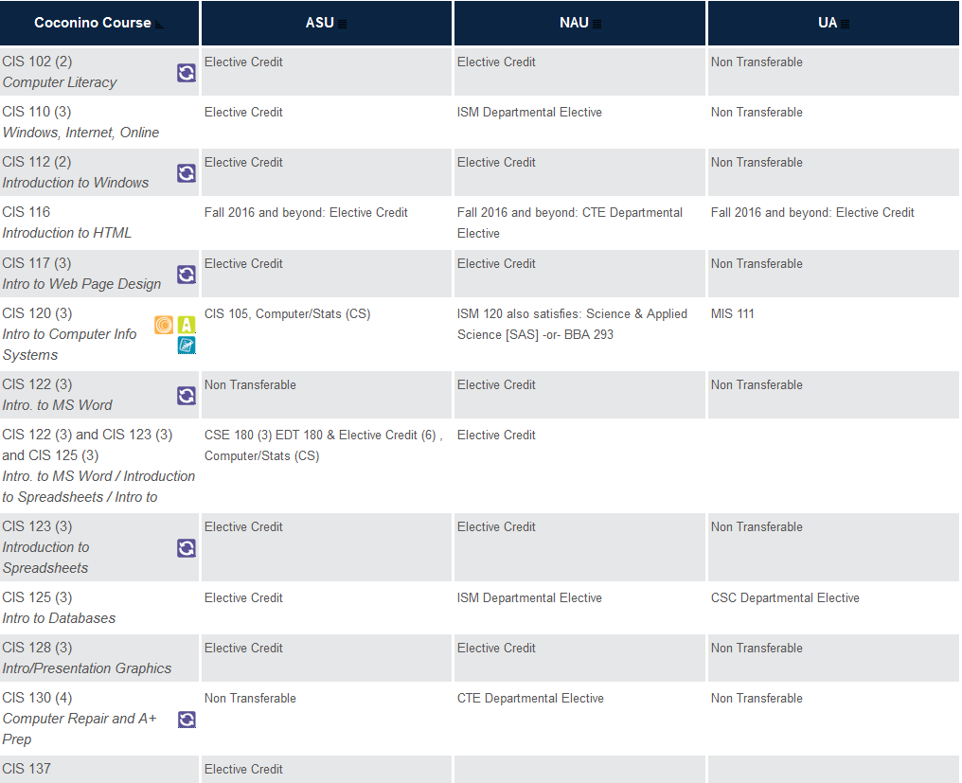

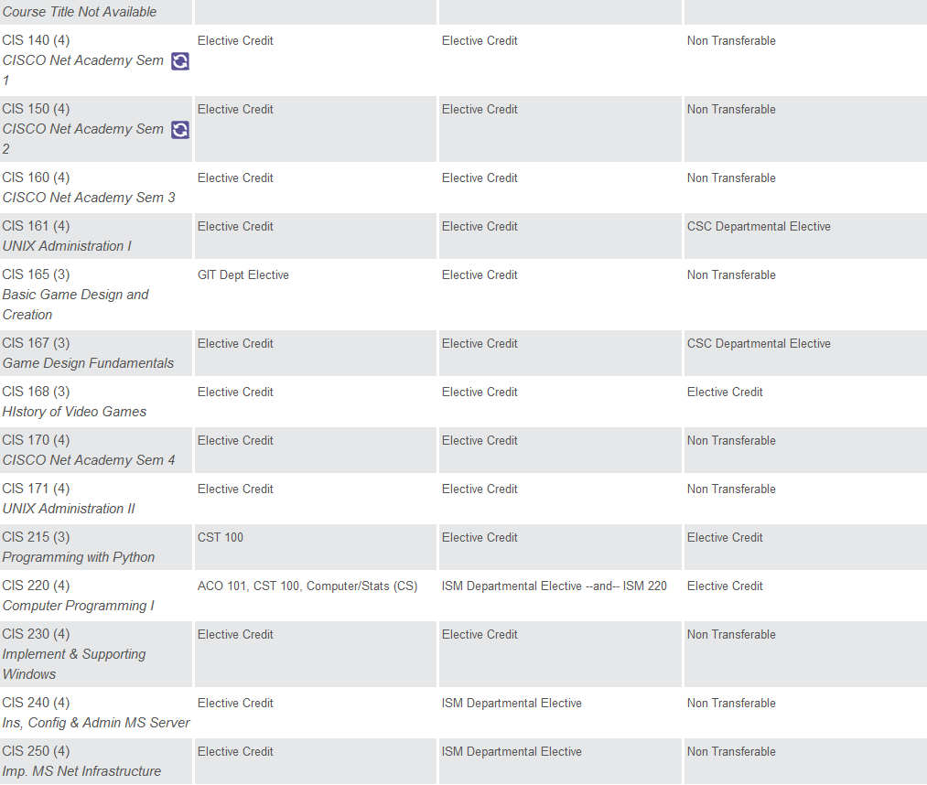

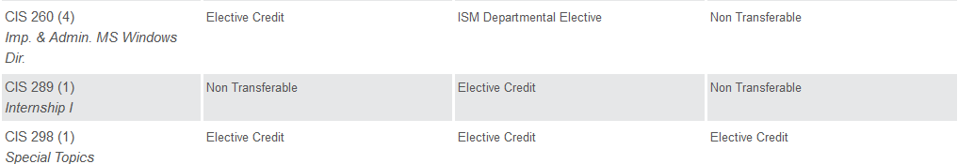

*If applicable, is the program accredited by a programmatic accrediting agency? If so, name the agency and include the status of your most recent accreditation.*

*Teaching Loads:*

The three full-time Faculty members are responsible for teaching the majority of courses, developing curricula, and assessing learning outcomes in the assigned discipline. They are also responsible for overseeing the implementation and growth of the CIS degree program and courses. They provide assistance and academic advising to students outside of regularly scheduled class time. Teaching assignments may include alternative delivery methods including online, day and evening classes, and may be at multiple sites. This is a full-time, benefits eligible position.

Essential Duties and Responsibilities

1) With students:

a) Teaches 30+ load hours per year.

b) Formally evaluates student performance

*SECTION3 – Staff, Resources, Facilities, and Funds*

*Internal factors:*

*What do you see as internal strengths of the program?*

The Computer Information System department has highly qualified and Industry Standard Certified faculty with years of business experiences before being hired as faculty. They bring a considerable and diverse knowledge and history of the growth and changes in technology over the years since PC’s were designed and developed. CIS is a valuable training resource for HS students supporting the CAVIAT program, and the community stakeholders through non-credit hands-on workshops. Students indicate that the hands on training received is highly valuable and gives them confidence when entering the workforce. The department has an excellent reputation with the community and the instructors are sought for many professional input needs. The enrollment is relatively stable and strong.

*What do you see as internal weaknesses of the program?*

The greatest internal threat is lack of funding to allow our department to hire more faculty with knowledge and diversity in the many different aspects of new and current technologies to create and grow new programs.

*List the recommendations from your last program review and any recommendations from Program Advisory Committees (if applicable).*

Our instructors are allocated to teach the course(s) that they are qualified/certified to teach and therefore, their skills are utilized to the fullest degree. Finding effective and qualified faculty in CIS is a challenge at the standard faculty wages. Very few people apply for open positions and those that do apply are often not qualified. The lack of qualified applicants as well as high turnover suggests that the CIS salary level is not adequate to attract and retain qualified staff. We have proposed to the Compensation Committee, a salary schedule model similar to that of Nursing or the technology area at the college. The committee has added this to its agenda and a possible proposal to have this accepted by the DGB. Due to budget constraints, we have difficulties providing our faculty with the necessary professional development that would support our programs to the fullest. We are finding the level of technology and support from the ITS department is beginning to improve. IT has created a Technology Committee which addresses budget, fee structures, and has representation from all areas of the college. This helps our department communicate with the IT department regarding our needs. We have found that as technology becomes more common, the computer classrooms that were once only needed by CIS are now being utilized by many other departments. This has required a lot of juggling and compromise, but seems to be working better each semester.

**SECTION 4—ANALYSIS AND RECOMMENDATIONS**

**Description**:

The mission of this program is to offer courses that will prepare our students to compete for positions in the work force which aligns our programs with CCC’s strategic planning goals. This program is meeting the needs of the target student population and after meeting with our Advisory Councils, they are satisfied with how this program has the right amount of courses to produce future productive employees. Also, we believe this program is meeting the needs of the target demographics.

**Assessment:**

The current methods to assess our CIS courses vary between courses. Following are some of the methods used:

1. Pre-Post Tests

2. Capstones

3. Rubrics

***Challenges:***

Once again our challenges tie-to financial limitations and limited faculty which leads to limited variety of course offerings, keeping up with current technology and being able to implement the changes in a reasonable time and coordinating this with the technology offered to our students when purchasing new technology.

***Summary of Computer Information Systems Program:***

The CIS department offers courses required by students to succeed in current technology careers. Some of these students complete our AAS Degree(s), which can be transferred allowing them to move on to a 4-year institute and complete a Bachelor’s degree (with 2 years completed). Other student’s complete specific courses of interest that will further them in their career and/or knowledge base to obtain a career.

# ***Appendix A Examples of Course Syllabi***

## Course Syllabus Coconino Community College Introduction to Computer Information Systems *Spring 2016 – CRN 13003 CIS 120-01*

**INSTRUCTOR:**

*Dave Bowman*

**CONTACT INFORMATION:**

Phone: 928 226-4361

Email: [dave.bowman@coconino.edu](mailto:dave.bowman@coconino.edu)

Office Room Number - 422

**ATTENDANCE REQUIREMENTS:**

***Attendance will be taken in this class. If you fail to attend the first week of class (for in-person classes) or fail to log-in and participate by the identified date (for online courses), you will be counted as absent, and you will be dropped. Financial Aid students that exceed the number of absences for a class will have financial aid reduced and/or revoked due to non-attendance, and will owe money to the College. Students may also be suspended from receiving Financial Aid in future semesters for failure to attend classes in the current semester. It is especially important that Financial Aid students attend all classes so that this does not happen. Regardless of whether or not you are a Financial Aid student, if you are going to be absent from a class, you need to inform your instructor that you will be absent. Failure to notify the instructor could lead to being dropped from class and/or your financial aid being reduced or cancelled.***

**Codes used for Attendance Requirements**

1. **NS -** No Show – will be dropped
   1. Used for students who **don’t** attendthe **first week** ofclass**!**
2. **ID -** Instructor Drop
   1. Used for students who attended a minimum of one time, then stopped attending or participating. Deadline to drop without record - **3/3**
   2. The student may also drop without any record on his/her transcript by **3/3**
3. **IW – Instructor Withdrawal**
   1. Used for students who attended a minimum of one time, then stopped attending or participating between **3/4 and 4/22**
   2. The student may also drop between **3/4 and 4/22** but will receive a “W” on his/her transcript.
4. **Letter Grade**
   1. After **April 22**,the student will receive a letter grade of **A, B, C, D, or F,** whichever grade is earned for the semester

Students are allowed **1** **unexcused** and **to 2 excused** absences for a **total** of ***3 absences*** for the semester. After that, the student will either receive an **“ID”** (if before **3/3**) or an **“IW” (**if before **4/23).** After **April 22** the student will receive a letter grade ofA, B, C, D, or F, whichever grade is earned for the semester.

**OFFICE HOURS:**   
**“Click on the link “**[**Office Hours - spring 2016**](https://coconino.instructure.com/courses/1383134/files/55176807/download?verifier=YFt8cbKGuU5jgL76nlD7MlIu4W4NYnfgu7x5XI03&wrap=1)” **from the Canvas Home Page”**

**SEMESTER CALENDAR:** - **Important *spring 2016* Dates:**

|  |  |
| --- | --- |
| **January** |  |
| 1/18 | Deadline to add classes |
| 1/18 | **Martin Luther King, Jr. Day – College closed** |
| 1/19 | Instruction Begins |
| 1/25 | Deadline for 100% refund |
| 1/26 | Begin 0% refund |
| 1/29 | Deadline to add classes with Instructor signature |
| 1/29 | Deadline to change registration status from audit to credit or credit to audit; or S/U (for eligible courses) |
| **February** |  |
| 2/15 | **President’s Day – College Closed** |
| **March** |  |
| 3/3 | **Deadline to drop without record** |
| 3/3 | Faculty deadline for submitting FTSE enrollment verification |
| 3/7 | Spring Graduation applications due |
| **3/14-3/18** | **Spring Break – College Closed** |
| **April** |  |
| 4/1 | **Employee Development Day – College services closed entire day  Scheduled classes will run normally** |
| 4/22 | Final deadline for withdrawing with a grade of "W" |
| **May** |  |
| 5 - 9-13 | Last week of fall semester – finals week |
| 5/13 | Commencement |
| 5/17 | Final grades due |
| 5/19 | Spring grades available online |
| 5/30 | **Memorial Day – College Closed** |

**COURSE DESCRIPTION:**   
Concepts and theories regarding computer hardware, software, and information processing systems. Includes an intensive lecture component covering the most current technological and computer information available and a hands-on component using word processing, spreadsheet, database, and presentation, e-mail and web browsing application software packages. No prior experience necessary. General Education: Options. Three lecture.

**COURSE GOALS:**

To provide students with necessary knowledge and skills to become intelligent users of business computer systems with reference to programs, procedures, data, people, and hardware.

**COURSE OUTCOMES:**

**Students will:**

1. Describe computer hardware, software, and information processing and how they are applied to current business operations and management.
2. Describe current and future uses of and careers in computers.
3. Effectively operate a computer system and its various peripheral devices, such as printers and disk drives.
4. Correctly use computer-related vocabulary.
5. Describe the limitations of computer systems and their applications in various environments.
6. Discuss the impact of the Internet, telecommunications, and networks to the way computers are used.
7. Identify issues related to security, ethics, and privacy when using a computer.
8. Produce computer-generated projects through the use of word processing, spreadsheet, database, and presentation, e-mail, and web browsing computer application software.

**COURSE CONTENT:**   
**Will include:**

* An overview of computer concepts and computer software applications.
* Input to and output from the computer
* The system unit and secondary storage
* Communications, networks and the Internet.
* Operating systems
* Information management and information systems
* Information systems development and program development
* Security, ethics, and privacy issues related to computer usage
* The future of the Information Age
* Computer Careers and Certification
* Intro to using word processing, spreadsheet, database, presentation, e-mail, and web browsing software

**PREREQUISITE:**

**No prior experience necessary.**

**REQUIRED TEXTBOOKS AND MATERIALS  
  
1. Access Codes for Emerge and SAM2013**

* **You can purchase these from the CCC Bookstore or from the following website:**
* <http://www.cengagebrain.com/course/1-23YALC8> - latest version
* <http://www.cengagebrain.com/course/1-203DPMV>

**\*\*\*Required Software\*\*\***

Microsoft Office **Professional** **2013** includes:

* **Word 2013**
* **PowerPoint 2013**
* **Excel 2013**
* **Access 2013**

If you do **not** purchase **Professional 2013**, **Access is not included.**  **However, all software to complete this class’s lab assignment is available to students in the computer labs at Coconino Community College Lone Tree, 4th Street, and Page Campus’s.**

**ETHICS**

* + Each student is responsible for completing his or her own work.
  + Cheating of any kind may lead to expulsion from the college and/or a grade of "F" for the course.
  + Cheating on a quiz/exam will always result in (at least) a zero on that quiz/exam.
  + Cheating on homework will always result in (at least) a zero on that entire assignment for all parties involved.

**Following is a list of activities that are considered cheating on homework assignments. This list is not intended to be all-inclusive:**

* + Two or more students using the same file for their individual homework assignments.
  + Duplicating another person's work.
  + Turning in projects that from start to finish are not your own.
  + Copying a homework file onto or from another student's diskette for any reason.

**HOMEWORK**

* All lab assignment (SAM 2013) projects can be turned in prior to the due date and time. Students are strongly discouraged from waiting until the last day to submit assignments.
* Lab assignments are due by 11:59 p.m. on the date indicated in the course outline.
* All Projects must be submitted by due dates

**CLASS ACTIVITIES:**

Final grades will be determined according to the notations and tables below:

* Quiz and exam points are determined by your scores on the 10 timed quizzes, the Mid-term and Final Exam.
* 4 Video Projects
* The Midterm and Final Exams will be available the last day of class for the week they are scheduled
* There are no make-ups for missed quizzes, the Mid-term or the Final Exam (unless there is an unforeseen circumstance).
* Project Assignment points are determined by the SAM 2013 project assignments.
* The 4 Capstones are also graded by SAM 2013
* Quizzes are available at the beginning of the week (Monday, 8:00 am) through the end on the week (Sunday, 11:59 pm)
* Failure to take a scheduled quiz or exam could result in a grade of "0" for that quiz or exam.

**Letter Grades Based of Percentages**

90% or higher A

80%-89% B

70%-79% C

60%-69% D

59% or lower F

**Grade Distribution –** There are a total possible **1350** points

|  |  |  |
| --- | --- | --- |
| **Grade Distribution** | | |
| **General Points** |  | Pts Possible |
| Pre/Posttests, (Completion Points Only) – 5 pts each / *10 Points Total* |  | 10 |
| EXTRA CREDIT | subtotal | **10** |
|  |  |  |
| **Conceptual (Emerge)** |  |  |
| Concept Quizzes (10) – 300 Points |  | 300 |
| Midterm Exam (chapters 1-5) - 100 Points |  | 100 |
| Final Exam (chapters 6-9, and 11) – 100 *Points* |  | 100 |
|  | subtotal | **500** |
|  |  |  |
| **Practical (Word, Excel, Access, PPT) (SAM2013)** |  |  |
| Office 2013 Projects (25 pts per projects – **4** projects for Word, Excel, Access, AND **2** PPT) – 350 Points |  | 350 |
| Office 2013 Capstones (one per application at 100 pts a piece i.e. 1 capstone for Word, 1 for Excel) – 400 Points |  | 400 |
| Emerge Video Projects (one per application at 25 pts a piece) – 100 Points |  | 100 |
|  | subtotal | **850** |
|  |  |  |
| **Total Points Possible** |  | **1350** |

**MODIFICATION:**   
The instructor may choose to add his opinions when relevant to the content to provide additional context and examples for the sake of learning and discussion.

It is the student's responsibility to have read and be familiar with the policies and procedures outlined in the Student Handbook which can be found in the online CCC catalog.

The instructor reserves the right to make additions, deletions, and modifications to the syllabus, outline, and course requirements with reasonable notification to the students enrolled

|  |  |  |  |
| --- | --- | --- | --- |
| **COURSE OUTLINE FALL 2015**  **CIS 120 - INTRODUCTION TO COMPUTER INFORMATION SYSTEMS** | | | |
| **Week** | **Date** | **Activities** | Due |
| **Key:** (e) = in emerge content; (S) = complete in SAM; (C) = complete in Canvas tools | | | |
| 1 | 1/18 – 1/24 (1/18 – Holiday) **(Mon)** | Complete Orientation module (C).  Review the syllabus and take the pretest (C). | Due 1/24:   * Pretest (C) |
| 2 | 1/25 – 1/31 | Concepts 1 – Digital Technology (e)  Begin Skills 5 – Word 2013 (e) Emerge Video Project | Due 1/31:31   * Concepts 1 Quiz (C) |
| 3 | 2/1 – 2/7 | Concepts 2 – Hardware (e)  Complete Skills 5 – Word 2013 (e) Emerge Video Project Begin Projects (1-4)Word *(S)* | Due 2/7:   * Concepts 2 Quiz (C) * Video Project – Word (C) |
| 4 | 2/8 – 2/14 | Concepts 3 – Software (e)  Complete Projects (1-4) - Word *(S)* | Due 2/14:   * Concepts 3 Quiz (C) * Projects (1-4) – Word (S) |
| 5 | 2/15 – 2/21 (2/15 – Holiday) **(Mon)** | Concepts 4 – Internet (e) Complete Capstone – Word (S)  Begin Skills 6 – Excel 2013 (e) Emerge Video Project (C) | Due 2/21:   * Concepts 4 Quiz (C) * Capstone - Word (S) |
| 6 | 2/22 – 2/28 | Complete Skills 6 – Excel 2013 (e) Emerge Video Project Begin Projects (1-4) – Excel (S) | Due 2/28:   * Video Project – Excel (C) |
| 7 | 2/29 – 3/6 | Concepts 5 – Telecommunications (e) Complete Projects (1-4) – Excel (S) Complete Capstone – Excel (S) | Due 3/6:   * Concepts 5 Quiz (C) * Projects (1-4) – Excel (S) * Capstone – Excel (S) |
| 8 | 3/7 – 3/13 | Mid-Term *Covers Concepts 1-5 (C) | Due – 2nd Day of Class:   * Mid-Term Exam (C) |
|  | **3/14 – 3/20** | **SPRING BREAK – COLLEGE CLOSED** |  |
| 9 | 3/21 – 3/27 | Concepts 6 – Information Security (e)  Begin Skills 7 – PowerPoint (e) Emerge Video Project | Due 3/27:   * Concepts 6 Quiz (C) |
| 10 | 3/27 – 4/3 | Concepts 7 – Digital Media (e)  Complete Projects (1-2) - PowerPoint (S)  Complete Skills 7 – PowerPoint (e) Emerge Video Project  **\*\*\*Course Evaluation*** opens** | Due 4/3:   * Concepts 7 Quiz (C) * Projects (1-2) – PowerPoint * Video Project – PowerPoint |
| 11 | 4/4 – 4/10 | Concepts 8 – Database (e)  Complete Capstone – PowerPoint (S) Begin Skills 8 – Access 2013 (e) Emerge Video Project | Due 4/10:   * Concepts 8 Quiz (C) * Capstone PowerPoint (S) |
| 12 | 4/11 – 4/17 | Concepts 9 – E-Commerce (e)  **\*\*\*Course Evaluation*** Closes Sunday, Nov 22\*\*** | Due 4/17:   * Concepts 9 Quiz (C) * **\*\*\*Course Evaluation\*\*\*** |
| 13 | 4/18 – 4/24 | Concepts 11- Artificial Intelligence (e) | Due 4/24:   * Concepts 11 Quiz (C) |
| 14 | 4/25 – 5/1 | Complete Projects (1-4) – Access (S) | Due 5/1:   * Projects (1-4) – Access (S) |
| 15 | 5/2 – 5/8 | Complete Capstone – Access (S) PostTest opens | Due 5/8:   * Capstone – Access (S) |
| 16 | 5/9 – 5/13 | PostTest (C)  Final Exam *Covers Concepts 6, 7, 8, 9, & 11 (C) | PostTest AND Final Exam **(Final Exam will be taken the last class period of the Semester)** |

# ***Appendix B Job Description of Full Time Faculty***



|  |  |
| --- | --- |
| **Job Title: Full-Time Faculty** | **Pay Grade:**  **Salary placement on the Faculty Salary Schedule is based on education and experience. See the Faculty Salary Schedule for more information**. |
| **Department: Career & Technical Services – CISCO & CIS** | **FLSA: Exempt** |
| **Reports To: Academic Dean** | **Revision Date: 10/2/15** |

**Summary**

Responsible for teaching Cisco and CIS courses including MS, programming using current languages, Unix/Linux, and MSCA courses, developing curricula, and assessing learning outcomes in the assigned discipline. Also responsible for providing assistance and academic advising to students outside of regularly scheduled class time. Teaching assignments may include alternative delivery methods including web and ITV, day, evening and weekend classes, and may be at multiple sites. Responsible for keeping up to date in the assigned discipline. Responsible for maintaining discipline/course specific certifications and licensing where appropriate in order to fulfill teaching assignment. This is a full-time, benefits eligible, regular position.

**Essential Duties and Responsibilities**

**1. With students:**

1. Teaches 30 load hours per year in a professional manner.
2. Provides advising outside of class time.
3. Maintains a minimum of five posted office hours per week

**2. With colleagues**

1. Adhere to a professional code of conduct and ethics.
2. Collaborate with other college employees as necessary and appropriate.

**3.   Scheduling**

1. Provides schedule building input and review as requested

**4.   Budget**

1. Cooperates with supervisor on the department budget.

**5.   Assessment and strategic planning**

1. Promotes the mission, values, purposes, and Strategic Plan of the College and learning college philosophy
2. Participates in the development, implementation, and assessment of programs, including the assessment of student learning outcomes, as prescribed by department.

**6. Curriculum**

1. Develops new or revises existing curricula as needed, which may include College supported Articulation Task Force (ATF) participation.
2. Remain current in the assigned discipline(s).
3. Maintain discipline/course specific certifications and licensure where appropriate.

**7. Institutional Leadership**

1. Assists supervisor in the evaluation of part-time faculty as requested.
2. Participates in the operation and/or shared governance of the college through college committee assignments and faculty meetings.
3. Assists in the building of programs relevant to their discipline.
4. Serves as a professional role model for students and other faculty.

**Knowledge, Skills and Abilities**

Ability to teach effectively. Knowledge and currency of the subject area, computer and related technology. Ability to maintain professional ethics and confidentiality of students and staff. Ability to support and promote the mission, values, purposes, and strategic plan of the College. Ability to work in a culturally diverse and team environment. Ability to integrate subject area with other related curricula. Knowledge of the applicable state and federal laws, such as FERPA.

**Minimum Qualifications**

Bachelor’s Degree and at least 2 years’ experience in occupational field, or any equivalent combination of education, certifications and occupational experience and/or training to meet Coconino Community College’s credentialing requirements which include filling out the Supplemental Credentials form, completion of EDU 250 course, and submission of transcripts. Must be or eligible to be CCNA certified in Cisco, Cisco Networking Academy Certified Instructor, Cisco A+ (IT Essentials) certified.

**Preferred**

Curriculum development or coursework valued. Recent experience teaching in a community college setting. Experience working with a diverse student population. Experience working with learning management systems or online learning tools.

**Physical Demands**

The physical demands described here are representative of those that must be met by an employee to successfully perform the essential functions of this job. Reasonable accommodations may be made to enable individuals with disabilities to perform the essential functions.While performing the duties of this Job, the employee is regularly required to stand; walk; sit; use hands to finger, handle, or feel and talk or hear. The employee must occasionally lift and/or move up to 25 pounds. Specific vision abilities required by this job include close vision and ability to adjust focus.

**Work Environment**

The work environment characteristics described here are representative of those an employee encounters while performing the essential functions of this job. Reasonable accommodations may be made to enable individuals with disabilities to perform the essential functions. The noise level in the work environment is usually moderate.

**NOTE: This job description is not intended to be all-inclusive. Employee may perform other related**

**duties as negotiated to meet the ongoing needs of the organization.**

**Coconino Community College is an equal opportunity employer.  Auxiliary aids and services are available upon request to individuals with disabilities.**