**Program Review of the Business Program**

**SECTION 1 –OVERVIEW:**

***Narrative***

The AA in Business and ABUS degree programs are designed for students who will be transferring to a university to obtain a four year degree.

The AAS Business Degree program is designed to prepare students to enter the business profession, at an entry level position, with tracks in General Business and Accounting by providing them with general knowledge and skills specializing in their area of interest. The program allows students the option of selecting support courses to strengthen their overall education and courses in their area of special interest or job opportunity.

The accounting certificate program is designed for students who will seek employment in an entry-level accounting position.

The Hotel and Restaurant Management degree programs are designed for students who will be transferring to a university to obtain a four year degree.

***Program mission statement***

The business programs strive to instill knowledge to prepare students for the business world.

***Staffing of the program***

Currently there are two full-time faculty members in the program with the remainder of the program being staffed by part-time faculty. All faculty are supervised by the Dean of Career and Technical Education.

***Decision making***

The program has maintained an Advisory Council since its inception that meets twice per year to review curriculum, create internship opportunities, and to discuss upcoming training needs and trends in the industry. Our full and part-time faculty members work in collaboration with the Division dean in making departmental decisions.

***Summary of student assessment results since last program review and programmatic changes as a result of the assessment results.***

Business students have a high success rate in the program. Student success rates have improved since the last program review. A recent example of a student success project was to identify and link “at-risk” students with tutors. The tutors would then provide feedback to the instructor, who then would work with the students and tutors in a collaborative environment to improve student success.

***A statement of the program’s accomplishments in support of the College’s current strategic plan.***

**Business**

* Enrollment has increased 3.5% since the last program review;
* Business programs have promoted a learner-centered environment in an effort to increase student success rates; and
* Through the Business Advisory Council, the department has expanded its community outreach programs.

**Hotel and Restaurant Management**

* Since the last program review, the Hotel and Restaurant Management program has continued to be supported, even with reduced funding.

***A description of the current facilities needed to conduct the program, including space and equipment.***

**Business**

Business courses are taught in classrooms with a capacity of twenty-five to thirty students. Classrooms have audio-visual equipment and whiteboards for instructor use. Dedicated classrooms for the Business Department would enhance student learning. Faculty would have the ability to have classroom materials related to each business program presented on bulletin boards, etc. Internships, scholarships, professional student membership opportunities and clubs could be posted.

**Hotel and Restaurant Management**

Hotel and Restaurant Management has adequate space and equipment to conduct HRM 140/240. All other HRM courses are taught in regular classrooms.

**SECTION 2- TEACHING AND LEARNING:**

***Program requirements and course offerings***

The Coconino Community College Course Catalog provides detailed information regarding the Business courses and programs. Any prerequisites for courses are identified in the catalog as well. The following is a listing of the Business degrees/certificates in addition to courses and descriptions from the CCC catalog:

**AA in Business: 62 credits** The Associate Arts in Business degree is designed for transfer to The Frankie College of Business bachelor's degree at Northern Arizona University (NAU).  Students interested in these programs or who are planning to transfer to a university other than NAU should see an advisor.  Students completing this degree will transfer a minimum of 62 credits to all Arizona public universities.

**AAS in Business: 61 credits** This program is designed to prepare students to enter the business profession, at an entry level position, with tracks in General Business and Accounting by providing them with general knowledge and skills specializing in their area of interest. The program allows students the option of selecting support courses to strengthen their overall education and courses in their area of special interest or job opportunity.

**AA in Hotel and Restaurant Management: 62 credits** The Associate of Arts in Hotel Restaurant Management is designed for transfer to the Hospitality bachelor's degree at Northern Arizona University (NAU). This program trains graduates for management careers in one of the fastest growing industries in the United States, the hospitality industry. Students completing this degree will transfer a minimum of 60 credits to NAU. Students planning to transfer to a university other than NAU should see an advisor.

**AAS in Hospitality Management: 57 credits** This program prepares students for entry‐level management careers in the hospitality industry. Students completing this degree will develop knowledge and skills necessary to compete in one of Arizona’s fastest growing businesses.

**Accounting Certificate: 26 Credits** The Accounting Certificate program is designed to prepare students for employment as entry‐level bookkeeper/ accounting position. Students may apply earned credit hours of this program toward the Associate of Applied Science in Business degree with an Accounting track.

**Accounting (ACC)**

**ACC 100 Practical Accounting Procedures (5)** Practical accounting offers a step by step approach to the study of accounting. This includes accounting for service, merchandising, and small business operations. The course includes the financial statements, basic accounting cycle, special journals, procedures for controlling cash and payroll accounting. Computerized accounting systems and procedures for small businesses are stressed. Five lecture.

**ACC 105 Income Tax I (3)** Internal Revenue Service Code and Regulations as they pertain to the individual. Tax principles are applied to problems and the preparation of the individual income tax return. Three lecture.

**ACC 110 Payroll Accounting (3)** A course that provides comprehensive and practical instruction in manual and computerized preparation and calculation of a business’s payroll records and tax returns. Prerequisites: ACC 100 or ACC 255 or Consent of Instructor. Three lecture.

**ACC 206 Computerized Accounting (3)** Electronic data processing systems as they apply to accounting systems. Provides hands‐on experience with microcomputer hardware and software packages. Includes accounting cycle transaction and management decision‐making applications. Three lecture.

**ACC 255 Principles of Financial Accounting (3)** Financial accounting theory as applied to corporate form of business involving service and merchandising activities. Includes analysis and recording of business transactions and preparation of financial statements. Prerequisite: MAT 140 or ACC 100 or placement. Three lecture.

**ACC 256 Principles of Managerial Accounting (3)** Offers both theory and practice as it applies to the uses of accounting information and techniques in the realm of the management decision making process of an organization. Introduces manufacturing accounting concepts, which include cost concepts, cost behavior analysis, profit planning, budgeting, and capital budgeting decisions. Prerequisite: ACC 255. Three lecture.

**ACC 289 Accounting Internship (1–6)** Designed for students who are looking for paid or voluntary, practical application of applied accounting principles.  Agreed upon internship will have a direct link to responsibilities regarding the business aspects of transaction analysis, journalizing, adjusting, posting, creating financial statements, and doing fundamental evaluation of the statements. Credit hours will be negotiated based on the successful completion of a course contract.   Each credit hour requires the completion of a minimum of 45 hours of related work as indicated by the course contract. Prior experience or course work in the area of interest is required.  One to six variable credit hours. Grading option S/U.

**BUSINESS (BUS)**

**114 BUS 100 Mathematics of Business (3)** Mathematical concepts and procedures involved in financial transactions. Includes percentages, liabilities, insurance, investments, assets, amortization, proration, taxes, and banking as it pertains to business. Prerequisites: MAT 091 or placement. Three lecture.

**BUS 101 Personal Money Management (1)** Introduction to spending money wisely, saving money, personal budgeting, applying for financial aid, understanding your credit score, how to interpret your paycheck, basic investing, and protecting yourself from identify theft.  This class is a lecture format with interaction in a computer in a computer lab. Grading option S/U. One lecture.

**BUS 103 Personal Finance (3)** Students will learn the fundamentals of assessing, managing, and implementing a plan for personal finance.  Coursework includes individual budgeting, personal banking, home ownership, investing, insurance, and planning for retirement. Three lecture.

**BUS 105 Basic Investments (3)** Basic investment strategies. The study of stocks and bonds, mutual funds, investment principles, and strategies to evaluate potential investments. Three lecture.

**BUS 111 Business English (3)** Effective listening, responding, reading, and writing with emphasis on using these skills in the workplace, from job application and interview to on‐the‐job oral and written communications. Prerequisite: ENG 100 or placement. Three lecture.

**BUS 204 Business Communications (3)** Solving business problems through effective oral and written communications.   Letter forms and methods of writing business letters. Creating functional letters related to inquiry, response, good will, sales, credit, and adjustment and collection.  General Education: Options. Special Requirement: Intensive Writing/Critical Inquiry. Pre/Co‐requisite: ENG 102. Three lecture.

**BUS 206 Principles of Management (3)** Fundamentals of management including the management principles and techniques used for business objectives, structure, operational procedures, and control procedures. Principles and techniques discussed may be applied to any area of business and industry. Three lecture.

**BUS 207 Principles of Marketing (3)** Environment of marketing including, analysis of various marketing activities and discussion of the economic, psychological, and sociological factors which influence marketing activities. Three lecture.

**BUS 211 Human Resources/Personnel Management (3)** Human resources planning and its application to the organization’s goals and objectives. Human resources policies, job analysis, employee selection, training, performance evaluation, benefits, compensation, labor relations, morale, safety, and termination. Three lecture.

**BUS 213 Small Business Management (3)** Students will learn the fundamentals of starting and operating a successful business.  Studies will include business objectives, operational procedures, financing, legal organizations, feasibility studies, and marketing.  Three lecture.

**BUS 214 Legal, Ethical, and Regulatory Issues in Business (3)** Legal theories, ethical issues, and regulatory climate affecting business policies and decision.  General Education:  Social/Behavioral Sciences. Prerequisite: ENG 101 or Consent of Instructor. Three lecture.

**BUS 216 Principles of Business Finance (3)** Principles of financial management as applied to the operations of non‐ financial business and industry firms. Application of financial analysis tools and techniques needed for the process of business and industry financial administration and decision making, goals and functions of financial management, analysis and planning, working capital management, capital budgeting, and the cost of capital risk. Three lecture.

**BUS 232 Business Statistics and Analysis (3)** Business statistics, including the collection, tabulation, and analysis of business and economic data. Averages, dispersion, statistical inference, correlation and regression, and statistical decision making and problem solving. General Education: Options. Prerequisite: MAT 140 or higher or placement test score beyond prerequisite. Three lecture.

**BUS 289 Internship I (1–6)** Designed for students who are looking for paid or voluntary practical application of applied business principles.  Agreed upon internship will have a direct link to responsibilities regarding the business aspects of management, finance, customer service, or marketing. Credit hours will be negotiated based on the successful completion of a course contract.  Each credit hour requires the completion of a minimum of 45 hours of related work as indicated by the course contract. Prior experience or coursework in the area of interest is required.  One to six variable credit hours. Grading option S/U. BUS 298 Special Topics (1‐6)

**Economics (ECN)**

**ECN 204 Macroeconomic Principles (3)** Basic principles of macroeconomics designed to acquaint the student with workings of the national economy: market economy, national income accounting, fiscal and monetary policy, and the Federal Reserve System. General Education: Social/Behavioral Sciences. Three lecture.

**ECN 205 Microeconomic Principles (3)**

Microeconomic topics of market structures, elasticity, price and output determination, and general equilibrium. General Education: Social/Behavioral Sciences. Three lecture.

***The following table provided by Coconino Community College Institutional Research indicates multiple factors about course enrollment data for the past five years.*** Table 1 below has been split for this Program Review.

**Enrollment as of Day 10 for each semester**

|  |  |  |  |  |  |  |
| --- | --- | --- | --- | --- | --- | --- |
|  | Columns |  |  |  |  |  |
|  | 2010-11 | | | 2011-12 | | |
| Courses | #Sec | #Enr | Tuition* | #Sec | #Enr | Tuition* |
| **ACC** | **21** | **236** | **$ 61,520** | **24** | **265** | **$71,712** |
| ACC 100 - Practical Accounting Proc | 5 | 38 | $ 14,000 | 4 | 42 | $16,185 |
| ACC 105 - Income Tax I |  |  |  | 1 | 3 | $747 |
| ACC 110 - Payroll Accounting | 3 | 10 | $ 2,400 |  |  |  |
| ACC 206 - Computerized Accounting |  |  |  | 2 | 23 | $5,727 |
| ACC 255 - Prin. of Financial Accounting | 8 | 130 | $ 31,200 | 11 | 121 | $30,129 |
| ACC 256 - Prin. of Managerial Acct. | 4 | 57 | $ 13,680 | 5 | 64 | $15,936 |
| ACC 298 - Special Topics | 1 | 1 | $ 240 | 1 | 12 | $2,988 |
| **BUS** | **26** | **389** | **$ 91,920** | **36** | **466** | **$106,157** |
| BUS 100 - Mathematics of Business | 2 | 32 | $ 7,680 | 2 | 29 | $7,221 |
| BUS 101 - Personal Money Management |  |  |  | 2 | 13 | $1,079 |
| BUS 103 - Personal Finance | 3 | 39 | $ 9,360 | 3 | 21 | $2,988 |
| BUS 105 - Basic Investments |  |  |  |  |  |  |
| BUS 111 - Business English | 1 | 17 | $ 4,080 | 1 | 15 | $3,735 |
| BUS 204 - Business Communications | 4 | 81 | $ 19,440 | 6 | 109 | $27,141 |
| BUS 206 - Principles of Management | 1 | 22 | $ 5,280 | 3 | 37 | $9,213 |
| BUS 207 - Principles of Marketing | 3 | 28 | $ 5,280 | 4 | 40 | $5,727 |
| BUS 211 - Human Resources/Personnel Mgt. |  |  |  |  |  |  |
| BUS 213 - Small Business Management | 1 | 25 | $ 6,000 | 3 | 29 | $5,976 |
| BUS 214 - Legal-Eth.-Reg. Issues in Bus. | 3 | 59 | $ 14,160 | 3 | 72 | $17,928 |
| BUS 232 - Business Statistics & Analysis | 8 | 86 | $ 20,640 | 9 | 101 | $25,149 |
| **ECN** | **16** | **326** | **$ 78,240** | **16** | **304** | **$75,696** |
| ECN 204 - Macroeconomic Principles | 8 | 154 | $ 36,960 | 8 | 150 | $37,350 |
| ECN 205 - Microeconomic Principles | 8 | 172 | $ 41,280 | 8 | 154 | $38,346 |
| **LDR** | **7** | **49** | **$ 6,280** | **5** | **48** | **$6,972** |
| LDR 115 - Workplace Ethics | 2 | 19 | $ 1,520 | 1 | 12 | $996 |
| LDR 201 - Leadership Basics | 1 | 17 | $ 2,720 | 1 | 22 | $3,652 |
| LDR 202 - Leadership and Decision-Making | 1 | 5 | $ 800 | 1 | 8 | $1,328 |
| LDR 203 - Leadership & Communication | 1 | 5 | $ 800 | 1 | 3 | $498 |
| LDR 204 - Leadership and Power | 1 | 2 | $ 320 | 1 | 3 | $498 |
| LDR 289 - Leadership Internship | 1 | 1 | $ 120 |  |  |  |
| **Grand Total** | **70** | **1000** | **$ 237,960** | **81** | **1083** | **$260,537** |

|  |  |  |  |  |  |  |
| --- | --- | --- | --- | --- | --- | --- |
|  |  |  |  |  |  |  |
|  | 2012-13 | | | 2013-14 | | |
| Courses | #Sec | #Enr | Tuition* | #Sec | #Enr | Tuition* |
| **ACC** | **23** | **278** | **$74,460** | **23** | **280** | **$78,126** |
| ACC 100 - Practical Accounting Proc | 4 | 31 | $11,475 | 4 | 29 | $12,615 |
| ACC 105 - Income Tax I |  |  |  |  |  |  |
| ACC 110 - Payroll Accounting | 1 | 10 | $2,550 | 1 | 9 | $2,349 |
| ACC 206 - Computerized Accounting |  |  |  |  |  |  |
| ACC 255 - Prin. of Financial Accounting | 12 | 163 | $41,565 | 11 | 155 | $40,455 |
| ACC 256 - Prin. of Managerial Acct. | 6 | 74 | $18,870 | 7 | 87 | $22,707 |
| ACC 298 - Special Topics |  |  |  |  |  |  |
| **BUS** | **36** | **447** | **$109,395** | **41** | **523** | **$130,239** |
| BUS 100 - Mathematics of Business | 2 | 20 | $5,100 | 3 | 34 | $8,874 |
| BUS 101 - Personal Money Management |  |  |  |  |  |  |
| BUS 103 - Personal Finance | 2 | 20 | $5,100 | 3 | 36 | $9,396 |
| BUS 105 - Basic Investments | 2 | 7 | $1,785 |  |  |  |
| BUS 111 - Business English | 1 | 9 | $2,295 | 4 | 32 | $8,352 |
| BUS 204 - Business Communications | 7 | 109 | $27,795 | 8 | 95 | $24,795 |
| BUS 206 - Principles of Management | 3 | 47 | $11,985 | 3 | 57 | $14,877 |
| BUS 207 - Principles of Marketing | 4 | 42 | $6,120 | 6 | 73 | $12,789 |
| BUS 211 - Human Resources/Personnel Mgt. | 1 | 2 | $510 | 1 | 1 | $261 |
| BUS 213 - Small Business Management | 1 | 22 | $5,610 | 1 | 17 | $4,437 |
| BUS 214 - Legal-Eth.-Reg. Issues in Bus. | 4 | 78 | $19,890 | 5 | 86 | $22,446 |
| BUS 232 - Business Statistics & Analysis | 9 | 91 | $23,205 | 7 | 92 | $24,012 |
| **ECN** | **16** | **328** | **$83,640** | **19** | **325** | **$84,825** |
| ECN 204 - Macroeconomic Principles | 8 | 149 | $37,995 | 9 | 153 | $39,933 |
| ECN 205 - Microeconomic Principles | 8 | 179 | $45,645 | 10 | 172 | $44,892 |
| **LDR** | **3** | **20** | **$2,805** | **9** | **52** | **$7,395** |
| LDR 115 - Workplace Ethics | 2 | 7 | $595 | 2 | 19 | $1,653 |
| LDR 201 - Leadership Basics | 1 | 13 | $2,210 | 4 | 30 | $5,220 |
| LDR 202 - Leadership and Decision-Making |  |  |  | 1 | 1 | $174 |
| LDR 203 - Leadership & Communication |  |  |  | 2 | 2 | $348 |
| LDR 204 - Leadership and Power |  |  |  |  |  |  |
| LDR 289 - Leadership Internship |  |  |  |  |  |  |
| **Grand Total** | **78** | **1073** | **$270,300** | **92** | **1180** | **$300,585** |
|  |  |  |  |  |  |  |

|  |  |  |  |  |  |  |
| --- | --- | --- | --- | --- | --- | --- |
|  |  |  |  |  |  |  |
|  | 2014-15 | | | 2015-16 | | |
| Courses | #Sec | #Enr | Tuition* | #Sec | #Enr | Tuition* |
| **ACC** | **22** | **306** | **$91,932** | **17** | **230** | **$72,362** |
| ACC 100 - Practical Accounting Proc | 5 | 35 | $15,510 | 3 | 28 | $13,580 |
| ACC 105 - Income Tax I |  |  |  |  |  |  |
| ACC 110 - Payroll Accounting | 1 | 6 | $1,692 | 1 | 8 | $2,328 |
| ACC 206 - Computerized Accounting | 1 | 9 | $2,538 | 1 | 8 | $2,328 |
| ACC 255 - Prin. of Financial Accounting | 9 | 151 | $42,582 | 8 | 137 | $39,867 |
| ACC 256 - Prin. of Managerial Acct. | 6 | 105 | $29,610 | 4 | 49 | $14,259 |
| ACC 298 - Special Topics |  |  |  |  |  |  |
| **BUS** | **43** | **497** | **$140,154** | **41** | **511** | **$147,837** |
| BUS 100 - Mathematics of Business | 4 | 37 | $10,434 | 4 | 61 | $17,751 |
| BUS 101 - Personal Money Management |  |  |  |  |  |  |
| BUS 103 - Personal Finance | 4 | 31 | $8,742 | 5 | 30 | $8,730 |
| BUS 105 - Basic Investments |  |  |  |  |  |  |
| BUS 111 - Business English | 3 | 17 | $4,794 | 2 | 16 | $4,656 |
| BUS 204 - Business Communications | 7 | 122 | $34,404 | 5 | 110 | $32,010 |
| BUS 206 - Principles of Management | 3 | 40 | $11,280 | 3 | 54 | $15,714 |
| BUS 207 - Principles of Marketing | 3 | 27 | $7,614 | 4 | 42 | $11,358 |
| BUS 211 - Human Resources/Personnel Mgt. |  |  |  |  |  |  |
| BUS 213 - Small Business Management | 2 | 25 | $7,050 | 2 | 23 | $6,693 |
| BUS 214 - Legal-Eth.-Reg. Issues in Bus. | 8 | 93 | $26,226 | 8 | 99 | $28,809 |
| BUS 232 - Business Statistics & Analysis | 9 | 105 | $29,610 | 8 | 76 | $22,116 |
| **ECN** | **16** | **324** | **$91,368** | **15** | **331** | **$96,321** |
| ECN 204 - Macroeconomic Principles | 7 | 139 | $39,198 | 7 | 165 | $48,015 |
| ECN 205 - Microeconomic Principles | 9 | 185 | $52,170 | 8 | 166 | $48,306 |
| **LDR** | **4** | **49** | **$7,708** | **4** | **39** | **$6,014** |
| LDR 115 - Workplace Ethics | 1 | 16 | $1,504 | 1 | 16 | $1,552 |
| LDR 201 - Leadership Basics | 3 | 33 | $6,204 | 3 | 23 | $4,462 |
| LDR 202 - Leadership and Decision-Making |  |  |  |  |  |  |
| LDR 203 - Leadership & Communication |  |  |  |  |  |  |
| LDR 204 - Leadership and Power |  |  |  |  |  |  |
| LDR 289 - Leadership Internship |  |  |  |  |  |  |
| **Grand Total** | **85** | **1176** | **$331,162** | **77** | **1111** | **$322,534** |

|  |  |  |  |
| --- | --- | --- | --- |
|  |  |  |  |
|  | Total #Sec | Total #Enr | Total Tuition* |
| Courses |
| **ACC** | **130** | **1595** | **$450,112** |
| ACC 100 - Practical Accounting Proc | 25 | 203 | $83,365 |
| ACC 105 - Income Tax I | 1 | 3 | $747 |
| ACC 110 - Payroll Accounting | 7 | 43 | $11,319 |
| ACC 206 - Computerized Accounting | 4 | 40 | $10,593 |
| ACC 255 - Prin. of Financial Accounting | 59 | 857 | $225,798 |
| ACC 256 - Prin. of Managerial Acct. | 32 | 436 | $115,062 |
| ACC 298 - Special Topics | 2 | 13 | $3,228 |
| **BUS** | **223** | **2833** | **$725,702** |
| BUS 100 - Mathematics of Business | 17 | 213 | $57,060 |
| BUS 101 - Personal Money Management | 2 | 13 | $1,079 |
| BUS 103 - Personal Finance | 20 | 177 | $44,316 |
| BUS 105 - Basic Investments | 2 | 7 | $1,785 |
| BUS 111 - Business English | 12 | 106 | $27,912 |
| BUS 204 - Business Communications | 37 | 626 | $165,585 |
| BUS 206 - Principles of Management | 16 | 257 | $68,349 |
| BUS 207 - Principles of Marketing | 24 | 252 | $48,888 |
| BUS 211 - Human Resources/Personnel Mgt. | 2 | 3 | $771 |
| BUS 213 - Small Business Management | 10 | 141 | $35,766 |
| BUS 214 - Legal-Eth.-Reg. Issues in Bus. | 31 | 487 | $129,459 |
| BUS 232 - Business Statistics & Analysis | 50 | 551 | $144,732 |
| **ECN** | **98** | **1938** | **$510,090** |
| ECN 204 - Macroeconomic Principles | 47 | 910 | $239,451 |
| ECN 205 - Microeconomic Principles | 51 | 1028 | $270,639 |
| **LDR** | **32** | **257** | **$37,174** |
| LDR 115 - Workplace Ethics | 9 | 89 | $7,820 |
| LDR 201 - Leadership Basics | 13 | 138 | $24,468 |
| LDR 202 - Leadership and Decision-Making | 3 | 14 | $2,302 |
| LDR 203 - Leadership & Communication | 4 | 10 | $1,646 |
| LDR 204 - Leadership and Power | 2 | 5 | $818 |
| LDR 289 - Leadership Internship | 1 | 1 | $120 |
| **Grand Total** | **483** | **6623** | **$1,723,078** |

|  |
| --- |
| *\* Tuition Notes:* |
| *Dual Enrollment sections do not generate tuition revenues. See The Dual Enrollment tab for section details.* |
| *Tuition is based on in-state rates* |
| *Differential Tuition began 2014-15* |

***Credentialing***

All faculty are credentialed according to the Higher Learning Commission (HLC) guidelines. Due to the new requirements of the HLC, current full-time faculty are working with the CTE Dean in meeting these new requirements.

***How often are course outlines reviewed and updated?***

Through the Business Advisory Council meetings, as well as the Business/Economic and HRM ATF meetings, course outlines are reviewed and updated at a minimum of every other year.

*Curriculum:*

Business Program updates vetted through CCC’s curriculum process:

* ABUS degree was last updated in November 2011
* AA Business degree was last updated in Fall 2014 and Fall 2011
* AAS Business degree was last updated in Fall 2014 and Fall 2012
* Accounting certificate was last updated in November 2011
* AGEC-Business certificate was last updated in Fall 2011
* BUS 204 was added to AGEC Options and Intensive Writing effective fall 2014
* LDR 202, 203, 204 were removed from the AAS Business effective Fall 2014

Curriculum:

Any changes in course or program outlines needed as indicated by the advisory councils, statewide Articulation Task Force (ATF) or College need have been put through the CCC curriculum process over time.

*Articulation:*

Course articulation is done through the annual Business/Economic and HRM ATF meetings.

Accounting (ACC) Courses 2016-2017

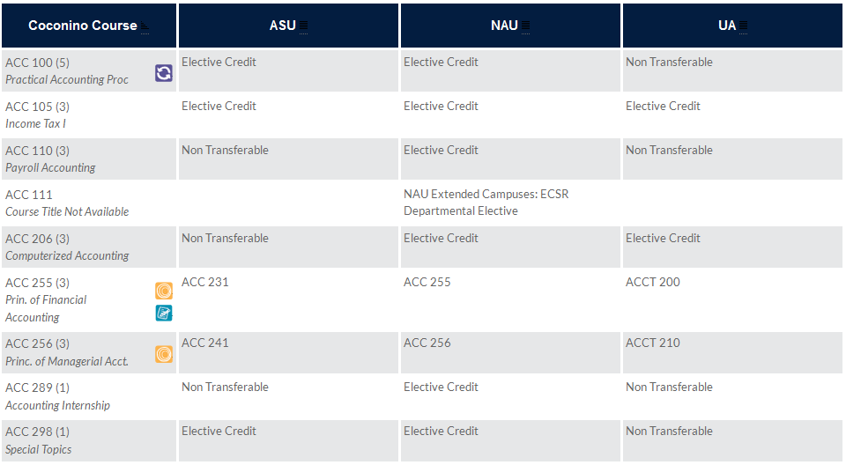

Business (BUS) Courses 2016-2017

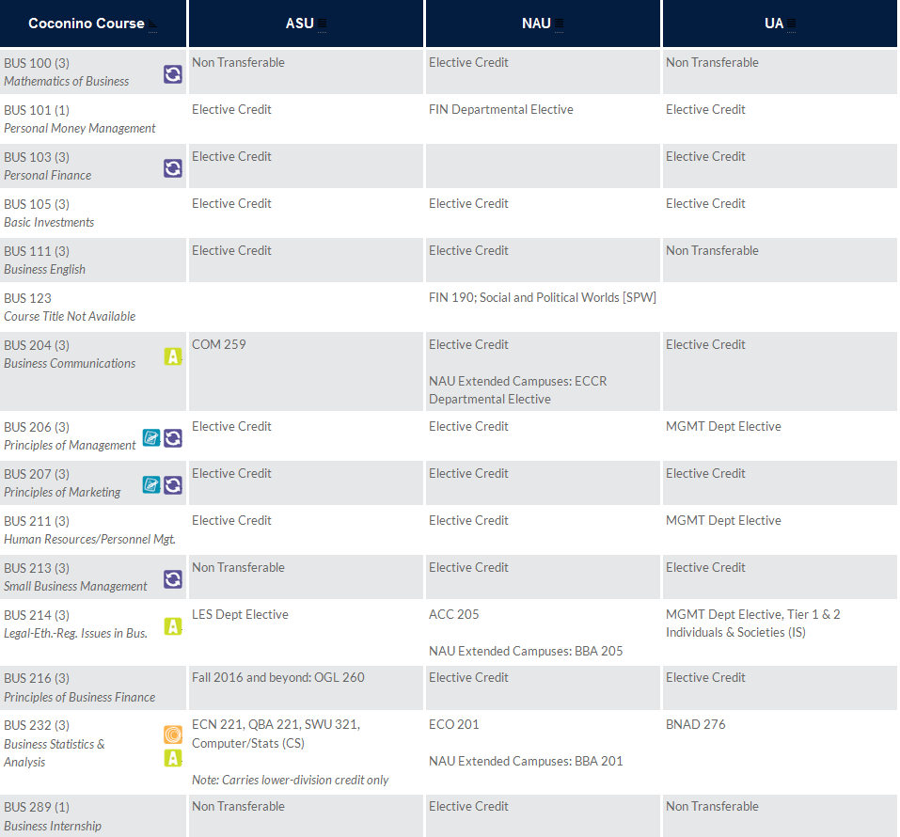

Economics (ECN) Courses

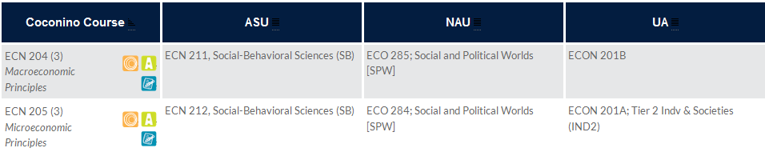

*If applicable, is the program accredited by a programmatic accrediting agency? If so, name the agency and include the status of your most recent accreditation.*

N/A

*Teaching Loads:*

All full-time faculty are required to teach a load of 30 credit hours per year.

*SECTION3 – Staff, Resources, Facilities, and Funds*

*Internal factors:*

*What do you see as internal strengths of the program?*

* Supportive faculty and staff;
* Great leadership;
* Cohesive team that encourages and supports one another;
* Open door policies; and
* Sharing of learning material

*What do you see as internal weaknesses of the program?*

* Lacking an additional full-time faculty member;
* Lacking financial resources;
* Lacking student resources; and
  + Business Scholarships
  + Business Internships
  + Professional Memberships
  + Business Certificate Program
  + Entry-level accounting courses
  + Study area for business students
* Meeting HLC faculty credentialing requirements in specific specialty areas.

*What do you see as opportunities for the program?*

* Creation of a Business lab
* Creation of a Business Certificate program
* Creation of entry-level accounting courses
* Student access to professional organizations (AICPA, IEDC, etc.)

*List the recommendations from your last program review and any recommendations from Program Advisory Committees (if applicable).*

**SECTION 4—ANALYSIS AND RECOMMENDATIONS**

Description: Business

**Assessment:** The last program review dated 6/28/2012 did not have any program recommendations.

Description: Hotel and Restaurant Management (HRM)

Assessment: The last program review dated 6/28/2013 recommended an increase in funding to allow expansion of course sections. The review indicated that a lack of course sections may put the program at risk. Since 2013, there has not been an increase of funding to support this expansion, which may be related to the reduction in course sections for the program being reduced from 23 to 20 over the past three year period.

***Challenges:***

1. Funding
2. Staffing

***Summary of Business Program:***

The AA in Business and ABUS degree programs are designed for students who will be transferring to a university to obtain a four year degree.

The AAS Business Degree program is designed to prepare students to enter the business profession, at an entry level position, with tracks in General Business and Accounting by providing them with general knowledge and skills specializing in their area of interest. The program allows students the option of selecting support courses to strengthen their overall education and courses in their area of special interest or job opportunity.

The accounting certificate program is designed for students who will seek employment in an entry-level accounting position.

The Hotel and Restaurant Management degree programs are designed for students who will be transferring to a university to obtain a four year degree.

APPENDIX “A”

**COCONINO COMMUNITY COLLEGE**

**ECN 204 – Macroeconomic Principles**

**CRN 11318/11536**

**Tuesday/Thursday 1:00-2:15 p.m.**

**Lone Tree Campus – Room 124**

**FALL SEMESTER 2016: August 29, 2016 – December 16, 2016**

**Instructor: Mrs. Drew**

|  |  |
| --- | --- |
| **Office Location:** | Lone Tree Campus – Building 4 – Office 426 |
| **Office Phone:** | 928-226-4366 |
| **Fax Number:** | 928-226-4118 |
| **E-Mail:** | [hollie.drew@coconino.edu](mailto:hollie.drew@coconino.edu) |
| **Office Hours:** | As Posted |

**Text and Materials:**

Economics Today (18th ed.), R. LeRoy Miller, Pearson – ISBN#: 13-9780133919912

Pearson Course code: drew15196

***You must have an e-text and an access code to MyEconLab (Pearson) to be in the course. Failure to have an e-text and access code is no excuse for not completing assignments and may result in being dropped from the course. I do not want to hear excuses as to why you do not have a text. If you ordered your e-text and MyEconLab access code online, you have assumed the responsibility for not having these items on time as the CCC bookstore has ordered an adequate supply prior to the beginning of the semester.***

Calculator

**COURSE DESCRIPTION**

Basic principles of macroeconomics designed to acquaint the student with workings of the national economy: market economy, national income accounting, fiscal/monetary policy and the Federal Reserve System. General Education: Social and Behavioral Sciences. Three lecture hours.

**COURSE GOALS**

To prepare students to interact in the economic environment and to understand the impact that changes in the Global arena have on the national economy. Principles of technology may be utilized.

**COURSE OUTCOMES/COMPETENCIES**

* Define economic vocabulary;
* Examine and explain the structure of the American economic system;
* Analyze how economic cycles influence economic growth and development;
* Examine and explain the national income accounting system;
* Analyze the impact which fiscal/monetary policy has had on business growth and development in the USA:
* Explain and summarize how the Federal Reserve System functions; and
* Discuss/explain comparative advantage and international trade.

**INSTRUCTOR METHODOLOGY**

This course may contain the following teaching methodologies:

* Lectures
* Collaborative Learning
* Problem Solving
* Exams/Quizzes

**ASSESSMENT OF COURSE OUTCOMES**

Assessment of course outcomes will include instructor assigned reading, homework assignments, quizzes and exams.

**LEARNING ACTIVITIES**

Class meetings are designed to help you learn the principles of macroeconomics. A portion of our class time will be devoted to lecture on the chapter material, discussion of current events, with the rest of the time devoted to discussing and working out problem solutions.

Reading assignments should be completed before the material is discussed in class. The “learning objectives” listed at the beginning of each chapter should guide your study. Each chapter offers “Examples, What If and Self Checks” to reinforce your understanding of the material. I highly recommend that you work through these sections when reading each chapter. Keep in mind that it is imperative to stay current in your work in this course. To achieve success in this course, it is essential to devote out-of-class time to studying the text and working all problems assigned. *If I feel students haven’t read the material prior to class, a pop quiz is always in order.*

**COURSE CONTENT WILL INCLUDE**:

* Introduction to economics: definitions and theory, including supply and demand graphical representations and economic environment;
* Determining output and employment: Keynesian view and fiscal policy;
* Money, financial markets and monetary policy;
* Aggregate supply, economic growth and development; and
* The world economy.

**ATTENDANCE**

Regular attendance is crucial in the learning process. I will have a designated sign-in sheet each class period at the beginning of class. *Please do not ask to sign the sign-in sheet once I have collected it. I will collect it promptly at the beginning of class.* **A maximum of three absences are allowed. On the fourth absence, regardless of reason, you will be dropped from the course. There are NO exceptions to this rule so please do not ask to stay in class or question your drop should this occur. Each tardy arrival counts as ½ absence, so be sure to be punctual.** Punctuality in the business world is crucial so you need to learn this soft-skill that employers want starting in our class.

If school is in session during inclement weather, attendance will be taken. If you are absent, this will count as an absence regardless of the weather. CCC determines if classes are held in inclement weather, not me, so if the college is in session you are expected to be here.

**Please note that you will also be dropped for failing to submit work regularly.** I allow you to miss four assignments (homework, quizzes, exams, etc.). Pop quizzes are also included in this total. On the fifth missed assignment, regardless of your current grade, you will be dropped from the course. Keep in mind that there may be class periods that have more than one assignment due. If you are absent that day, all missed assignments are counted as zero and go toward the total allowable missed. If you need to be absent, turn in your work early. I do not give make-up quizzes or exams so you need to be in class and not miss those.

**COURSE EVALUATION**

|  |  |  |  |
| --- | --- | --- | --- |
| ***Grading Scale*** |  | ***Point Breakdown for the Course*** |  |
|  |  |  |  |
| 90%+ | A | Homework – 17 @ 20 Points Each | 340 |
| 80-89.99% | B | Quizzes – 17 @ 10 Points Each | 170 |
| 70-79.99% | C | Critical Thinking Problems 16@5 Points Each | 80 |
| 60-69.99% | D | Three Semester Exams @ 100 Points Each | 300 |
| Below 60% | F | Final Comprehensive Exam | 200 |
|  |  | ***TOTAL POINTS POSSIBLE*** | 1090 |

***Homework (340 points)***

Actively participating in the learning process will improve your understanding of the economics and the related skills required for the course. You must come to class ***on time***, ***having completed the homework*** and ***be an active participant*** to receive points. Therefore, you should come to class prepared, having completed all assignments due that day. ***Assignments will not be accepted late, so if you miss an assignment, expect to receive a grade of “0” for the assignment.*** If you know that you will miss a class, please turn in all work prior to the class period that the assignments are due if you want credit for your work. ***Again, it is the student’s responsibility to have purchased a textbook and access code prior to the beginning of the semester. Failure to have purchased a text and access code is not my responsibility and is not a reason for not completing homework that is due.***

**All homework assignments will be completed in MyEconLab.**

***Chapter Quizzes (170 points)***

There will be a chapter quiz for each chapter/appendix presented. Each quiz is valued at 10 points.

**All quizzes will be completed in MyEconLab.**

***Critical Thinking Problems (80 Points)***

There will be a critical thinking problem for each chapter/appendix presented. Each problem is valued at 5 points.

**All Critical Thinking Problems will be completed in MyEconLab.**

***Chapter Exams (300 points)***

You will have three chapter exams valued at 100 points each.

**All Unit Exams will be completed in MyEconLab.**

***Comprehensive final exam (200 points)***

There comprehensive final exam will include material from all chapters presented.

**Comprehensive Final will be in Class.**

**CLASSROOM BEHAVIOR**

Behavior that interferes with the orderly functioning of the college, interferes with an individual’s pursuit of an education or disrupts the learning environment is prohibited. Penalties for these offenses are outlined in the Student Code of Conduct and will be followed. Respect is required toward your instructor and fellow classmates and anything less will not be tolerated. If I believe that you are being disrespectful, I will ask you to leave the class for the remainder of the class period. *I will not debate disrespectful behavior or being asked to leave in class as a result of your behavior.*

**USE OF ELECTRONIC DEVICES DURING CLASS**

All electronic devices, other than e-books, shall be silenced and put away during class. No cell phones shall be on the desks/tables. You are here to learn and as such, these phones and electronics need to be stowed away. Should you have a situation that requires you to keep your cell phone out during a certain class period, please speak with me *in advance* to get approval. Anyone having a device out without permission will be asked to leave class and will be marked absent for the period. Any devices out during a quiz or exam will result in a “0” for the quiz/exam.

**FOOD IN CLASS**

No food of any kind is allowed to be brought into the classroom. If you bring food into the classroom, you will be asked to dispose of the food or leave class for the period and will be marked absent.

**STUDENT CONCERNS**

Any student concerns shall be put in writing to me and sent via email to my email address above. I will address your concerns in a timely manner, but will not address concerns that are brought forth in a rude and disrespectful manner. If a satisfactory resolution cannot be reached, then I will reach out to our Dean for assistance.

**COURSE SCHEDULE**

A tentative course schedule is attached for your convenience. ***The schedule is subject to change at the discretion of the instructor at any time.***

|  |  |  |  |
| --- | --- | --- | --- |
| Date | Reading Assignment | Topic | Activity |
| 8/30 |  | Syllabus Review | Get Started Homework and Quiz - Due 9/1 |
| 9/1 | Chapter 1 Lecture | The Nature of Economics | HW/Quiz - Due 9/6 |
| 9/6 |  |  | Chapter 1 HW/ Quiz/CTP |
| 9/8 | Chapter 2 Lecture | Scarcity and the World of Trade-Offs | HW/Quiz/CTP - Due 9/13 |
| 9/13 |  |  | Chapter 2 HW/Quiz/CTP |
| 9/15 | Chapter 3 Lecture | Demand and Supply | HW/Quiz/CTP - Due 9/20 |
| 9/20 |  |  | Chapter 3 HW/Quiz/CTP |
| 9/22 | Chapter 4 Lecture | Extensions of Demand and Supply Analysis | HW/Quiz/CTP - Due 9/27 |
| 9/27 |  |  | Chapter 4 HW/Quiz/CTP |
| 9/29 | Chapter 5 Lecture | Public Spending and Public Choice | HW/Quiz/CTP - Due 10/4 |
| 10/4 |  |  | Chapter 5 HW/Quiz/CTP |
| 10/6 | Chapter 6 Lecture | Funding the Public Sector | HW/Quiz/CTP - Due 10/11 |
| 10/11 |  |  | Chapter 6 HW/Quiz/CTP |
| 10/13 | Chapter 7 Lecture | The Macroeconomy: Unemployment, Inflation and Deflation | HW/Quiz/CTP - Due 10/18  Exam #1 – MyEconLab  Chapters 1-6  Due 10/18 |
| 10/18 |  |  | Chapter 7 HW/Quiz/CTP/Exam #1 |
| 10/20 | Chapter 8 Lecture | Measuring the Economy’s Performance | HW/Quiz/CTP - Due 10/25 |
| 10/25 |  |  | Chapter 8 HW/Quiz/CTP |
| 10/27 | Chapter 9 Lecture | Global Economic Growth and Development | HW/Quiz/CTP - Due 11/1 |
| 11/1 |  |  | Chapter 9 HW/Quiz/CTP |
| 11/3 | Chapter 10 Lecture | Real GDP and the Price Level in the Long Run | HW/Quiz/CTP - Due 11/8  Exam #2 – MyEconLab Chapters 7-9 Due 11/8 |
| 11/8 |  |  | Chapter 10 HW/Quiz/CTP/Exam #2 |
| 11/10 | Chapter 11 Lecture | Classical and Keynesian Macro Analysis | HW/Quiz/CTP - Due 11/15 |
| 11/15 |  |  | Chapter 11 HW/Quiz/CTP |
| 11/17 | Chapter 12 Lecture | Consumption, Real GDP and the Multiplier | HW/Quiz/CTP - Due 11/22 |
| 11/22 |  |  | Chapter 12 HW/Quiz/CTP |
| 11/24 |  |  | Holiday – College Closed |
| 11/29 | Chapters 13/14 Lecture | Fiscal Policy/Deficit Spending and the Public Debt | HW/Quiz/CTP - Due 12/1 |
| 12/1 |  |  | Chapter’s 13/14 HW/Quizzes/CTP |
| 12/6 | Chapter 15 | Money, Banking and Central Banking | HW/Quiz/CTP - Due 12/8  Exam #3 MyEconLab Chapters 10-14  Due 12/8 |
| 12/8 |  |  | HW/Quiz/CTP - Due 12/8 |
| 12/13 |  |  | Comprehensive Final Exam – In Class |

# ***Appendix B Job Description of Full Time Faculty***