***Program Review for Construction Technology Management, Automotive, and Welding***

**I. Executive Summary**

The Construction Technology Management (CTM) Program at Coconino Community has seen many changes since 1993. Over the years, this department has included several different topic areas including drafting, agriculture, aviation, apprenticeship training programs, automotive, welding, and construction. The initiative undertaken within the program has been to offer training in the construction trades areas that provide students with transfer opportunities as well as skills training for direct employment through credit and noncredit offerings. Currently the department includes construction, basic automotive, and welding courses. In 2020, the goal for the current Lead faculty of these areas was to introduce an automotive certificate program to increase enrollment, student employment opportunities and provide the community with skilled automotive technicians.

The construction department is a strong community partner. The full-time faculty member sits on various committees throughout the community including Northern Arizona Builders Association (Board of Directors), Red Feather Organization (Board of Directors), Sustainable Economic Development Initiative, the Coconino County Sustainable Citizens Advisory Committee and the NABA Government Affairs Committee. All of these seats are committed to the growth of construction in our community and the Construction Technology Program.

**II. Overview**

a. Narrative:

1. The Construction Technology Management (CTM) Program at Coconino Community College trains a diverse population of students in the areas of Construction Technology, Construction Management, Alternative Energy, and Sustainable Construction. All course work is dedicated to strengthening the students’ knowledge, skills and ability to work in multiple areas of the building and mechanical trades, provide credit and non-credit training for workforce development, as well as promote transfer to a 4-year institution.
2. CTM uses a variety of nationally recognized curricula to determine the course outcomes of each program. This includes Solar Energy International (SEI), U. S Green Building Council (USGBC), International Code Council (ICC), the National Apartment Association (NAA) and HVAC Excellence. The program outcomes are driven by community needs and vetted through the Northern Arizona Builders Association (NABA) and Coconino Community College’s Construction Advisory Council, held every spring. An example of CCC’s response to community needs and advisory councils was the inception of the HVACr program which started in the fall of 2020 and the Automotive program starting in the fall of 2021.
3. The first course offered at Coconino Community College in construction was in the fall of 1993. CCC now offers 28 courses that educate students in all major fields of construction ranging from concrete and masonry, framing, electrical wiring and plumbing, to solar installation.

b. Program Goals:

1. Upon completion of a program in CTM, students will have the basic skillset, knowledge and abilities to work in many construction-related areas. The CTM degree and certificate programs cover a large variety of workforce training needs such as certificates of completion in alternative energy (solar installers) and HVACr level 1 technicians. All certificate programs align with an Associates of Applied Science degree in Construction Technology Management or the Environmental Science Degrees in Alternative Energy and Sustainable Green Building. The CTM faculty work closely with Northern Arizona University’s Construction Management department to maintain up-to-date and current curriculum in the Associates of Arts Degree for students who wish to transfer to a 4-year institution and complete their bachelor’s in construction management. CTM also develops credit and non-credit courses that include industry certification and specialized training needed for construction professionals in Coconino County.

c. Decision Making:

1. The CTM program uses a variety of industry standards to help guide the decision-making process. Agencies such as the U.S. Department of Labor (OSHA), the American Council for

Construction Education (ACCE), the National Center for Construction Education & Research

(NCCER), the International Code Council (ICC), HVAC Excellence, and Solar Energy

International (SEI) all provide industry guidelines on curriculum used in CTM programs. The

final administrative decision considers the Construction Advisory Council recommendations,

community needs, assessment of current programs and resources, student and labor force needs, and alignment with the mission of the college.

d. Construction Technology Management program accomplishments that support the College’s Strategic Plan over the past 5 years.

1. Goal 1 – Team Excellence

A. 1.2 *“improve and increase county residents attending the Community College”*

Through advisory councils and community feedback, CTM recognized the lack of formal training or promotion for the building trades at the local high school level. CTM faculty launched the Construction Technology Certificate, designed specifically for high school students enrolled in CAVIAT and dual enrollment programs to earn college credits that align with the AAS degree in Construction Technology. The advisory council and lead faculty also recognized a need for formal automotive training for the region’s adult-returning student populations and developed the first Automotive Certificate Program to be offered at CCC.

B. 1.3 *“Students will successfully navigate the college with minimal barriers.”*

Changes to course curriculum in 2018 in CTM 130 – Blue Print Reading and Estimating and CTM 224 – Concrete and Masonry Systems has created a more robust credit transfer into the bachelor’s program at NAU. This has increase enrollment in those courses by 6-9%.

C. 1.4 *“Students will build goal commitment through their engagement”*

1.4.1 - The implementation of developmental, 2-semester, and 4-semester pathways in all CTM degree paths and certificates has helped advisors and students navigate

the programs of study with more ease and clarity. Each pathway gives students milestones to help them understand and achieve their academic goals.

1.4.2 – CTM has established an annual “Construction Job Fair and Industry Networking” event held every spring since 2017. While nurturing community relationships, this event helps students develop resumes, build on employability skills, and network

with contractors to find local employment in their program of study. It has also helps increase the amount of internship placements, job-shadowing, and employment opportunities for students in the construction industry. Since the inception of this networking event, two local contractors have started and maintained academic scholarships for construction management students. The CTM internship or work-based learning program has been a successful addition to

the Alternative Energy and Sustainable Green Building programs. Interns from these programs have gained full-time employment with local solar companies and general contractors around

Coconino county. Interns have written polices on construction waste reduction and evasive plant species that have been adopted into county wide procedures.

2. Goal 2 – Team Sustainability

A. 2.1 *“Demonstrate leadership for outstanding and effective sustainability practices”*

2.3.1 – With funding from the Del E. Webb Foundation Grant, CTM/WLD has added VRTEX 360 virtual welding and HVACr training equipment that will help reduce CCC’s environmental impact by reducing waste of non-recyclable materials, ozone-depleting compounds, and material supply cost.

3. Goal 3 – Team Opportunity

A. 3.1 – *“The college will increase and improve community connections”*

3.1.1 – Through community out-reach and advisory councils it was determined that HVACr technicians and Architectural CADD designers were an area of need in Coconino

county. CTM faculty devolved an HVACr program that helps fill the workforce training needs in the county and provide continuing education for community members already in the field of HVACr. With funding from the Del E. Webb Foundation Grant, CCC and CTM have plans to complete a construction-based computer lab that will aid in training for architectural design in REVIT and AUTOCAD software.

CTM also added industry certificates and employability skills training to the Certified

Apartment Maintenance Program (CAMT). Industry certifications include the Environmental Protection Agency - EPA 609 and the U.S. Department of Labor OSHA 10. This non-credit program was designed to fill a workforce need in building maintenance, re-tool the unemployed and encourage community members already in the field to come to CCC to get certified in these areas. In 2018, with funding from Coconino County and the workforce Initiative Act (WIA), CCC was able to purchase a mobile training trailer to expand this program to other areas of Coconino County. The first expanded offering was located at CCC’s Page campus where CTM faculty modified course curriculum to include house boat maintenance. This modified offering is the precursor for the newly created marine tech program.

4. Goal 4 – Team Community

A. 4.2 - *“partnerships throughout Coconino County to support community engagement and workforce devolvement.”*

4.2.1 - Community partnerships are the lifeblood of the CTM program. CTM has established several community partnerships over the years. With the CAMT program, these partners include Coconino County, Goodwill of Northern Arizona, Vocational Rehab and the Phoenix Indian Center. These community partners have provided financial support for training equipment, classroom supplies and sponsored several students through scholarships to attend this workforce development workshop. Other community partners across Coconino county such as Bella Investments, MEB Management Services and Little America have provided lectures on employability skills, workforce training and job shadowing opportunities for students in the program.

Another developing community partnership is with the automotive dealerships in the Flagstaff area. This partnership includes curriculum development and utilization of shop space at Findlay Honda. With these types of partnerships, this program has the capability of being a leader in automotive training in Northern Arizona.

B. 4.3 *“Increase the number of fundraising actives”*

4.3.3 - Over the past 3 years CTM has worked with two local contractors, Loven Contracting and JKC INC to establish 2 construction scholarships. In August of 2021,

faculty will be working with the Northern Arizona Builders Association to provide a disk

golf fund raiser event where all proceeds will be donated to the CCC Foundation to launch a scholarship for non-traditional students in construction technology.

**III. Teaching and Learning**

All CTM certificates are designed to transfer into an AAS or AA program at CCC. Pathways with milestones have established for easy navigation by students to give them a feeling of control over their academic goals and achievements. Each pathway gives students information on fall and spring offerings of each CTM and Automotive course.

1. Certificate Programs

**A. Automotive Technology Certificate**

The Automotive Technology Certificate program is designed to help aspiring technicians prepare for a productive career in the automotive industry. Students learn shop safety awareness and develop the basic technical foundation and skills to repair, service and maintain automobiles for an entry-level automotive service technician and prepare for the ASE – G1 *Auto Maintenance and Light Repair* certification.

|  |  |  |
| --- | --- | --- |
| Course | Course Title | Credit Hours |
| AUT 100 | Automotive Basics | 3 |
| AUT 101 | Automotive General Maintenance and Service | 3 |
| AUT 106 | Automotive Engines | 3 |
| AUT 107 | Automotive Engines Service and Repair | 3 |
| AUT 110 | Automotive Electrical and Electronic Systems | 3 |
| AUT 120 | Automotive Brake Systems | 3 |
| AUT 133 | Automotive Automatic Drive Trains | 3 |
| AUT 136 | Automotive Manual Drive Trains | 3 |
| AUT 139 | Automotive Suspension and Steering | 3 |
| AUT 142 | Automotive Heating, Ventilation, and Air Conditioning Systems | 3 |

Guided Pathway

|  |  |  |
| --- | --- | --- |
|  | SEMESTER 1 |  |
| Course | Course Title | Credit Hours |
| AUT 100 | Automotive Basic | 3 |
| AUT 106 | Automotive Engines | 3 |
| AUT 110 | Automotive Electrical and Electronic Systems | 3 |
|  | SEMESTER 2 |  |
| AUT 142 | Automotive Heating, Ventilation, and Air Conditioning Systems *(EPA 609)* | 3 |
| AUT 107 | Automotive Engines Service and Repair | 3 |
| AUT 133 | Automotive Automatic Drive Trains | 3 |
|  | SEMESTER 3 |  |
| AUT 101 | Automotive General Maintenance and Service *(ASE-G1 Preparation*) | 3 |
| AUT 136 | Automotive Manual Drive Trains | 3 |
| AUT 120 | Automotive Brake Systems | 3 |
| AUT 139 | Automotive Suspension and Steering | 3 |

Industry certifications Include:

1. Environmental Protection Agency (EPA) 609 – Motor Vehicle Air Conditioning (MVAC) Systems

2. Automotive Service Excellence (ASE) G1- Auto Maintenance and Light Repair

**B. Heating, Ventilation, Air Conditioning, Refrigeration (HVACr) Level I Technician Certificate**

The HVACr (Heating, Ventilation, Air Conditioning, and Refrigeration) Certificate provides students with a technical foundation required of an entry-level technician in the growing HVACr Industry. Students will learn the concepts and principles of refrigeration, electrical and mechanical systems through classroom instruction and state of the art technical training systems. Students will have the opportunity to learn the necessary skills required for an entry-level technician in diagnostics, repair, service and maintenance of Residential and Light Commercial HVAC systems.

Credit Requirements: 25

|  |  |  |
| --- | --- | --- |
| Course | Course Title | Hours |
| CTM 111 | Plumbing | 3 |
| CTM 123 | Building Construction Methods I | 3 |
| CTM 130 | Blueprint Reading and Estimating | 3 |
| CTM 124 | Building Construction Methods II | 3 |
| CTM 150 | Basic Electrical Theory | 3 |
| CTM 151 | House Wiring | 3 |
| CTM 211 | International Residential Code | 3 |
| CTM 238 | Heating Ventilation, Air Conditioning, and Refrigeration I  Industry Certification – EPA 608 | 3 |
| CTM 239 | Heating Ventilation, Air Conditioning, and Refrigeration II | 4 |

Guided Pathway

|  |  |  |  |
| --- | --- | --- | --- |
| Semester 1 | Credits | Semester 2 |  |
| CTM 111 Plumbing | 3 | CTM 130 Blue Print Reading | 3 |
| CTM 123 Building Methods I | 3 | CTM 151 House Wiring I | 3 |
| CTM 150 Basic Electrical Theory | 3 | CTM 211 Intern. Residential Code | 3 |
| CTM 238 HVACr I | 3 | CTM 239 HVACr II | 4 |

Industry certification include:

OSHA 10 Construction (CTM 123)

EPA 608 (Environmental Protection Agency) Refrigerants (CTM 238)

**C. Construction Technology Certificate**

The Construction Technology Certificate provides the student with a technical foundation required to compete in today's construction field. The student will be instructed through mastery learning components and field study workshops arranged with local contractors. Students may apply credit hours earned in this program toward the Associate of Applied Science degree in Construction Technology.

Credit Requirements: 27

|  |  |  |
| --- | --- | --- |
| Course | Course Title | Hours |
| CTM 111 | Plumbing | 3 |
| CTM 115 | Introduction to Wood Working | 3 |
| CTM 123 | Building Construction Methods I | 3 |
| CTM 124 | Building Construction Methods II | 3 |
| CTM 130 | Blue Print Reading and Estimating | 3 |
| CTM 150 | Basic Electrical Theory | 3 |
| CTM 151 | House Wiring | 3 |
| CTM 211 | International Residential Code | 3 |
| CTM 238 | Heating Ventilation, Air Conditioning, and Refrigeration | 3 |

Guided Pathway

|  |  |  |  |
| --- | --- | --- | --- |
| Semester 1 | Credits | Semester 2 | Credits |
| CTM 111 Plumbing | 3 | CTM 124 Building Construction Methods II * | 3 |
| CTM 115 Introduction to Wood Working * | 3 | CTM 130 Blue Print Reading | 3 |
| CTM 123 Building Methods I * | 3 | CTM 151 House Wiring I | 3 |
| CTM 150 Basic Electrical Theory | 3 | CTM 211 Intern. Residential Code | 3 |
| CTM 238 HVACr I | 3 |  |  |
| * Fall/Spring Offerings | 15 |  | 12 |

Industry certification include:

OSHA 10 Construction (CTM 123)

EPA 608 (Environmental Protection Agency) Refrigerants (CTM 238)

ICC (International Code Council) Building Code Specialist (CTM 211)

**D.** **Environmental Technology Alternative Energy Technician Intermediate Certificate**

The **Intermediate**certificate is designed to introduce the student to the construction and electrical industries and provide the foundations for hazard recognition and safety design issues associated with home construction, community development and passive solar design.

Credit Requirements: 19

|  |  |  |
| --- | --- | --- |
| Course | Course Title | Hours |
| CTM 111 | Plumbing | 3 |
| CTM 115 | Introduction to Woodworking | 3 |
| CTM 123 | Building Construction Methods I | 3 |
| CTM 124 | Building Construction Methods II | 3 |
| CTM 130 | Blueprint Reading and Estimating | 3 |
| CTM 138 | Introduction to Solar Design Applications | 1 |
| CTM 150 | Basic Electrical Theory | 3 |

Guided Pathway

|  |  |  |  |
| --- | --- | --- | --- |
| Semester 1 | Credits | Semester 2 | Credits |
| CTM 111 Plumbing | 3 | CTM 115 Introduction to Woodworking * | 3 |
| CTM 123 Building Methods I * | 3 | CTM 124 Building Construction Methods II * | 3 |
| CTM 138 Introduction to Solar Design Applications | 1 | CTM 130 Blue Print Reading | 3 |
| CTM 150 Basic Electrical Theory | 3 |  |  |
| * Fall/Spring Offerings | 10 |  | 9 |

Industry certification include: OSHA 10 Construction (CTM 123)

**E. Environmental Technology Alternative Energy Technician Advanced Certificate**

The **Advanced**certificate improves the student's expertise and knowledge in construction from an economic perspective. This certificate advances electrical skills with particular applications in Photovoltaic and wind power electrical generation, and blueprint reading, and drafting skills are developed.

Credit Requirements: 44

|  |  |  |
| --- | --- | --- |
| Course | Course Title | Hours |
|  | [Completion of the Intermediate Certificate](https://catalog.coconino.edu/preview_program.php?catoid=3&poid=169) | 19 |
| CTM 120 | Building the Human Environment | 3 |
| CTM 132 | Solar Water Heating Systems | 2 |
| CTM 133 | Solar Green House Design | 1 |
| CTM 151 | House Wiring | 3 |
| CTM 235 | Solar Home Design | 3 |
| CTM 236 | Photovoltaics and Wind Power | 3 |
| CTM 237 | Battery-Based Photovoltaics Systems | 3 |
| CTM 289 | Internship 1 | 2 |
| MAT 140 | College Math with Algebra or Higher-level course | 5 |

Guided Pathway

|  |  |  |  |
| --- | --- | --- | --- |
| Semester 1 Fall | Credits | Semester 2 Spring | Credits |
| CTM 120 Building the Human Environment | 3 | CTM 132 Solar Water Heating Systems | 2 |
| CTM 133 Solar Green House Design | 1 | CTM 151 House Wiring | 3 |
| CTM 237 Battery-Based Photovoltaics Systems | 3 | CTM 235 Solar Home design | 3 |
| MAT 140 College Math with Algebra or Higher-level course * | 5 | CTM 236 Photovoltaics and Wind Power | 3 |
|  |  | CTM 289 Internship I * | 2 |
| * Fall/Spring Offerings | 12 |  | 13 |

Industry certification include:

North American Board of Certified Energy Practitioners (NABCEP) Solar Installers

2. Degree Programs

**A. Construction and Industry Trades (AAS)**

Credit Requirements: 60

This degree will prepare the student with the trade skills related to a career in trades fields. Completion of this degree involves completion of all apprenticeship and or union-related qualifications requirements of “step” trade work experience as well as all union-related classroom training required to achieve “Journeyman” status. This final degree is only available to Certified Journeymen in the trades areas who provide appropriate documentation of their completed apprenticeship.

General Education Requirements: 19-21

|  |  |  |
| --- | --- | --- |
| Course | Course Title | Hours |
| ENG 101 ***or***  ENG 101A | College Composition I  College Composition I with review | 3  5 |
| ENG 102 | College Composition II | 3 |
|  | Arts and Humanities | 3 |
|  | Social and Behavioral Sciences | 3 |
|  | Physical and Biological Sciences | 4 |
| CIS 120 | Introduction to Computer Information Systems (optional) | 3 |

Major Requirements: Credits 40-45

|  |  |  |
| --- | --- | --- |
| Course | Course Title | Hours |
|  | State Approve Apprenticeship Practicum | 32 |
| CTM 211 | International Residential Code **** | 3 |
| CTM 288 | Construction Supervision and Scheduling *** | 3 |
| WLD 102 | Basic Welding Fabrication **** | 3 |

***Would like to change these courses to electives in either CTM or WLD

**B. Construction Technology (AAS)**

This degree will provide students with the skills to pursue a career in the construction trades or in construction management. The students will be instructed through mastery learning components and field study workshops arranged with local contractors. Students may apply credit hours earned in the Construction Technology Certificate toward completion of the AAS degree.

General Education Requirements: 25

|  |  |  |
| --- | --- | --- |
| Course | Course Title | Hours |
| ENG 101 ***or***  ENG 101A | College Composition I  College Composition I with review | 3  5 |
| ENG 102 | College Composition II | 3 |
| MAT 140 | College Math with Algebra or Higher-level course | 5 |
|  | Arts and Humanities | 6 |
|  | Social and Behavioral Sciences | 6 |
|  | Physical and Biological Sciences | 4-5 |

Degree Requirements: Credits 33

|  |  |  |
| --- | --- | --- |
| Course | Course Title | Hours |
| ACC 108 | Practical Accounting Procedures I | 3 |
| BUS 204 | Business Communications | 3 |
| CIS 120 | Introduction to Computer Information Systems | 3 |
| CTM 111 | Plumbing | 3 |
| CTM 123 | Building Construction Methods I | 3 |
| CTM 124 | Building Construction Methods II | 3 |
| CTM 130 | Blueprint Reading and Estimating | 3 |
| CTM 150 | Basic Electrical Theory | 3 |
| CTM 211 | International Residential Code | 3 |
| CTM 224 | Concrete and Masonry Systems | 3 |
| CTM 288 | Construction Supervision and Scheduling | 3 |
|  |  |  |
|  |  |  |
|  |  |  |
|  |  |  |

Degree Elective Requirements: 3

|  |  |  |
| --- | --- | --- |
| CTM 115 | Introduction to Woodworking | 3 |
| CTM 120 | Building the Human Environment | 3 |
| CTM 151 | House Wiring | 3 |
| WLD 102 | Basic Welding Fabrication | 3 |

Guided Pathway

Semester 1

|  |  |  |
| --- | --- | --- |
| Course | Semester | Hours |
| CTM 123 – Building Methods I | Fall, Spring | 3 |
| CIS 120 - Introduction to Computer Information Systems | Fall, Spring, Summer | 3 |
| ACC 108 - Practical Accounting Procedures I | Fall, Spring, Summer | 3 |
| ENG 101 - College Composition I | Fall, Spring, Summer | 3 |
| Mat 140 - College Math with Algebra | Fall, Spring, Summer | 5 |
|  |  | 17 |

Semester 2

|  |  |  |
| --- | --- | --- |
| Course | Semester | Hours |
| CTM 124 - Building Construction Methods II | Fall, Spring | 3 |
| CTM 130 - Blueprint Reading and Estimating | Spring | 3 |
| CTM 211 - International Residential Code | Spring | 3 |
| ENG 102 - College Composition II | Fall, Spring, Summer | 3 |
| Physical and Biological Sciences | Fall, Spring, Summer | 4 |
|  |  | 16 |

Semester 3

|  |  |  |
| --- | --- | --- |
| Course | Semester | Hours |
| CTM 111- Plumbing | Fall | 3 |
| CTM 120 - Building the Human Environment | Fall | 3 |
| CTM 150 - Basic Electrical Theory | Fall | 3 |
| BUS 204 - Business Communications | Fall, Spring, | 3 |
| Arts and Humanities | Fall, Spring, Summer | 3 |
|  |  | 15 |

Semester 4

|  |  |  |
| --- | --- | --- |
| Course | Semester | Hours |
| CTM 115 - Introduction to Woodworking | Fall, Spring | 3 |
| CTM 224 - Concrete and Masonry Systems | Fall | 3 |
| CTM 288 - Construction Supervision and Scheduling | Fall | 3 |
| CTM 151 - House Wiring | Spring | 3 |
| Social and Behavioral Sciences | Fall, Spring, Summer | 3 |
|  |  | 15 |

Industry certification include:

OSHA 10 Construction (CTM 123)

ICC (International Code Council) Building Code Specialist (CTM 211)

**C. Environmental Technology Alternative Energy (AAS)**

Credit Requirements: 67

The Associate of Applied Science in Environmental Technology: Alternative Energy Technician will provide students with the skills to pursue a career in the Alternative Energy field. The student will be instructed through mastery learning components and field study workshops arranged with local contractors.  Students may apply credit hours earned in the Construction Technology Certificate toward completion of the AAS degree.

 General Education Requirements: 25-30

|  |  |  |
| --- | --- | --- |
| Course | Course Title | Hours |
| ENG 101 ***or***  ENG 101A | College Composition I  College Composition I with review | 3  5 |
| ENG 102 | College Composition II | 3 |
| MAT 140 | College Math with Algebra or Higher-level course | 5 |
|  | Arts and Humanities | 3 |
|  | Social and Behavioral Sciences | 6 |
|  | Physical and Biological Sciences | 4-5 |
| CIS 120 | Introduction to Computer Information Systems (optional) | 3 |

Degree Requirements: Credits 40-45

|  |  |  |
| --- | --- | --- |
| Course | Course Title | Hours |
| CTM 111 | Plumbing | 3 |
| CTM 115 | Introduction to Woodworking | 3 |
| CTM 120 | Building the Human Environment | 3 |
| CTM 123 | Building Construction Methods I | 3 |
| CTM 124 | Building Construction Methods II | 3 |
| CTM 130 | Blueprint Reading and Estimating | 3 |
| CTM 132 | Solar Water Heating Systems | 2 |
| CTM 138 | Introduction to Solar Applications | 1 |
| CTM 150 | Basic Electrical Theory | 3 |
| CTM 151 | House Wiring | 3 |
| CTM 211 | International Residential Code | 3 |
| CTM 235 | Solar Home Design | 3 |
| CTM 236 | Photovoltaics and Wind Power | 3 |
| CTM 237 | Battery-Based Photovoltaics Systems | 3 |
| CTM 289 | Internship 1 | 1-6 |

Industry certification include:

OSHA 10 Construction (CTM 123)

ICC (International Code Council) Building Code Specialist (CTM 211)

North American Board of Certified Energy Practitioners (NABCEP) Solar Installers

**D. Sustainable Green Building (AAS)**

Credit Requirements: 61

The Associate of Applied Science in Sustainable Green building is designed to educate students comprehensively on the many subjects related to Green Building Categories and related Environmental and occupant issues, Energy Efficiencies and Sustainable Building design considerations.

General Education Requirements: 22

|  |  |  |
| --- | --- | --- |
| Course | Course Title | Hours |
| ENG 101 | College Composition I | 3 |
| ENG 102 | College Composition II | 3 |
| MAT 140 | College Math with Algebra or Higher-level course | 5 |
|  | Arts and Humanities | 3 |
|  | Social and Behavioral Sciences | 6 |
|  | Physical and Biological Sciences | 4 |

Degree Requirements: Credits 39

|  |  |  |
| --- | --- | --- |
| Course | Course Title | Hours |
| ENV 113 | ***Global Environmental Issues \*\*\*\*\*\**** | 3 |
| CTM 120 | Building the Human Environment | 3 |
| CTM 123 | Building Construction Methods I | 3 |
| CTM 124 | Building Construction Methods II | 3 |
| CTM 130 | Blueprint Reading and Estimating | 3 |
| CTM 131 | Green Building Introduction | 1 |
| CTM 132 | Solar Water Heating Systems | 2 |
| CTM 133 | Solar Green House Design | 1 |
| CTM 134 | Rain Water Harvesting Systems | 1 |
| CTM 138 | Introduction to Solar Applications | 1 |
| CTM 150 | Basic Electrical Theory | 3 |
| CTM 235 | Solar Home Design | 3 |
| CTM 236 | Photovoltaics and Wind Power | 3 |
| CTM 250 | Innovative Building Materials | 3 |
| CTM 260 | Green Building 1 | 3 |
| CTM 289 | Internship | 1-6 |

***\*\*\*\* Need to change to BIO 105***

Industry certification include:

OSHA 10 Construction (CTM 123)

Leadership in Energy and Environmental Design (L.E.E.D) Green Associate

**E. Construction Technology Management (AA)**

This degree is designed for transfer to the Construction Management bachelor’s degree at Northern Arizona University (NAU).

General Education Requirements: 35

|  |  |  |
| --- | --- | --- |
| Course | Course Title | Hours |
| ENG 101 | College Composition I | 3 |
| ENG 102 | College Composition II | 3 |
| MAT 187 | Pre-Calculus or Higher-level course | 5 |
|  | Arts and Humanities | 6 |
|  | Social and Behavioral Sciences | 6 |
|  | Physical and Biological Sciences | 8 |
| CIS 120 | Introduction to Computer Information Systems (options) | 3 |
| SPC 100 | Fundamentals of Speech Communication (options) | 3 |

Special Requirements: must be met within AGEC requirements by a minimum of two courses.

[Intensive Writing/Critical Inquiry “W”](https://catalog.coconino.edu/preview_program.php?catoid=3&poid=133#intensivewritingandcriticalinquiryw)

[Ethnic/Race/Gender Awareness “E”](https://catalog.coconino.edu/preview_program.php?catoid=3&poid=133#ethnicraceandgenderawarenesse)

[Contemporary Global/International or Historical Awareness “C”](https://catalog.coconino.edu/preview_program.php?catoid=3&poid=133#globalandinternationalawarenessorhistoricalawarenessc)

Degree Requirements: Credits 30

|  |  |  |
| --- | --- | --- |
| Course | Course Title | Hours |
| ACC 108 | Practical Accounting Procedures I | 3 |
| ACC 255 | Principles of Financial Accounting | 3 |
| ACC 256 | Principles of Managerial Accounting | 3 |
| ECN 205 | Microeconomic Principles | 3 |
| CTM 120 | Building the Human Environment | 3 |
| CTM 123 | Building Construction Methods I | 3 |
| CTM 124 | Building Construction Methods II | 3 |
| CTM 130 | Blueprint Reading and Estimating | 3 |
| CTM 224 | Concrete and Masonry Systems | 3 |
| CTM 253 | Plane Surveying and Building Layout | 3 |

**Enrollment**

Data from the U.S. Bureau of Labor Statistics indicates an upward trend in all construction related industries. The graph below shows a steady increase in employment opportunities from 2015-2019.

*Employment data collected by Ken Myers from BLS. May 2021*

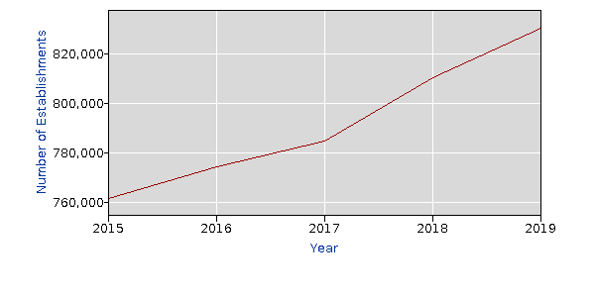

Areas with the largest occupational growth over the same time frame indicates that front-line construction workers/laborers are in higher demand than construction or project managers.



This trend is also a sign of CTM’s program growth or decline in these related areas.

(Prior to COVID-19 Pandemic, student enrollments were on a steady upward trend)

*Enrollment data collected by Sarah Southwick May 2021*

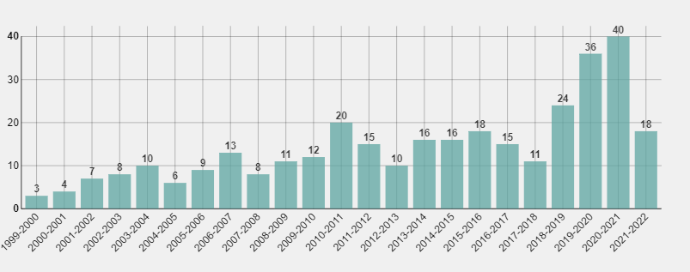

Number of declared students in Construction Technology – Certificate by year



Number of Declared Students in Construction Technology – AAS Degree by Year

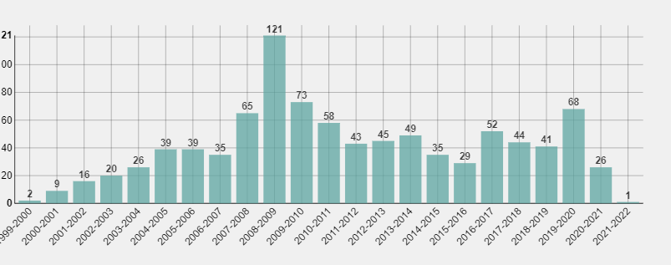

Number of Declared Students in Construction Technology Management – AA Degree by Year

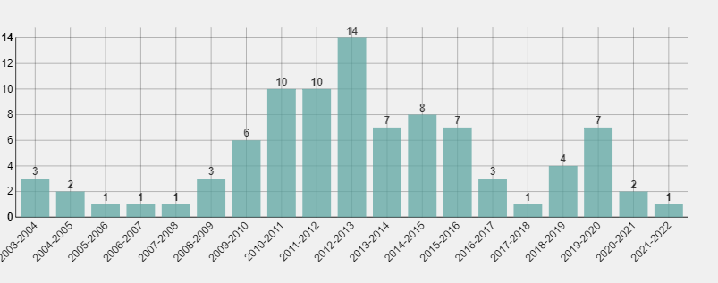

Number of Declared Students in Alternative Energy Technology – Intermediate Certificate by Year

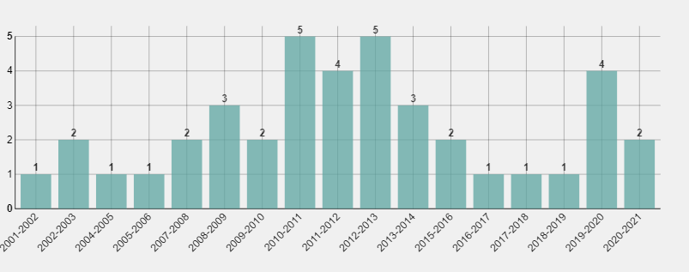

Number of Declared Students in Alternative Energy Technology – Advanced Certificate by Year

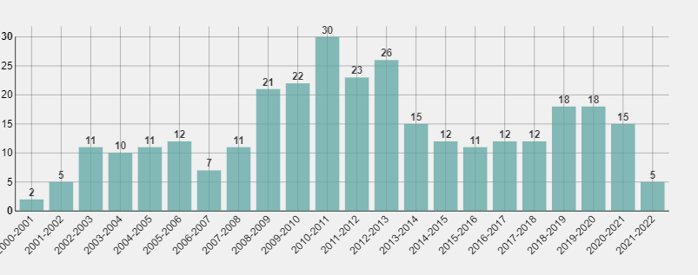

Number of Declared Students in Alternative Energy Technology – AAS Degree by Year

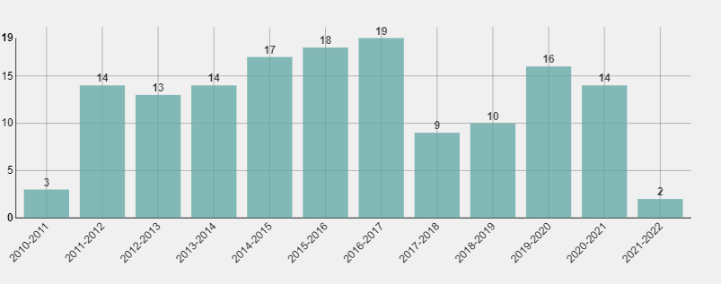

Number of Declared Students in Sustainable Green Building – AAS Degree by Year



2015-2020 CTM Course enrollment including CAVAIT and Dual Enrollment.



2015-2020 Auto Course enrollment includes Dual Enrollment



2015 – 2020 Welding Course Enrollment including Dual Enrollment

**Student Success**

Certificates and Degrees awarded 2015 -2021

|  |  |
| --- | --- |
| CERT/DEGREE | Award Count |
| AdvCrt - Alternative Energy | 2 |
| IntCrt - Alternative Energy | 12 |
| AAS - Alternative Energy | 11 |
| AAS – Sustainable Green Building | 10 |
| CertComp – Construction Technology (2018-2021) | 6 |
| AAS – Construction Technology | 8 |
| AA – Construction Technology | 7 |

Industry Certifications 2015 -2021 (credit and non-credit)

|  |  |
| --- | --- |
| Industry Cert. | Award Count |
| OSHA 10 (2017-2021) | 183 |
| Certified Apartment Maintenance Technician (2015-2021) | 68 |
| Environmental Protection Agency 608 (2015-2021) | 109 |
| International Code Council – Building Specialist (2018-2021) | 22 |

**Assessment**

The first assessment of the program’s *core* outcomes was completed in 2019. Program outcomes were modified to align more with the Construction Management (CM) program at Northern Arizona University. Program outcomes in Alternative Energy and Sustainable Green Building were also modified to meet current industry standards in the same year.

KAS (Knowledge, Application, Synthesis) mapping of program and course outcomes were implemented to determine if the courses are in fact meeting the program requirements. All courses are in the evaluation stage of the process with the goal of implementing the required changes in 2021/2022. Assessment of the program’s core will begin again in 2021/2022 to identify any changes that need to made to keep the programs current and relevant.

**Curriculum and Articulation**

In 2019 new program curriculum was developed for the HVACr program, Alternative Energy program and the Construction and Industry AAS degree. NAU’s CM Department program review was just completed in 2020, some CTM course updates and modifications are needed to meet articulation requirements for transfer credits. Other courses in CTM need to be reviewed and updated to meet current industry standards.

**Teaching Loads**

Over the past 3 years there has been 2 full time faculty members in CTM. Due to the disruption of the shop remodel and the COVID-19 pandemic, there has not been enough teaching load hours to continue to support both positions. Part-time faculty will be the direction of the program until enrollment justifies the need to open another full-time position. The Automotive program is currently looking to hire for a full-time instruction position, this is needed to expand the programs capability to offer more courses and grow to its full potential. Welding will continue to be delivered by part-time instructors.

**Credentialing**

CTM, Automotive and Welding programs have updated the credentialing process in 2021 to emphasize work force experience as a guiding factor for the hiring process. These CTE programs are industry based and require experts in specific content matter relevant to the discipline in which faculty would be teaching.

1. CTM

Master’s degree in the field of Construction Technology

OR,

Bachelor’s Degree in the field of Construction Technology and 2 years related industry experience

OR,

5 Years directly related industry experience with relevant industry certificates.

2. Automotive

Associate’s degree (or higher) in the field of Automotive Technology

OR,

2 years directly related industry experience and all current and relevant industry certifications

3. Welding

Bachelor’s degree (or higher) in the field of Welding Engineering Technology

OR,

4 years directly related industry experience and relevant industry certifications

**IV. Facilities and Resources**

With funding from the Perkins Grant and a 1 million dollar grant from the Del E. Webb foundation, Coconino Community College has designed and built a state-of-the-art construction laboratory. Conex boxes have been added for outside storage to allow for a larger shop area to perform hands-on skills training. Top of the line simulation equipment has been purchased to improve the quality of instruction and enhance the real world, interactive activities of the students.

The new training equipment includes:

1. Welding VRTEX simulators by Lincoln Electric with interactive software. These simulators help students adjust welding technique with real-time feedback to increase welding performance while decreasing materials cost and environmental impact.

2. The HVACr Mini-split, heat pump and refrigeration trainers give students real -world experience on equipment used in residential and commercial construction. Instructors can input faults into the system so students have to use problem solving skills to identify solutions. This equipment includes industry recognized curriculum and industry certifications.

3. The Solar PV trainer is an interactive, full solar array with all the components required for off-grid and grid-tied PV systems. The major benefit to the trainer is that it requires no “sun light” to simulate these types of systems. This equipment comes with curriculum that allows students to get the required knowledge on hands-on skills needed to pass the NABCEP solar installers industry exam.

4. A construction-based computer lab will be completed in summer 2021. This will help establish an architectural drafting and building design program, fulfill program requirements for NAU transfer credits, and provide a testing location for industry certifications.

CTM, automotive and welding programs will continue to use grant opportunities and other resources to enhance the student experience.

**V. Analysis and Reflection**

1. Strengths of the program include…

a. Dedicated faculty and staff.

b. Strong community partnerships.

c. Clear pathways for student success.

d. Excellent training facilities and equipment.

2. Weakness of the program include….

a. Course work is limited to “beginners” in the building trades. To be a true trades program, there needs to be more than just one class on the topic. (e.g. House wiring, concrete/masonry, plumbing).

b. Lack of dedicated and experienced teaching staff. With several fields in the construction industry, not all disciplines are adequately covered adequately. This limits program growth and the amount of course’s and sections that can be offered.

c. Students say having multiple advisors is confusing and provides them conflicting information for certificate/degree declaration and completion.

3. Opportunities for the program include…

a. Seek industry accreditation in CTM and Automotive programs.

b. Offer welding qualification.

c. Expand internship program.

d. Develop apprenticeship training programs.

e. Develop training programs in other areas of the construction industry such as architectural CAD designer and building inspector.

f. Develop non- credit home improvement summer workshops for the community.

**VI. Recommendations**

1. This review process has highlighted several areas of concern within the Alternative Energy, Sustainable Green Building, and Construction Technology program’s completion rates. This will require some significate changes to the programs direction and course offerings to encourage program completion and increase student enrollment.

2. Prior to the pandemic, faculty had established a partnership with the American Masonry Council to provide masonry training for Coconino County. Programs like this require more than just one class on the topic and CTM construction courses and training are limited due to this fact. Course work needs to be developed to give students a real opportunity in improve the skills needed to be a trades worker. The HVACr certificate was the first attempt to train for a specific trade and with the right community partnerships, this program could become a local apprenticeship training program.

3. Part-time faculty will be essential for program growth. Industry specialist in specific areas such as electrical, plumbing, solar, and HVACr will improve the quality of instruction, expand program growth and increase completion rates.

4. Relaying on FUSD and other facilities to teach automotive and welding course limit what can be done to expand these programs. Finding a facility that is controlled by CCC would help with program growth.