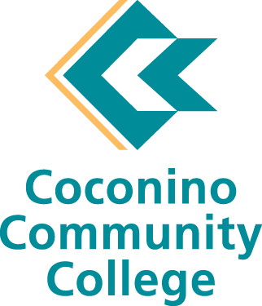

Academic Program Review

# Computer Information Systems

## 2020-2021

### I. Executive Summary

#### Summary

* Curriculum:
  + The department has been making good strides to revamp the current curriculum including strengthening the degree core and allowing for broader elective choices.
  + The department has expanded its offerings, kicking off the AWS certificate and the Google IT Support Professional Certificate in 2021. Faculty have worked hard to design this curriculum and to get the required training/certifications to be able to teach the new topics.
* Staffing:
  + The department needs to address the ongoing problem of hiring new faculty and building a solid part-time faculty base. With the current salary schedules we have experienced two unsuccessful searches for the open FT CIS faculty line. In both cases, an offer was made and declined due to inadequate compensation. The college salaries are not competitive with available industry jobs like they are in nursing. The jobs we are training individuals for upon graduation from our program outrank our faculty salaries greatly.
* Future actions:
  + It is important for the department to continue to look at the program holistically to understand what is realistic to continue offering and what is not. If staffing continues to be an issue, then the department will need to carefully consider its offerings and overall priorities for the college.
  + Additional initiatives outside of that currently being offered must be carefully considered each year to ensure program sustainability. This includes transferability of courses and or degrees, additional certificate programs, degree offerings, and alignment to the workforce.

### II. Overview

#### Narrative

* The main purpose of the Computer Information Systems (CIS) program at Coconino Community College is to prepare students for entry-level jobs in the field of IT and other technology-related positions. We are providing the community with a local training opportunity for students to acquire skills ranging from basic computer maintenance, programming, networking, security, and more.

A secondary purpose for the department is to provide a general education offering to students. The CIS120 course is widely taken by CCC students because it provides a transfer computer course that is accepted across the state.

* The CIS program is in constant flux as it responds to community needs and changing industry standards. This is a difficult task in this field as technology is changing at a more rapid pace than educational offerings. The department must plan far ahead and predict changes well in advance of the market to be able to include those topics in the current curriculum. The department keeps a pulse on developments by participating in biannual Industry Advisory Meetings, monitoring publications tracking technological trends and advances, as well as participating in statewide program planning groups. This past year, by recommendation of the College President, the department joined state initiatives in offering the AWS certificate and the Google IT Support certificate. As well, CIS faculty worked with the curriculum committee, CTE Dean, and Provost to establish a Fast-Track curriculum review for CTE programs that have a direct industry partner that ends in an industry certificate.
* The CIS program has existed at the college for over 20 years. The program continually evolves and grows based on industry standards, technological advancements, and best practices in the field.
* The last program review was completed in 2016. Since this time the program has undergone two significant changes in programming, including two complete overhauls to the degree and course offerings.

#### Program goals

* The CIS program provides accessible, affordable training for the workplace and preparation for industry-standard certifications. Students will gain a working knowledge of technology in a variety of areas through individualized courses and/or completion of degrees or certificates, many of which align with industry-recognized certificates increasing employment opportunities.
* The institutional mission statement commits to “providing accessible and affordable educational programs that prepare students for the future”. The CIS program directly contributes to this mission by offering a variety of opportunities to students that prepare them for careers or career advancement in IT. Our program provides opportunities for students with an interest but no experience in IT (e.g. our Google IT Support Certificate) to individuals that currently work in the field and are looking to advance themselves (e.g. through our AWS certificate program). This creates life-long learning opportunities for students to continue to grow within their desired technology field. Finally, to contribute to the college’s mission to provide university transfer education, the CIS department offers students transfer options such as CIS120. CIS120 is ranked among the top in CCC enrollment numbers by course each semester.

#### Decision making

* Communication within the program, among faculty, the Dean of CTE, and other departments is clear and open.

* Within the CIS department, the decision-making process begins with research and discussion about the needs of our students, the community, and current trends in the industry. The department has an active Advisory Council which assists the department in program development, reviewing curriculum, and making recommendations. The Advisory Council includes members of the community, some of which are NAU, CCC, Mountain Heart, Flagstaff Unified School District, Flagstaff Medical Center, Coconino County, City of Flagstaff, local computer companies, Nestle Purina, W.L. Gore, etc. After recommendations and collaboration, final decisions are made by the CIS department faculty members along with the Dean of CTE (and other leadership and staff as needed).
* Outside agencies that play a role in our decision-making process and scope include industry partners that change their technology (versions) which in turn, in some cases, forces the department's hand to shift the technology being taught. This may include but is not limited to the following:
  + Microsoft, Adobe, and other software/operating system version updates
  + CompTIA exam versions and standards
  + Google and AWS program changes

#### A statement of the program’s accomplishments in support of the College’s current strategic plan

* Strategic Goal #1: CCC will help each student achieve success through a supported and individualized educational experience.
  + Students who are part of the CIS program have a strong sense of belonging. They are part of organically formed cohorts as they work through our certificate and degree programs. They know why they are here and what they are trying to accomplish. The CIS program offers a variety of opportunities that allow students to take courses that will directly benefit their current or future career in IT. Students can pick elective courses within our AAS degree which allows them to focus on topics that interest them. Students can take one or more courses that prepare them for industry-standard certifications. Students are supported throughout the program directly by full and part-time CIS faculty as well as student worker staffed lab hours and general college tutoring.
* Strategic Goal #2: CCC will practice sustainability through responsible stewardship of economic, public, and environmental resources to accomplish its educational mission.
  + The CIS program continually supports and contributes to CCC’s revenue stream by increasing program offerings (continually changing offerings to meet community and industry demands) and offering university transfer. CIS120 contributes to one of the highest enrollments per course per semester, and strategically provides a wide variety of opportunities with minimal resources.
* Strategic Goal #3: CCC will promote a learning culture that is innovative, flexible, entrepreneurial, and responsive to the needs of our students and the communities we serve.
  + The CIS program supports life-long learning by offering courses to train students with no IT experience (through the Google certificate) to individuals currently working in the field (with our AWS certificate) and all others with our customizable degree offerings. We offer a variety of workforce development opportunities that are supported by community connections (by way of our advisory councils).
* Strategic Goal #4: CCC will strengthen Community Engagement in support of student success through advocacy, strategic partnerships, and new fundraising initiatives.
  + The CIS program prides itself in the community relationships we with have fostered for many years. We value the input from our community and use it to guide our program. Our community partners play an integral role in our internship program and helping students gain the hands-on experience they need to begin a career in IT.

### III. Teaching and Learning

#### Program requirements and course offerings

* Degrees – The CIS Program has 2 AAS degree offerings.
  + **Computer Technology - Associate of Applied Science (AAS) Degree:** This degree is designed to prepare students for computer technology positions in the IT field. The program allows students to choose a focus area by selecting a variety of elective courses to expand their knowledge in Programming, Security, Linux, Servers, or a specific focus learned experience through an Internship. Many courses in the program align directly with industry-standard certifications.
  + **Cybersecurity - Associate of Applied Science (AAS) Degree:** This program will provide students with the necessary knowledge and skills to enter the IT workforce with an emphasis on Cybersecurity. The program provides students with the foundational knowledge and hands-on skills necessary for work in the industry. Some courses in the program align directly with industry-standard certifications.

The CIS department has revised the degree programs multiple times since the last program review. This is based on community and industry research and evolving trends in the field of IT. During the 2020 curriculum cycle, the CIS department revised the existing degree to remove the specific tracks students could declare. The degree core was strengthened by adding a database course, our Linux admin I course, and a networking essentials course. The general education requirements were lessened and students were given elective options to choose from.

* Certificates - The CIS department has two main certificate programs.
  + The **Google IT Support Professional Certificate**. This certificate is designed to prepare students for entry-level jobs in IT Support. This certificate is a complete program designed in collaboration with Google. The program consists of a series of three (3) CCC courses, which upon successful completion (and meeting designated Google benchmarks), allows students to receive their Google IT Support Professional Certificate. The Google IT Support Professional Certificate introduces learners to troubleshooting, customer service, networking, operating systems, system administration, and security. No prior IT experience is needed to complete this program.
  + The **Amazon Web Services (AWS) Certificate**. This certificate is designed to prepare students in a course of study focusing on Cloud computing. This certificate is based on Amazon Web Services (AWS) concepts and techniques. It prepares them to take key professional certifications from Amazon (AWS) and provides career prospects in Cloud computing.

Our other certificate programs were retired in the 2020 curriculum cycle. This included the Computer Technician Basic/Advanced certificate and the Graphics and Web Design Certificate.

* Course Offerings: The CIS department offers a variety of courses many of which align directly to industry-standard certifications. Our courses are offered in-person, online, and via zoom. We try to rotate our offerings and modalities to accommodate our student population. Courses that are part of our degree core (130, 215, 236, 161, 228) are offered each Fall and Spring semester, electives are taught once per year, Google and AWS certificate classes follow a rotating schedule for that certificate, and CIS120 is always offered in Fall, Spring and Summer sessions. Courses include: 
  + CIS 116 Introduction to HTML (3)
  + CIS 117 Intro to Web Page Design (3)
  + CIS 120 Intro to Computer Information Systems (3)
  + CIS 122 Introduction to MS Word (3) – retired
  + CIS 123 Introduction to Spreadsheets (3) – retired
  + CIS 125 Introduction to Databases (3) – retired
  + CIS 130 Digital Technology Repair and A+ Introduction (4) – modified to (5) and combined with CIS135
  + CIS 132 Google IT Support Professional I (5) – new
  + CIS 134 Google IT Support Professional II (3) – new
  + CIS 136 Google IT Support Professional III (4) – new
  + CIS 135 Basic Server Operating System Fundamentals (4) – retired
  + CIS 161 Linux Administration I (4)
  + CIS 171 Linux Administration II (4)
  + CIS 215 Programming with Python (3) – modified to (4) to align with universities
  + CIS 220 Computer Programming I (4)
  + CIS 228 Networking Essentials (4)
  + CIS 230 Implementing & Supporting Windows (4) – retired
  + CIS 236 Enterprise Database and SQL – new
  + CIS 237 Introduction to Computer Security (4)
  + CIS 240 Installing, Configuring, and Administering Microsoft Windows Server (4)
  + CIS 243 AWS Cloud Foundations and Architecting (4) – new
  + CIS 244 AWS Cloud Foundations and SysOps (4) – new
  + CIS 245 AWS Cloud Foundations and Developing (4) – new
  + CIS 261 Cybersecurity Fundamentals (3)
  + CIS 262 Ethical Hacking for Cybersecurity (4)
  + CIS 289 Internship I (1-6)
* Enrollment and student success information for the previous five years
  + Overall enrollment in our courses (and the number of students declaring our degrees and certificates) has had its ups and downs and remains lower than what we have seen in the past. We believe this is attributed to a variety of factors. With changing technology comes changes in our offerings and overall program changes (e.g. two complete degree and certificate overhauls since the last program review). Significant changes take time for students to become aware of and ultimately declare as their program of study. In addition, these types of changes take time to work through our current curriculum process. With the delay in our ability to change curriculum at a rapid pace, our enrollments tend to take significant time to regain momentum, and as we found since the last program review when the momentum starts to pick up it is time for a new change. We recognize that although this change is needed to keep topics relevant for our students it may be having a negative overall impact on our enrollment. To remedy this, we have revised our degree and course offerings to allow more flexibility in what we can offer within the current curricular outlines and what students can take to meet their educational and career goals.
  + Overall, we are finding our students are successful in our course offerings. We find this especially true in the degree and certificate-related courses (courses students are taking because it directly leads to their success in the workforce). We have found that our CAVAIT students are very successful over the past few years.
  + Our in-person and hybrid courses tend to have higher overall success rates than our online offerings. Many factors contribute to this finding including a higher percentage of our general education course (CIS120) being offered online rather than in-person and success in general education courses compared to degree-focused courses tends to be lower.

#### Licensure/certifications of students

* **CompTIA certifications** 
  + Course alignment:
    - CIS130: CompTIA A+
    - CIS228: CompTIA Network+
    - CIS237: CompTIA Security+
    - CIS161 & CIS 171: CompTIA Linux+
  + Students complete the required coursework and then sit for the exam following the course.
* **Google IT Support Professional Certificate (a digital certificate direct from Google)**
  + Successful completion of CIS132, CIS134, CIS136. Students must pass all graded quizzes and hands-on labs with an 80% or above.
  + Students are also prepared to sit for CompTIA A+ certification exam after compiling the program.
* **AWS (Amazon Web Services) Certifications**
  + CIS 243: AWS Cloud Foundations and Architecting -- AWS Certified Cloud Practitioner and Certified Solutions Architect exams
  + CIS 244: AWS Cloud Foundations and SysOps -- AWS Certified Cloud Practitioner exam
  + CIS 245: AWS Cloud Foundations and Developing -- AWS Certified Cloud Practitioner exam

#### Curriculum

1. Course outline reviews and updates
   * + - Course outlines are continuously reviewed to keep up with ever-changing technology and industry demand. This is quite a difficult task within the CIS department to stay far enough ahead of technology and still meet college curriculum deadlines.
       - Our department is striving to rework outlines to allow them to be flexible enough to change with technology and not require constant revision through the curriculum process (yet still outlining the course in the depth required).
       - The CIS department is excited about the new fast-track process within the Curriculum committee. This will allow us to bring new courses onboard at a much quicker pace than previously done.
2. Discuss the delivery methods of courses
   * Courses are taught in-person, online, hybrid (half online, half in-person), and via zoom. The department strategically balances student needs with the best delivery method for each course. This typically means rotating course modalities from semester to semester (in appropriate courses).
3. Other curriculum changes
   * + - The CIS department has undergone a variety of curriculum changes since 2016. Most recently in the 2020/2021 curriculum cycle the department completed the following changes:
         1. Revised degree completely - With the IT field changing at a rapid pace, we are recommending a modification to the degree to reflect current needs from the industry. We are simplifying the degree by deleting the tracks and adding electives to allow students to determine their focus area. We have also strengthened the core by requiring courses routinely required by the industry.
         2. Added Google IT Support Certificate

Adding CIS132, CIS134, CIS136

* + - * 1. Added AWS (Amazon Web Services) Certificate

Adding CIS243, CIS244, CIS245

* + - * 1. Revised several courses including:

CIS130 – combining with CIS135 – changing credits to 5

CIS228 – Alignment with Network+

CIS215 – alignment with universities and revised credit hours

* + - * 1. Course Deletions: CIS135, CIS122, CIS123, CIS125, CIS230

#### Articulation

* The CIS department is part of the statewide CIS Articulation Task Force (ATF). The ATF meets twice a year to discuss articulation, current trends, and technical advances affecting curriculum and course offerings.
* CIS215 has been revised to align with the University's and current “programming course” requirements following the last ATF meeting.
* Course Equivalency is outlined in the Appendix – AZTransfer_CEG_CIS

#### Is the program accredited by a programmatic accrediting agency? If so, name the agency and include the status of the most recent accreditation.

* None. Although we have alignment with industry partners as mentioned in the licensure/certifications section.

#### Teaching loads

* The department currently has 3 full-time faculty teaching full course loads (and typically an overload) each semester.
  + One full-time faculty also teaches a full CIS load during the summer term.
  + One full-time faculty also teaches in another department at the college (the course load is split). This means this faculty member does not always teach five CIS courses and requiring CIS to reach out side the department for PT coverage.
* We have one vacant full-time faculty position which we were unable to fill this past year. We will have a retired faculty take on this role as a temporary position until we can fill it permanently.
* We have one part-time faculty who teaches for us each Fall and Spring. Load typically ranges from 1 to 2 classes.
  + We will be looking for additional part-time faculty to cover the needs within the department and the increased load based on recent curriculum changes, inability to fill he current open position, and the course constraints of sharing the second CIS faculty between CTE and A&S.

#### Faculty credentials

* + Credentialing is divided into 2 categories
    1. All courses except CIS120
       - Bachelor’s degree (or higher) in the field of Computer Information Systems

Any of the following areas is within the teaching field of Computer Information Systems: Information Systems, Information Technology (IT or IFT), Management Information Systems (MIS), Information Systems Management (ISM), Computer Science and Engineer (CSE), Computer Science (CS), Geographic Information Systems/Science Technology, Informatics

AND 3 years directly related industry experience

AND relevant certifications, if applicable (e.g. CompTIA (e.g. A+, Network+, Security+), CCNA, MCSE)

* + 1. CIS120
       - Master’s degree (or higher) in the field of Computer Information Systems

Any of the following areas is within the teaching field of Computer Information Systems: Information Systems, Information Technology (IT or IFT), Management Information Systems (MIS), Information Systems Management (ISM), Computer Science and Engineer (CSE), Computer Science (CS), Informatics

OR Master’s degree in any field and 18 graduate credits in the teaching field.

Graduate level coursework (500 level or equivalent and above) with the following titles, prefixes, or keywords is within the teaching field of Computer Information Systems

#### Student Learning Assessment

* Assessment methods vary from course to course. Most courses use a combination of a final exam and/or cumulative final project (Capstone Project) to assess student learning.
  + Some courses, such as the Google certificate courses, require students meet benchmarks set directly by Google. These courses use hands-on labs, graded multiple-choice assessments, and writing assessments.
* Student success is also measured by completion of industry-standard certifications (e.g. CompTIA certifications, AWS certifications), and/or end-of-course pre-certification exams (as used with the TestOut software), and successful completion of program certificates (i.e. Google certificate program).
* In the Fall 2019, Fall 2020, and Spring 2020 semesters the CIS department participated in class level assessment to measure a specific course outcome.
  + Results were used to further refine the material presented in CIS120.

### IV. Facilities and Resources

#### Specify any designated space that is primarily for the program’s use since the last program review.

* Since the past program review, the designated space for this program has not changed.

#### Specify the designated equipment used primarily for the program’s use.

* The CIS department has a variety of equipment used primarily for the program. For the most part, this equipment contributes positively to the program’s overall student success. Note: All equipment requires routine upgrades (and maintenance) to remain current and productive in our program.

Currently, the CIS department utilizes a couple of virtual servers that we use to teach both server technologies and Linux on a virtualized platform. One of these is older and one is brand new.

To support our Cybersecurity program (courses) we would like to implement a cyber range for our students to use and train with. We have some hardware that is waiting to be donated from NAIPTA (servers) that can also be used to teach server platforms in an on-premise course. Depending on the capabilities of these we may be able to implement a cyber range with them. To completely facilitate a cyber range, we will also need to acquire some switches and network hardware as well as numerous other systems (this will be added to our action plan). $14,500.00 in funding was set aside in Perkins to support the cybersecurity program needs.

#### Specify any designated equipment purchased primarily for the program’s use since the last program review.

* Our student success is essential. Not only the success in CCC classes but also with industry exams and successful entry into the workforce. To support student success, we regularly update our equipment to meet technological demands. Below is a list of equipment purchased since our last program review to support student learning and success.
* A dedicated CIS Virtual Server to allow many students access to a virtual machine (Linux, Windows, Windows Server, etc.) both in and outside the classroom.
* A dedicated Cybersecurity Server
* 20 Raspberry Pi 3 computers for Linux and programming projects
* 20 Arduino kits for Linux and programming projects
* Dedicated iLab space for CIS coding, hardware, security, and networking classes as well as tutoring and exploration
* Purchase of 20 powerful desktop workstations with additional graphics capabilities to support, VR, CAD, gaming, etc.
* Large TV 4K Monitors and Wall Mounts
* Purchase of various (six) 3D printers and 2 3D printer kits and related filament and other supplies
* Purchase of a desktop CAD multi axis machining unit
* Purchase of a computer driven laser cutter/engraver
* Purchase of 20 programmable drones for coding
* Purchase of a professional level drone​

#### Specify any designated budget and differential tuition that is primarily for the program’s use.

* CIS 130 and CIS161 are at the Level 4 tuition rates. The other CIS courses are at the standard tuition rate.

### V. Analysis and Reflection

#### Strengths, Weakness, and Challenges Analysis

* + - What do you see as internal strengths of the program?
    - The CIS department offers a wide variety of course offerings that directly benefit the community. This is done with minimal resources. The department faculty have diverse backgrounds and bring a balance of industry experience and exceptional teaching methods. The department works well together and has a “get it done” attitude. The department supports college initiatives by quickly dedicating the necessary time and effort to bring up new programs with little notice.
    - What do you see as internal weaknesses of the program?
    - Similar to what was stated in our last program review, the greatest internal weakness we have is not having enough faculty to cover our current offerings and growing program. Currently, faculty are teaching overloads and working year-round with minimal breaks. Faculty must maintain their current credentials and to pick up new credentials to stay current. We recognize burnout as a threat and weakness to the program. A one-course release was provided in 2021 for development of the Google and AWS programs.
    - What do you see as opportunities for the program?
    - Technology is constantly evolving and changing. Jobs in IT and technology-related jobs are in high demand. This presents an opportunity for our department to support the community and provide the critical training needed in this field.
    - We currently do not provide many courses intended for transfer. We would like to continue to work with NAU (and other state Universities) to determine additional alignment for students wanting to pursue 4-year degrees.
    - What do you see as challenges of the program?
    - An ongoing challenge is having the faculty teach our current program and to support the department to grow new programs. The department would benefit from additional funding to allow our department to hire faculty with varied knowledge and diversity to support the program.
    - Technology is changing faster than our curriculum can keep up with. A challenge is keeping our course offerings relevant without having to completely overhaul the program every few years as we have done in the past.
    - CCC constantly has to compete with salaries available to faculty if they return to industry. Industry jobs requiring similar skill sets and certifications as we require our faculty to have would allot them much higher salaries. This financial draw is a huge challenge in our department. This hinders recruitment and sustainability within the department, as documented by the two failed CIS searches in the 2020-2021 academic year.

#### Previous Recommendations and Results

* + - List recommendations that were received at the last program review.
    - In the 2016 program review, staffing the CIS department with qualified faculty was discussed. The struggle to hire qualified faculty was identified in 2016 and remains a struggle to date. In 2016 it was stated, “We have proposed to the Compensation Committee, a salary schedule model similar to that of Nursing or the technology area at the college.” Since this recommendation has NOT been addressed since 2016 we would like to highlight it again and request further discussion by college leadership. Without a revision to the current salary schedule for CIS, we find it difficult for the department to continue to support a growing program.

### VI. Recommendations

#### Five Year Plan

* + - Where will this program be in five years?
    - In five years, we hope to see the department flourishing. There is a clear need from an industry perspective (jobs in IT fields are in demand and on the rise). We hope to match that need and provide additional educational opportunities to support the community.
    - We hope to offer a degree with a core foundational curriculum that prepares students for work in CIS including:
      1. Fundamental CIS concepts including hardware and basic software/desktop support
      2. Database capabilities
      3. Programming (Python and other...)
      4. Networking skills on a modern IS infrastructure
    - Our core should be preparing students not only for workforce placement but also for the advanced pathways of cloud technologies and Cybersecurity fundamentals.
    - Aside from these workforce pathways, we hope to provide the core curriculum as a stepping stone into advanced degree programs at the 4-year level and beyond. This is a new endeavor for the department that we believe would be beneficial to expand into.

#### Action Plan/Recommendations (To be completed in the next five years). List action items in order of priority of completion.

* + 1. Further development of the Google IT Support certificate. This includes finding better ways to target students (e.g. high-school and/or recent high school graduates and adults looking for second career opportunities).
    2. Establish cohorts of enrolling students into the new curricular program. This may include additional outreach to High Schools and expanding the curriculum offered (e.g. Google IT Support Certificate).
    3. Continue to review our course curriculum to include concepts allowing the transfer of more of our courses to the University level, namely at the programming and conceptual levels. Also, a focus on strengthening our core by revising offerings and increasing options such as a project management course.
    4. Complete the needed faculty certifications to deliver on certain pathways (AWS and Google)
    5. Complete or acquire certifications/new hires to support a solid path forward in the Cybersecurity field.
    6. Establish a Cybersecurity range.  Either in-house or in association with another College.

## Appendix

* + *AZTransfer_CEG_CIS*

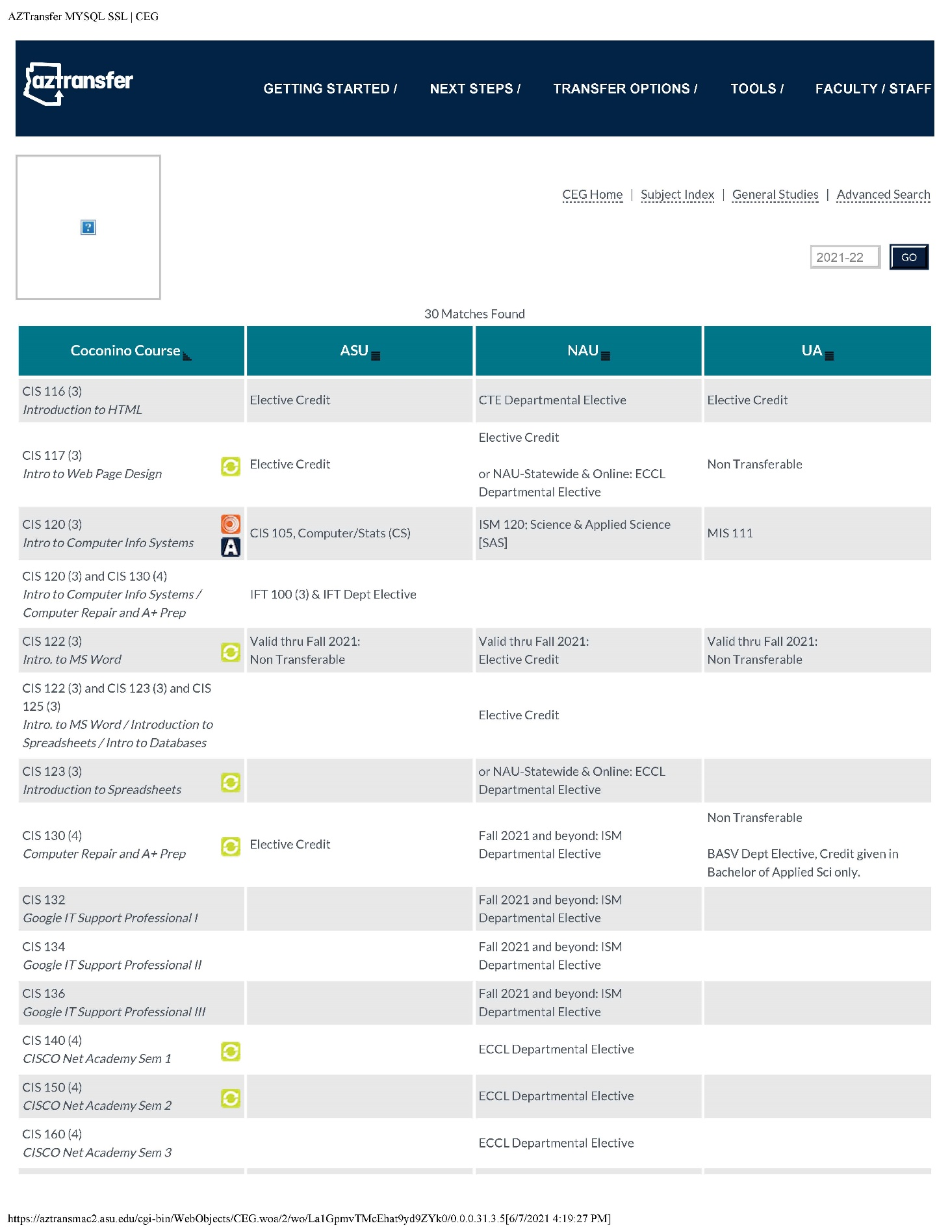

*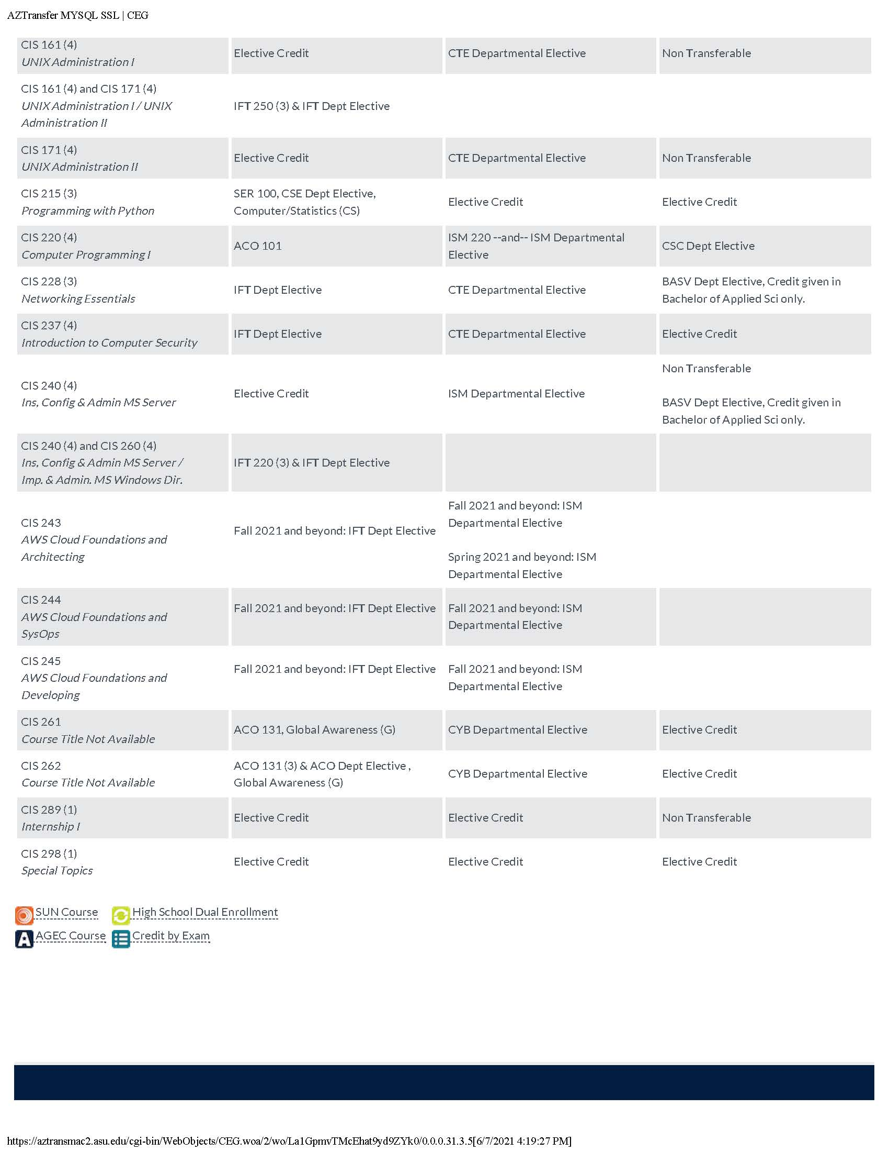page 2*