Academic Bi-Annual Review Form – English (ENG)
Years Two and Four of the Program Review Cycle

The Coconino Community College bi-annual review will consist of two areas: an update to the Program Review Action Plans/Recommendations and a review of program student learning outcomes, results, actions taken, and future actions since either the last program review or bi-annual review.

Prior to completing the Bi-Annual Review form, the Assessment Coordinator will provide the program with a variety of data: the most recently completed Program Review Actions Plans/Recommendations, Program Assessment Reports with associated assignments and rubrics, and a summary of related Course Assessment Reports. If Year Four, the previous Bi-Annual Review information will be provided as well.

Provide a status update to any of the recommendations. Then analyze the attached student learning assessment data and provide any future actions to be taken based on that data. If Year Four, provide an update on previously stated future actions from the previous bi-annual report. Attach any department/program minutes or other appropriate documentation that recorded discussion of updates to recommendations or of student learning assessment.

I. ACTION PLAN/RECOMMENDATION UPDATE
Action Item #: 1 – Hire FT Faculty to create more equitable ratio of FT to PT instructors
Anticipated date for completion: May 9, 2019
List potential benefits to student success: More consistency, time, instructor engagement, and expertise afforded to students.
Status Update (Only Update during Bi-annual Review Reporting) The department currently consists of 4 full-time faculty (1 developmental and 3 transfer-level); however, our developmental instructor is retiring at the end of Spring 2019. A full-time English position was posted in February and will close on March 11.
Last reviewed date: March 8, 2019­­­

Action Item #: 2 – Hire FT Development Reading Faculty
Anticipated date for completion: The hiring of a developmental reading faculty member was never completed. The last full-time instructor left at the end of Spring 2017 and her position was never filled.
List potential benefits to student success: A full-time instructor for reading would be more available to students outside of class and would serve to anchor and ensure that developmental reading instruction is consistent and addresses students’ needs. A full-time faculty member is better able to connect with other faculty to assess reading needs in other content areas. They can better work with the English department to ensure student readiness for required course work in 101 and other transfer courses. This position would offer better continuity within reading instruction.
Status Update (Only Update during Bi-annual Review Reporting) The developmental writing instructor (Ann Wells) is retiring at the end of spring semester 2019. Currently, that job is being advertised as a full-time English position with the possibility of it serving as a developmental position. This could also evolve into a writing and reading developmental position; however, the position could be filled by an English instructor with a varied skill set.
Last reviewed date: March 8, 2019

Action Item #: 3 – Research and discuss reduction of required course loads and/or cap sizes for transfer-level full-time faculty
Anticipated date for completion: December 19, 2019
List potential benefits to student success: Instructors would be able to provide more individualized instruction, research and develop innovative projects, engage in professional development opportunities, and teaching and learning discussions.
Status Update (Only Update during Bi-annual Review Reporting) Will discuss in upcoming Faculty Load/Release Time subcommittee.
Last reviewed date: March 8, 2019

Action Item #: 4 – Research and discuss viability of developmental course offerings at 4th Street
Anticipated date for completion: May 2020.
List potential benefits to student success: More convenient to students who live in that vicinity or are already taking courses at that location.
Status Update (Only Update during Bi-annual Review Reporting) The reason for not offering developmental courses at 4th Street include:
1. Lower enrollment and higher dropout rate than the same courses being offered at Lone Tree. 2. Lack of student services at 4th Street that better serve students in developmental courses (HELP desk hours, Trio, tutoring, Student Disabilities office, etc.)
3. It was felt there was a better opportunity for tie-in to campus life at Lone Tree, which may have changed since the revitalization of the 4th St. campus.
Last reviewed date: Was not reviewed by the English Dept.

Action Item #: 5 – Research the development of an ENG 101+ course
Anticipated date for completion: May 2019
List potential benefits to student success: More options for student success. Students close to placing into ENG 101 and students who placed into ENG 101, but may feel they need extra help can take this course option and would not need to take a separate developmental course to prepare them for ENG 101.
Status Update (Only Update during Bi-annual Review Reporting) This was adopted by the curriculum committee in February 2019. This is now named ENG 101A and will be offered starting Fall 2019.
Last reviewed date: Reviewed and accepted by General Education committee and Curriculum committee February 2019.

Action Item #: 6 – Review current literature course offerings and research the option of formally adopting writing intensive criteria into one or more courses.
Anticipated date for completion: March 4, 2019
List potential benefits to student success: More Writing Intensive/Arts and Humanities options, expansion of the creative writing program, and providing additional writing practice for students.
Status Update (Only Update during Bi-annual Review Reporting) ENG 139, 270, and 237 have been approved by Curriculum. ENG 139 and 270 (online and in-person) will be offered in Fall 2019, and ENG 237 online will be offered in Spring 2020.
Last reviewed date: March 8, 2019

Action Item #: 7 – Develop a departmental mentoring/training program for new and PT instructors
Anticipated date for completion: May 2020
List potential benefits to student success: Consistency across course sections, conversation and clarification concerning content sequencing, collaboration between faculty, and improved instruction, fostering a stronger TEAM. The Lead Faculty position will assist in creating a strong mentoring/training program for new and PT instructors.
Status Update (Only Update during Bi-annual Review Reporting) We are currently discussing viable methods of supporting new faculty with course manuals and supplemental materials/resources.
Last reviewed date: March 9, 2019

Action Item #: 8 – Review course offerings to determine viability
Anticipated date for completion: December 2018
List potential benefits to student success: Streamline offerings to meet pathways and student needs.
Status Update (Only Update during Bi-annual Review Reporting) Course deletions and revisions have been approved by Curriculum.
Last reviewed date: March 9, 2019

Action Item #: 9 – Provide a clear and consistent communication loop with PT faculty
Anticipated date for completion: March 11, 2019
List potential benefits to student success: Consistency across course sections, conversation and clarification concerning content sequencing, collaboration between faculty, and improved instruction, fostering a stronger TEAM.
Status Update (Only Update during Bi-annual Review Reporting) The Lead Faculty position will assist in bridging the communication gap and strengthen connections between part-time, dual-enrollment, and full-time faculty.
Last reviewed date: March 8, 2019

II. ASSESSMENT OF STUDENT LEARNING
General Education English Assessment

The General Education programs worked to establish clear and defined performance measures for critical thinking. The overall definition of critical thinking for General Education as a whole is the students will, “use a variety of inquiry methods, resources, and reasoning skills that support and promote lifelong learning.”

This year, the General Education blocks (Arts & Humanities, English, Math, Social & Behavioral Sciences, and Physical & Biological Sciences), met to discuss the following items:
1. How students move through the Gen Ed block,
2. Create shared critical thinking performance measures,
3. Identify key courses within the Gen Ed block that contribute to critical thinking,
4. And, create a shared assessment tool to measure critical thinking in the key courses.

The goal was to begin to use the new performance measures of critical thinking and gather program level learning outcomes data in the spring semester.
The following is the performance measures established by English, selected courses, and reporting assessment tool from which baseline data was collected.

English (ENG)

In English, critical thinking is demonstrated by the following two performance measures:
The student will:
Evaluate resources for credibility
Integrate evidence to support their own ideas.

The ENG program created one rubric to be used for shared assessing. This rubric was used in all of the ENG 102 courses.

PROGRAM OUTCOME/MEASURE | COURSE(S) ASSESSMENT GATHERED | METHOD OF ASSESSMENT
Using a variety of inquiry methods, resources, and reasoning skills that  support and promote lifelong learning. | ENG 101 and ENG 102 | Rubric
SEMESTER INFORMATION GATHERED | RESULTS OF ASSESSMENT | ASSOCIATED BENCHMARKS
FALL 2017 GENERAL EDUCATION CRITICAL THINKING | 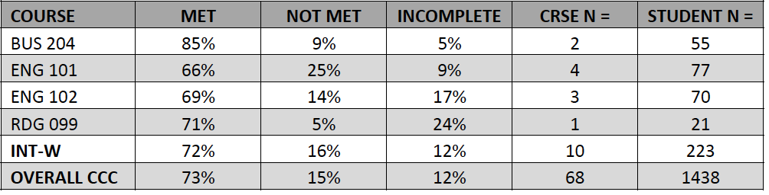 | 75% met

ANALYSIS: The following comments were collected for both ENG 101 and 102:

- ENG 101 I’m not sure what you are looking for here when you say actions taken to adjust student learning for the class. I would say this means what was changed during instruction to help students struggling with this outcome achieve it. For this course then, one thing that was adjusted for was additional one on one instruction. For example, as is usual for a rhetorical analysis assignment, several students have trouble understanding the difference between writing about the issue brought up by a text, and the way the writer of a text uses rhetorical tools to persuade an audience. While working on thesis development for our Rhetorical analysis, I modified the schedule and assignments for a portion of the class period and taught one on one rotating small groups to promote learning of this difficult concept, while students continued with the previously assigned group work assignment for the day.

- I am pleased with the results of this class, especially since they were my best‐performing composition class. In future iterations of this assignment, I might spend more class time covering how to write more cohesive evaluations of a text after it was analyzed. That seemed to be the skill that many students struggled with, particularly the ones who did not meet the criteria for the assessed course outcome.
- In future semesters, I would like to have students bring several sources to class to analyze how the sources are related, how they are interpreting the data and what conclusions they are coming to. This could be done in peer groups so individuals could gain the perspectives of their peers on the sources. For my next section of this course, I will spend more time discussing and explaining the differences between scholarly and popular sources, and why these differences are important. I also plan to construct additional opportunities for students to discuss these issues in more depth with their peers and to analyze specific sources collaboratively, prior to applying these skills independently. While I have been pleased overall with the student outcomes for this assignment, critical evaluation and utilization of source material is a key component of research skills. Therefore, it is a major focus of my constant revision and improvement of this course.

- ENG 102 This semester, I believed I scaffolded the learning opportunities in a way that supports students in meeting this outcome, however, it's clear that I need to be more intentional in my approach when I teach this course next semester. Though I provided feedback to these students in their formative assessments, which indicated how they could improve their outcomes, I'm thinking that I will use a different formative/low stakes assignment to help students hone these skills. I'm going to incorporate even more structure into the reading responses that students compose each week. Specifically, I'm looking to incorporate a regular assignment called a rhetorical precis, which requires students to compose a highly structured paragraph. The following example, which I will use as a model for creating the weekly assignment, is drawn directly from Oregon State.
- I believe that I'll be able to provide even more meaningful focused feedback to students through the rhetorical precis assignment. Furthermore, I think the rhetorical precis is a really great teaching tool to get students to analyze mentor texts while producing their own strong paragraphs that are well‐developed and well‐supported with evidence. In addition to using the rhetorical precis, I plan to be more intentional about how I teach students when to quote, paraphrase, or summarize. Most often, it seems that students default to using direct quotes when summarizing or paraphrasing would better serve their argument. Through the rhetorical precis, I can provide feedback which will help students be more agile in how they integrate evidence into their own writing. This assignment was used as part of a larger assignment. The idea was to permit students opportunities to create concepts for games to solicit social awareness with the persuasive appeals in mind. The second part of the assignment was to analyze the appeals for effectiveness in a rhetorical analysis.

Based on student feedback and nearly 100% critical thinking outcome success in the class, I will use this assignment again. I use words such as logic, analysis, assertions, proof, insight, and critical questioning. Every semester most students find that this is something they understand right away or after some discussion. However, every semester there are a few who write something that is only an informational recitation or a winding summary. Each semester I have tried to reach out to everyone, especially those who missed the point. My thoughts now center around finding a brilliant but accessible example of critical thinking and analysis in writing and having the class read it and explain why it is useful in understanding our task.

Course-level and individual instruction is addressed, but it is difficult to ascertain an overall program assessment without using an instructor-]shared assignment.
ALREADY TAKEN/FUTURE ACTIONS: No action taken at this time. Future actions include a clear, shared understanding of the assessment project, purpose, and benchmarks, using a common assignment and assessment norming session with all full- and part-time faculty.
UPDATE ON PREVIOUS ACTIONS: N/A

PROGRAM OUTCOME/MEASURE | COURSE(S) ASSESSMENT GATHERED | METHOD OF ASSESSMENT
Using a variety of inquiry methods, resources, and reasoning skills that  support and promote lifelong learning. | ENG 101, ENG 102, ENG 272 | Rubric
SEMESTER INFORMATION GATHERED | RESULTS OF ASSESSMENT | ASSOCIATED BENCHMARKS
SPRING 2018 GENERAL EDUCATION CRITICAL THINKING | 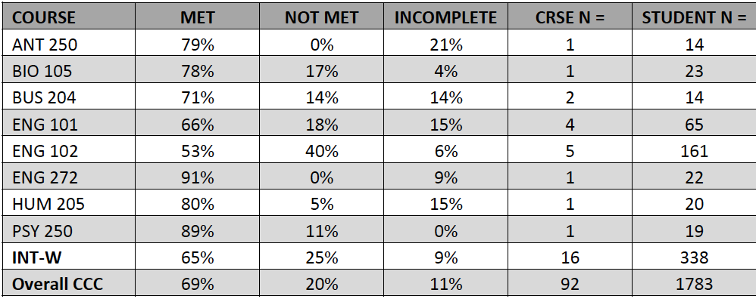 | We hope that increasing the benchmarks in ENG 101 and 102 to 75% will support the overall passing rate in WI courses.

ANALYSIS: The following comments were collected for both ENG 101 and 102:

ENG 101 Enhancing student learning for this course would involve additional lessons on the evaluation of academic source material, application of the source material in
supporting an argument, and correctly documenting these sources in an essay.

ENG 101 My threshold for determining whether or not students met the learning outcome was high because I took the idea of support seriously. The student essays that did not meet my threshold failed mainly in the area of using specific evidence to support their ideas. The majority of evidence used came from broad statements from experts, for example, or generalized or hypothetical examples. Reasoning was strong, but the evidence was weak.

I think enhanced instruction/practice in how to find and use specific evidence ‐ and
the difference between specific evidence and general statements might help. I also
may require the SEE structure for this assignment, as that paragraph structure
includes evidence as a built‐in component.

ENG 101 For future classes I would also spend some time teaching more logical fallacies since many students were able to spot errors or deceptions in reasoning, but they didn't have the terms to name and analyze them.

ENG 101 No action was necessary. The students who did not meet the requirements did not actively participate in learning.

ENG 102 It's clear that I need to make adjustments to support student learning for this
outcome. Ideas for improvement include expanding the lessons I teach on
summarizing, paraphrasing, and quoting to integrate evidence into arguments;
revisiting paragraph structure to show students how to craft topic sentences and then
support them clearly; and perhaps even taking a more formulaic approach to
paragraph construction in the first few weeks of the semester to help students get
comfortable with integrating evidence more smoothly into their writing. Especially for
online classes, I can find or make video tutorials that show students how to write a
paragraph and integrate evidence effectively.

Another idea I have is that after moving away from using the Three Thoughts
assignment (a reading response tool I developed and used in previous semesters to
help students learn how to integrate readings), I think I can bring it back and improve
upon it to further focus attention on integrating evidence to support conclusions. If
I've learned anything in assessing my courses this year, it seems certain this growth
process will be ongoing.

ENG 102 For the most part, the instructions and subsequent interactions with students on their analysis papers (abundant comments on what is working well and what isn't, with opportunity for multiple revisions for learning the material) gives students multiple
opportunities, examples, and one‐on‐one instruction to learn the material for this
essay and outcome. One thing that might be improved is a better link between the
listed outcome in the syllabus and the Essay 1 assignment.

ENG 102 I would not change any student learning because the students who completed the assignment, did very well. The other two simply did not do the work.

ENG 102 This assignment was followed up on in class, as a group, in order to chart our
collective research strategies, which I thought was a necessary follow‐up ‐‐ a collective
action to what began as an individual assignment. I would do something similar in the
future.

ENG 102 I've used this assignment for 2 years and I'm always a bit confused that there are 4 or 5 students in any given class who simply aren't ready to grasp thinking critically and deeply about a subject. I am most baffled by the student who doesn't even want to
try and would rather stay in a comfort zone rather than use the challenge to excel. For
instance, this semester I graded a paper called "The Art of Smoking." The men
sometimes write about professional athletes. I let them try because I want them to
expand that way they think about rhetoric, but they may benefit from limits in the
future.

ENG 272 This was a new assignment used to afford students the opportunity to interview their family members in order to retell a story from two or more perspectives. The family stories, then, were integrated into the writer's own memory of the event to reveal the various ways we recall memories.

I plan on using this same assignment next semester, but I will provide additional
examples to facilitate a better understanding of the expectations at the beginning of
the assignment.

Course-level and individual instruction is addressed, but it is difficult to ascertain an overall program assessment without using an instructor-]shared assignment.
ALREADY TAKEN/FUTURE ACTIONS: No action taken at this time. Future actions include a clear, shared understanding of the assessment project, purpose, and benchmarks.
UPDATE ON PREVIOUS ACTIONS: N/A

PROGRAM OUTCOME/MEASURE | COURSE(S) ASSESSMENT GATHERED | METHOD OF ASSESSMENT
Using a variety of inquiry methods, resources, and reasoning skills that  support and promote lifelong learning. | ENG 101, ENG 102 | Rubric
SEMESTER INFORMATION GATHERED | RESULTS OF ASSESSMENT | ASSOCIATED BENCHMARKS
SPRING 2018 GENERAL EDUCATION CRITICAL THINKING | 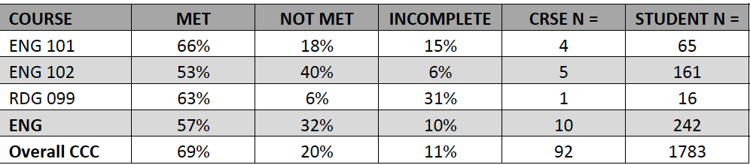 | 75% met

ANALYSIS: The following comments were collected for both ENG 101 and 102:

ENGLISH (ENG) COURSE CHANGES

ENG 101 Enhancing student learning for this course would involve additional lessons on the evaluation of academic source material, application of the source material in
supporting an argument, and correctly documenting these sources in an essay.

ENG 101 My threshold for determining whether or not students met the learning outcome was high because I took the idea of support seriously. The student essays that did not meet my threshold failed mainly in the area of using specific evidence to support their ideas. The majority of evidence used came from broad statements from experts, for
example, or generalized or hypothetical examples. Reasoning was strong, but the
evidence was weak.

I think enhanced instruction/practice in how to find and use specific evidence ‐ and
the difference between specific evidence and general statements might help. I also
may require the SEE structure for this assignment, as that paragraph structure
includes evidence as a built‐in component.

ENG 101 For future classes I would also spend some time teaching more logical fallacies since many students were able to spot errors or deceptions in reasoning, but they didn't have the terms to name and analyze them.

ENG 101 No action was necessary. The students who did not meet the requirements did not actively participate in learning.

ENG 102 It's clear that I need to make adjustments to support student learning for this
outcome. Ideas for improvement include expanding the lessons I teach on
summarizing, paraphrasing, and quoting to integrate evidence into arguments;
revisiting paragraph structure to show students how to craft topic sentences and then
support them clearly; and perhaps even taking a more formulaic approach to
paragraph construction in the first few weeks of the semester to help students get
comfortable with integrating evidence more smoothly into their writing. Especially for
online classes, I can find or make video tutorials that show students how to write a
paragraph and integrate evidence effectively.

Another idea I have is that after moving away from using the Three Thoughts
assignment (a reading response tool I developed and used in previous semesters to
help students learn how to integrate readings), I think I can bring it back and improve
upon it to further focus attention on integrating evidence to support conclusions. If
I've learned anything in assessing my courses this year, it seems certain this growth
process will be ongoing.

ENG 102 For the most part, the instructions and subsequent interactions with students on their analysis papers (abundant comments on what is working well and what isn't, with opportunity for multiple revisions for learning the material) gives students multiple
opportunities, examples, and one‐on‐one instruction to learn the material for this
essay and outcome. One thing that might be improved is a better link between the
listed outcome in the syllabus and the Essay 1 assignment.

ENG 102 I would not change any student learning because the students who completed the assignment, did very well. The other two simply did not do the work.

ENG 102 This assignment was followed up on in class, as a group, in order to chart our
collective research strategies, which I thought was a necessary follow‐up ‐‐ a collective
action to what began as an individual assignment. I would do something similar in the
future.

ENG 102 I've used this assignment for 2 years and I'm always a bit confused that there are 4 or 5 students in any given class who simply aren't ready to grasp thinking critically and deeply about a subject. I am most baffled by the student who doesn't even want to
try and would rather stay in a comfort zone rather than use the challenge to excel. For
instance, this semester I graded a paper called "The Art of Smoking." The men
sometimes write about professional athletes. I let them try because I want them to
expand that way they think about rhetoric, but they may benefit from limits in the
future.

Course-level and individual instruction is addressed, but it is difficult to ascertain an overall program assessment without using an instructor-]shared assignment.
ALREADY TAKEN/FUTURE ACTIONS: No action taken at this time. Future actions include a clear, shared understanding of the assessment project, purpose, and benchmarks, using a common assignment and assessment norming session with all full- and part-time faculty.

UPDATE ON PREVIOUS ACTIONS: N/A

Because critical thinking is not the main focus of ENG 272, the results were higher.

ENG 101 and 102 focus extensively on critical thinking skills. [Using a variety of inquiry methods, resources, and reasoning skills that
support and promote lifelong learning.]

