2018-2019 Academic Program Review

**Program Review Documents should be completed and submitted to the appropriate dean/reporting supervisor and the assessment coordinator no later than June 30th, 2019.**

In section I, provide a brief description of the program for someone who may not have direct interactions with the program. A more detailed explanation of the program will be included throughout the review document.

1. **Overview**
   1. **Narrative**: **State the purpose of the program and its contributions to the community***.*

Arts and Humanities courses do not constitute a distinct program at CCC, but rather, Arts and Humanities courses fulfill general education requirements. A & H classes are especially important for our students who plan to proceed to bachelor’s level institutions and beyond. These courses encourage students to explore, question, compare, and analyze moral, aesthetic, intellectual, spiritual, and cultural ideas and works.

All General Education coursework, and hence our Arts and Humanities courses, must fulfill the following criteria:

1. Meet the particular AGEC category criteria.

2. Promote intellectual exchange as an essential part of the learning process

3. With the exception of composition and math courses, all courses must provide tools for a broad

understanding of the world, humanity, and the role of individuals within both.

4. Be graded as A/F only, S/U grading is not allowed.

5. Be accepted for transfer credit as elective or better at all three Arizona state universities according to the

Course Equivalency Guide for the academic year in which the course was taken.

**Define what sets this program apart from other programs in the college.**

We are not a traditional program. Arts and Humanities occupies a unique place within the general education curriculum. Part of what makes our program unique is that diverse menu of courses offered requires us as educators to explore interdisciplinary connections among the broad range of subject areas -- principally art, literature, philosophy, history, and religion -- generally included within the Academic hemisphere known as "the Humanities."

**How does the program gather input and/or respond to community needs?**

We do not have a mechanism for receiving input from the community at large, but we do modify our content in response to those members of the community who enroll in our courses. The full-time faculty who teach Arts and Humanities general education courses do ongoing assessment to coordinate with one another regarding our overall objectives and categories which we use to define our outcomes. We have recently revised our definitions for our Thinking Skills and Communication performance measures. We have also collected data in the Spring of 2018 which measured student performance in regards to our Thinking Skills performance measures. In the current Spring of 2019 we will gather data for Communication.

As individuals, our faculty have engaged the community outside of class through several venues. Aaron Rizzieri has been a speaker as a part of CCC’s “ED TALKS” series, which is a series designed to directly engage the community around the 4th street campus. Professor Rizzieri collaborated with a student veteran on the topic of what we can learn from our war veterans regarding community. Rizzieri has also participated in a public forum on “Toxic Masculinity” which was run in conjunction with Philosophy and the Public Interest and the CCC common read program. Matthew Hernando is scheduled to give his own ED Talk in the Fall of 2019 which will be historical in nature.

**How long has the program existed?**

The Arts and Humanities general education program started with the college in 1991.

**When was the last program review?**

There has not been a systematic program review for Arts and Humanities before now. CCC has been reworking program assessment for all academic programs in order to put us in line with best practices.

* 1. **Program goals**: **Define the program goals.**

In our Art and Humanities courses our students learn to:   
  
1. Examine, analyze, and evaluate aesthetic and philosophical contributions of humanity.

2. Cultivate intellectual curiosity and a desire for the pursuit of knowledge.

3. Examine, analyze and evaluate significant trends from various cultures and epochs. In our Humanities survey courses, for example, we explore the connections between trends in science, religion, philosophy, and political theory and corresponding movements in the visual and performing arts, music, literature, and other forms of human self-expression. An example of this might be how the 19th century artistic and literary movement known as Romanticism responded to such changes as the Enlightenment, the Industrial Revolution, and the Napoleonic Wars in Europe.

4. Develop critical thinking and communication skills because our courses teach critical thinking, holistic thinking, and creative thinking skills which are necessary to succeed in advanced undergraduate and graduate level coursework.

All Arts and Humanities courses within the Arizona General Education Curriculum are tasked with teaching critical thinking and communication skills and assessing how well those courses meet the general education learning outcomes for critical thinking and communication. In the English Department’s creative writing courses, for example, students use critical thinking in analyzing and evaluating literature to see how various authors incorporate the established elements of fiction, creative nonfiction, and poetry. Students also employ critical thinking as they work on their Final Portfolios. Not only must they revise and edit their work to meet the high standards of publishable literature, but they must also write a reflective essay that analyzes the themes and characteristics of their work and charts their personal and academic growth over the semester. As for communication in those classes, students share their insights and interpretations about the assigned literature in class discussion, give presentations about authors and their work, and write about issues, themes, events, and people that are important in their lives.

**Describe how the program goals are tied to the institutional mission statement***.*

CCC’s institutional mission statement is as follows:   
  
“As a learning-centered college, Coconino Community College enriches lives by embracing diversity and transforming the future through quality education.”

Our Arts and Humanities classes are a main driver in exposing students to a diverse range of ideas, cultures, and cultural institutions through both historical and contemporary explorations. Understanding a broad plurality of ideologies and the various rationales behind them as they have been embedded in cultural contexts is necessary for the development of a perspective on the world and her peoples that is truly open to contingency and difference. Dissemination of this knowledge of the value of various types of cultural practices and institutions is a precondition of having a populace that can vote intelligently and relate to others in an empathetic manner.

* 1. **Decision making**: **Describe how decisions are made within the program.**

Decisions regarding the deletion, revision, and addition of new Arts & Humanities courses in the AGEC follow a streamlined process within the college. Individual instructors and their departments first design, develop, and revise curriculum during the fall semester and up to the beginning of the following spring term. In January and February new and revised curriculum is submitted to the General Education Committee through ACRES, and then is reviewed by that committee. Curriculum that does not meet our general education outcomes and criteria is returned to the instructor for revision, and approved courses are passed up to the Curriculum Committee for further review. The Associate Dean of Curriculum and Assessment and the Dean of Learning also review and approve the curriculum before sending it up to higher administration.

The full-time faculty who teach Arts and Humanities general education courses do ongoing assessment to coordinate with one another regarding how to define and evaluate the categories which we use to define our learning outcomes. We have recently revised our definitions for our Thinking Skills and Communication performance measures.

**Describe the communication process within the program***.*

See prior entry on how decisions are made within the program. Furthermore, we have recently selected a Faculty Senator (Aaron Rizzieri) who will represent our program at the college Senate for the 2019-2020 academic year. Colleen Carscallen will be serving as the Lead Faculty Member for A & H during this time as well. Having persons in these two newly created position will help us move towards establishing more formal and regular communication patterns. At the moment, our communication procedures within the department, apart from what has been delineated in regards to decision making, is very informal.

**Define any outside agencies that inform decision making and their scope***.*

There is a statewide general education ATF that determines requirements for the AGEC and our primary transfer institutions*.* There are also more specific ATF’s for Philosophy, Art, English, and History which have an effect on how classes transfer and what their content should be.

* 1. **A statement of the program’s accomplishments in support of the college’s current strategic plan**
     + ***Provide the goals from the strategic plan that the program contributes to****.*

A total of four goals were developed for the plan based on input received from all areas of the college in the planning process. Those goals are:

1. CCC will provide learners educational opportunities that are accessible and affordable, while also being economically feasible for the College.

Response: Like all CCC classes our General Education Arts and Humanities classes are about one-third the cost of comparable classes at NAU. We provide classes through many formats and at many different times. These formats include Online, ITV, and extension campus offerings as well as many live offerings at our two main campuses. **We have put the modalities data in Appendix A which lists the modalities used for each course from 2013-2018 and some comparative success rates.**

II. CCC will promote a learner-centered environment that incorporates innovative strategies and   
 support structures intended to reduce student attrition, increase retention, and improve learning.

It is the norm for our Humanities, English, and Philosophy professors to make use of multi-staged writing assignments so that our students have an opportunity to revise their works in light of substantive feedback.Our professors all keep attendance and follow-up with students who are not attending. It is the norm for our professors to consistently give out assignments to track the students’ comprehension and completion. We make heavy use of student development resources, office hours, and tutoring services. There is a lot of student directed research in our English courses.

III. CCC will empower students to achieve their individual learning goals and implement   
 strategies to increase certificate and degree completion rates.

A & H has been deliberate about adding courses which fulfill the writing intensive gen ed requirement. There had been a shortage of such options which delayed degree completion. We have followed the college as a whole in being more deliberate about spacing how our courses are scheduled in order to be available to the broadest array of students. For many of our courses this has resulted in an alteration regarding when night time courses start and end, and the modalities through which they are offered. Furthermore, we have made increasing use of ZOOM technology even beyond ITV courses. Some of our online professors have used ZOOM to conduct review sessions for online courses.

IV. CCC will strengthen the College’s working environment by maximizing college resources,   
 expanding community outreach, and implementing effective personnel management and   
 employee development strategies.

The Arts and Humanities department has recently hired a full-time philosophy instructor and a full-time history and humanities instructor. This has enabled us to have more effective contact with our part time faculty for philosophy, religious studies. This has also enabled us to use a full-time instructor (Matthew Hernando) for our humanities capstone courses. We have coordinated with the Assessment committee in regards to working with all of our faculty to revise the course objectives of large number of our courses in order to better fit the four main learning objectives for A & H general education classes. The diversification of times for classes alluded to earlier and the diversity of modalities through which we teach are relevant here as well.

In the following sections II-IV, provide a detailed description and provide evidence and data to support the claims.

1. **Teaching and Learning**
2. Program requirements and course offerings
   * 1. Degrees and Certificates
        + *Discuss any changes to the degree and certificate outcomes within the program.* (A curriculum map with the degrees and certifications will be provided by the assessment team to be included in the Appendix.)

Arts and Humanities is not a degree or certificate program. However, our classes contribute to fulfilling most of the degree programs throughout the college and many certificate programs as well. Here is a run-down. (**See Appendix B for a complete breakdown**)

**Associate of FIne Arts**

The Associate of Fine Arts degree in Visual Arts is intended for transfer to a variety of bachelor's degrees in visual arts at all Arizona public universities, as well as for life-long learners seeking a solid foundation in studio art. The program gives students a strong foundation in visual composition and art history and prepares them to continue their education in drawing, painting, photography, ceramics, sculpture, or any number of design disciplines. Students completing this degree will transfer 60-64 credits to all Arizona public universities.

**Philosophy and Religious Studies**

Neither philosophy nor religious studies is a degree or a certificate program in itself.Philosophy and religious studies classes tie into other programs at the college in such a manner that changes to those programs do not have a large effect on philosophy offerings. More specifically, three philosophy classes (PHI 101 (Introduction to Philosophy), PHI 103 (Introduction to Logic), and PHI 105 (Introduction to Ethics)) and REL 201 can be taken to fulfill general education degree requirements in a substantial portion of our degree programs in the form of AGEC elective credits. Furthermore, PHI 105 is an AGEC recommended course for our AA in Business degree.

**Humanities:** Humanities is not a degree or a certificate program in itself. In the Spring of 2018 we were hiring a full-time faculty member in history and humanities, but up to that time we had never had a full-time faculty member in that area.

* + - * *Discuss any opportunities and impacts to the program from changes to degrees and certificates at the college.*

**Philosophy and Religious Studies:** Looking forward, CCC is considering folding many of our degree programs into two specific degrees. One is an Associate of Arts in Transfer Studies, and the other is an Associate of Science in Transfer Studies. If this does take place, students who desire to pursue a philosophy degree at the bachelor’s level will have the flexibility to take a large number of philosophy courses.

**English:** ENG 238 is a required course for the Colorado Plateau Studies degree and the Environmental Studies degree; therefore, retirement of this course would directly impact these programs. Likewise, if changes to the degrees occurred, enrollment in ENG 238 may be adversely affected.

* + 1. Course Offerings
       - *Discuss course offerings, types of courses, modalities, scheduling of courses and frequency of offerings.*

**Appendix A contains a detailed breakdown of the rates of success students have had in our classes broken down by modality.** Here is a summary of that data:

Humanities 242 did not show great fluctuations in data in regards to modality.

Music 100 had very bad online success rates in comparison to their live courses. MUS 145 and 200showed consistent results across modalities.

PHI 105 students had a seven percent higher completion rate than PHI 101 students. For both classes, ITV receiver and online students did considerably worse than live students.

REL 201 had consistent results across modalities except for ITV receiver students.

The ART classes had pretty consistent results across modalities.

ENG classes had pretty consistent results across modalities.

ANT classes had pretty consistent results across modalities.

**Here is a table which lists the semesters when many of our courses are offered and the modality through which they are offered:**

|  |  |  |  |
| --- | --- | --- | --- |
| Types of Courses | Modalities | Scheduling | Frequency |
| ART 100: Art Appreciation | In-person, online | Fall, Spring, Summer | Every semester |
| ART 201: Art History I | In-person | Fall | Every year |
| ART 202: Art History II | In-person | Spring | Every year |
| ART 221: Art of the Southwest | In-person |  | Irregularly |
| CPS 100: An Overview of the Colorado Plateau | In-person, online | Fall, Spring, Summer | Every semester |
| ENG 272: Creative Writing Nonfiction | in-person, online | Fall, Spring, Summer | Every semester |
| *ENG 236: Intro to the American Short Story | in-person | Not offered | N/A |
| *ENG 237: Women in Literature | in-person | Not offered | N/A |
| ENG 238: Literature of the Southwest | in-person, online | Fall | Once per year |
| Hum 205: Technology and Human Values | In-person | Fall and Spring | Every Semester |
| Hum 235: American Arts and Ideas | In-person | Spring (till AY 2015-16) | Once per year |
| Hum 241: Humanities I | In-person, ITV | Fall | Once per year |
| Humanities 242: Humanities II | In-person, ITV | Spring | Once per year |
| PHI 101: Introduction to Philosophy | in-peron, online | Fall, Spring and Summer | Every semester (multiple sections) and summer |
| PHI 103: Introduction to Logic | in-person | Spring | Once per year |
| PHI 105: Introduction to Ethics | in-person, online, ITV | Fall, Spring, and Summer | Every semester (multiple sections) and summer |
| REL 201: Comparative Religions | in-person | Fall, Spring | Every semester |

*ENG 236 was last offered in 2013 but was canceled due to low enrollment, likely because its transfer status changed.

*ENG 237 was not offered for the past five years due to historical low enrollment.

*REL 241 has not been offered since 2013 and is being sunsetted.   
*PHI 103 is being taught again in the Spring semester for the first time in a long time (prior to 2013).

* + 1. **Enrollment and student success information for the previous five years**
       - *Elaborate on any patterns or outlying data contained within provided tables.* (**See Appendix A for breakdown by modality and Appendix C for a breakdown by semester**.) The first set of data tables will contain a breakdown by course of student success rates overall, by campus, by instructional method, and by session (Appendix A). The second set of data tables will contain an overview of the number of courses, sections, enrollments, and potential tuition earned for the previous five years. (Appendix C))
       - *Discuss other data collected by the program if desired.*

**Art:** In general, students taking Art History and Art Appreciation courses do well in their courses. Most courses have a success rate above 70%. A notable exception are the two art history survey courses ART 201 and ART 202, which have averages of 66% and 67%, respectively. One explanation for this may be the generally poor critical thinking skills that are captured in recent assessment projects. Art history is a particularly rigorous discipline and many lower division students today have developing study habits that don’t lend themselves to adequate preparation for writing assignments and exams. We do try to ameliorate this condition, and ultimately it is up to the student.

**Humanities**: In general, students taking Humanities courses have a high success rate. The overall success rate over the last five years has been 79.8%. This is despite the fact that HUM 205, HUM 241, and 242 are all writing intensive courses. HUM 242 was offered in the summer of AY 2017-18, but there is no completion data for that summer session.

**Philosophy and Religious studies:** Since 2013, the success rates of students enrolled in philosophy classes has gone up and down. The low mark is right around 74% success and the highmark for a year is 84%. The average rate of success from 2013-2014 until 2017-2018 is a 79% success rate. There has been a large variety of part-time faculty during this period which may account for the fluctuations in success rates. I will be interested to see if the statistics become more consistent now that most classes are taught by a single full-time faculty member and one main part-time factulty member.. Another trend worth noting is that the ethics students have performed better than the PHI 101 students. This is not surprising as the subject matter of ethics is a bit more accessible than the subject matter of the 101 course. Students in both PHI 105 and PHI 101 have performed significantly worse online and as an ITV receiver class, in terms of completing the course. The success rate for REL 201 is a solid 80%. There has been comparatively less fluctuation from year to year for this class. This is likely attributable to the fact that a single part-time faculty member has taught the bulk of these courses.

**English:** ENG 238 --68% success rate in the past 5 years. Success rate dipped in 2015-2016 to 50% success rate, with 10 students. Average enrollment in the class was approximately 9 students. Enrollment is possibly tied to Colorado Plateau Studies program and most likely not reflective of A&H program overall. The reason is that because there is no direct transferability, this is not a high-interest class.

**ENG 272-**-looks great. Overall success rate is 84%. The sample size is 635 students and we average 123 per year. This course is offered in-person and online.

1. Licensure/certifications of students
   * *Discuss what licensures/certifications students may be able to obtain upon completion of the program.*
   * *Outline the requirements for each licensure/certification.*
   * *Describe how the program contributes to the student’s ability to achieve the current licensures/certifications.*
   * *Discuss any impediments to the student obtaining the licensures/certifications.*

**ART**: ART 100, ART 201, ART 202, CPS 100, HUM 205, HUM 235, HUM 241, and HUM 242 do not directly lead to any certification or licensure.

**Philosophy and Religion:** PHI 101, PHI 103, and PHI 105 and REL 201 do not directly lead to any certification or licensure except the AGEC.

**English:** ENG 238 and 272 do not lead to any certification or licensure.

1. Curriculum
2. Course outline reviews and updates
   * + - *Define how often course outlines are reviewed and updated.*
       - *Discuss changes made to the course outcomes since the last program review.*
       - *Discuss the effects these changes have had on the program.*

ART course outlines are reviewed and, as required, updated approximately every five years or more often as required. The art classes are ART 100 (2001 ), ART 201 (2007), ART 202 (2007), CPS 100 (2004).

**Humanities**:

HUM course outlines are reviewed and, as required, updated approximately every five years or more often as required. HUM 205, HUM 235. HUM 241, HUM 242. Beginning in AY 2018-19 there will be a full-time faculty member in history and humanities, who will undertake regular and necessary reviews of these courses.

**English:** Course outlines are reviewed and updated approximately every five years or more often as required.

**Philosophy and Religious Studies:**

These course outlines are reviewed every five years or as required. The PHI 103 (intro to logic) course outline recently received a thorough rewrite in order to bring it into line with the course outcomes of similar courses taught at other AZ community colleges and four year colleges. This was to ensure it would be accepted as a general education course. The number of outcomes was reduced , and those that remained altered. PHI 103 is being taught in Spring 2019 and has solid enrollment. These changes have enabled the instructor to teach the same type of content as taught elsewhere. When Aaron Rizzieri was hired as the full-time philosophy faculty member in 2017 he reviewed the outlines for PHI 101, and PHI 105 as well. No alterations were made.   
  
The REL 201 has also been looked at by Aaron Rizzieri an Joe Maniglia, who is a part-time faculty member that teaches the REL 201 course, during the Fall of 2018 and no changes were made.

1. Other curriculum changes

* + - * *Describe any curricular changes since the last program review such as program outcome changes, pedagogy, software updates, different delivery methods, or different time offerings.*
      * *Note any impending course changes.*
      * *Discuss the effects these changes have had on the program.*

**Philosophy and Religious Studies:** REL 241 is being sunsetted. PHI 122 (Philosophy of Religion) has been approved by the faculty committee and approved for transfer credit to ASU, U of A, and NAU for philosophy elective credit. This course is now being put through the process of being approved for General Education credit and for fulfilling the special requirement of Contemporary Global/International Awareness or Historical Awareness. PHI 105 (Introduction to Logic) is being taught this semester (Spring of 2019) and has filled to near capacity.

**English**: ENG 272 in-person time offerings will be changed from evening courses to morning courses for an anticipated increase in enrollment of 5-10%. The department is investigating direct transferability of courses as well as researching prior enrollments to determine viability. The department is also considering submitting updates of selected courses to fulfill Gen. Ed. special requirements for improved student enrollment, direct transferability to Arizona universities, expansion of the Creative Writing Program, and student success.

**Everyone**: We modified the criteria for meeting the Critical Thinking requirement during the 2017-2018 academic year.

**Humanities:** There have been no modifications to course outlines over the last five years. There are no impending course changes.

1. Articulation
   * *Describe the program’s participation in Articulation Tasks Forces.*
   * *Discuss changes in transferable courses.*
   * *Provide elaboration on any courses that are only transferable as electives or non-transferable.* (A transfer table of the courses will be provided by the assessment team to be included in the Appendix.)
   * *Discuss at what level of transfer or workforce the curriculum prepares students for.*

**Fine Arts:** A Fine Arts faculty representative attends the Arizona Art Articulation Task Force meeting each fall. Aside from assigning SUN course numbers, there have been no recent changes in transferable ART courses. ART100, ART 201, and ART 202 all transfer as their equivalent courses. CPS 100 transfers as an elective. ART 100 and CPS 100 prepare students to transfer as sophomores, while ART 201 and ART 202 prepare students to transfer as juniors.

**Humanities**:

A Humanities faculty representative attends the Arizona Humanities Articulation Task Force meeting on an as needed basis. There have been no recent changes in transferable HUM courses. All humanities courses transfer as credit to the state universities and community colleges.

**Philosophy and Religious Studies:** In the Fall of 2017 and the Fall of 2018, Aaron Rizzieri has attended both the Philosophy and Religious Studies ATF meetings. Since PHI 101, PHI 103, and PHI 105 are AGEC courses no changes at the four year schools had an impact on our philosophy offerings. No changes in curriculum at the three four year schools have affected REL 201 either. Regarding changes in transferable courses. As noted above, the course outline for PHI 103 has been altered to fit accepted standards for the course.   
  
Our REL 201 transfers to both NAU and ASU as an equivalent for their World Religions courses. But, UA only accepts it as an elective credit. NAU and ASU are our two biggest transfer schools, but it would be better if UA offered more than elective credit.

**English:** We have been in the rotation to host the ATF at our campus. It is always the responsibility of at least one full-time English faculty to attend. As previously discussed, English faculty are researching transferability of Arts and Humanities courses for student success. Currently, ENG 236 and ENG 238 transfer as elective credits only. The English courses offered in Arts and Humanities assist students in meeting AGEC requirements.

1. Is the program accredited by a programmatic accrediting agency? If so, name the agency and include the status of the most recent accreditation.

**ART** - Not accredited.

**Humanities** - Not accredited.

**Philosophy and Religious Studies-** Not accredited.

**English** is not accredited by a programmatic accrediting agency.

1. Teaching loads
   * *Provide a description of the responsibilities and loads of the full-time faculty.*
   * *Provide a description of the responsibilities and loads of the part-time faculty.*
   * *Discuss the delivery methods of the courses.*
   * *Discuss any release time of the full-time faculty.* (Charts and tables detailing the number of courses and sections taught by full-time and part-time faculty will be provided by the assessment team to be included in the Appendix.)

All full-time faculty at CCC are required to teach 30 credit hours per academic year, serve on two committees, and perform other duties as assigned. Release time is granted for a limited number of activities such as evaluating part-time faculty, however, none of the full-time faculty in Arts and Humanities were granted such release time during the period under study. Part-time faculty are hired on an as needed basis for specific courses, and are expected to meet with students during class-times and perform course-relevant duties and assessment.

**Humanities**: During the period under study we had no dedicated full-time humanities instructors. Humanities courses were taught by a variety of credentialed full-time and part-time instructors. Humanities courses have been taught in a face-to-face lecture format, in ITV format, and in seminar format.

**ART** – FT – 30 load hours/academic year, Pt - <20 load hours/academic year Delivery method/modality is identified above.

**Philosophy and Religious Studies**: Aaron Rizzieri, who is the full-time philosophy faculty member taught 30 units of philosophy a year in the Fall and Spring semesters and has not taught any summer classes.

Joe Maniglia teaches either two or three sections of REL 201 each Fall and Spring semester of each academic year. A summer section, which Mr. Maniglia teaches, is also usually offered. Other adjuncts have taught Religious Studies over the past five years, but Joe is our only active religious studies part-time professor.   
  
Hana Maris teaches one or two sections of philosophy each Fall and Spring semester. Other adjuncts have taught philosophy over the past five years, but Hana is our only active philosophy part-time professor. Ms. Maris has also taught for us in the summer.

**English**: ENG 236 Introduction to the American Short Story has not been offered in several years.

ENG 237 Women in Literature has not been offered in several years, but will be offered online in Spring 2019 and taught by a full-time instructor.ENG 238 Literature of the Southwest is taught by Colleen Carscallen, Dean of Assessment and Curriculum, online. ENG 272 Creative Writing: Non‐Fiction has been taught by part-time instructors Kate Harkins and Allison Gruber both in-person and online, but the course is currently taught by Jeremy Martin and Sandra Dihlmann, both full-time instructors.

1. **Faculty credentials**
   * *Describe minimum credentials needed to teach in the program.*
   * *Discuss any specializations or achievements of the current faculty.* (A table listing the program faculty for the last five years with the faculty members’ degrees will be provided by the assessment team to be included in the Appendix.)

**All**: Prior to AY 2017-18, for the minimum qualifications for teaching in each discipline, the college followed credentialing guidelines established by the state of Arizona. Beginning in the Springing semester of 2016 CCC began a transition to the guidelines established by the Higher Learning Commission. These new qualifications are laid out in Procedure 308-01 Faculty Credentialing and are laid out in the table below. These new credentialing standards were implemented in AY 2017-81. Here they are:

|  |  |  |
| --- | --- | --- |
| Program/Course(s) | Threshold Standards | Documentation Required |
| General Education and MUS 120 | Master’s degree in the field or Master’s degree and 18 graduate hours in the field | transcripts from a regionally accredited institution |

**Appendix D** contains a list of all faculty who have taught in the Arts and Humanities over the last five years and their credentials.

1. **Student Learning Assessment**
   * *Provide detailed descriptions on types of assessment used to measure student learning.*
   * *Describe any course level assessments that were conducted and the results since the last program review.*
   * *Report any shared assessments within the program and data gathered from those assessments.*
   * *Record any observations or trends found within the student learning assessment data.*

**Shared Assessments (program level)**

Starting in the Fall of 2017, the Arts and Humanities department started renewed and systematic efforts to gather assessment data at both the program level and individual course level. Given the diversity of classes in our program, program level assessment has been unified by the use of a common rubric, but there has also been a broad array of assignments to which the rubric has been applied to. Hence, it is not clear that the aggregate data is particularly meaningful. In any case, we will now review the rubric that was used and some of the results for our Spring of 2017 Arts and Humanities Critical Thinking Assessment.

**Arts and Humanities Critical Thinking Assessment for Spring of 2017:** The first chart below concerns an assessment which was run in the Spring of 2017 to assess critical thinking in particular. All of our full-time faculty participated and we used a common rubric which is the second chart on the left of the next page. Even though we used the same rubric, we each used different assignments to which we applied the rubric. The three criteria for the rubric are listed on the left hand side of the following two pages of charts.   
  
As you can see the students who participated in the ENG 272 and PHI 101 sections had the vast majority of students either meet the requirement or meet with concerns for each of our three criteria (relevant concepts, credible evidence and conclusion). In contrast, only 40% of the ART 201 students met the relevant concepts and conclusion requirements for the assignment. We did not gather as a group to discuss these results. We suspect the widely disparate results between the art students and the English and philosophy students has a lot to do with a failure on the part of us as faculty to agree on the expectations for students in relation to this assignment.

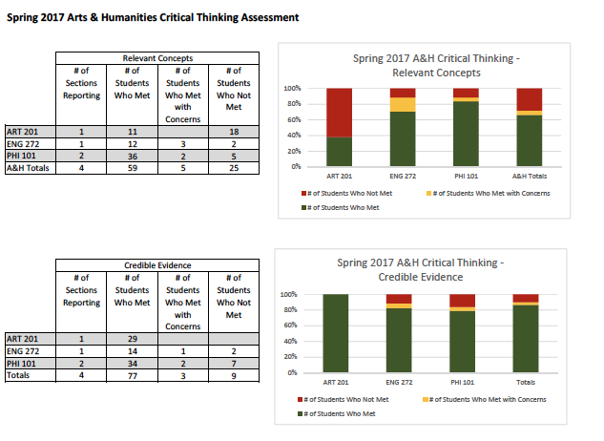

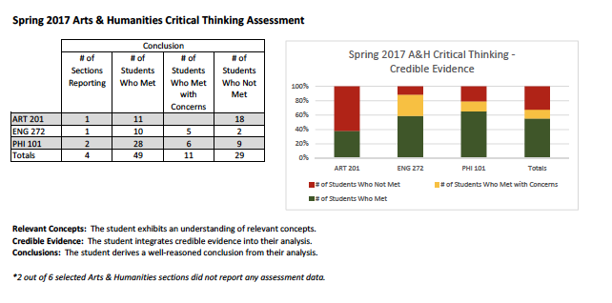

**Shared assessments (course level):** During both the Fall of 2017 and Spring of 2018 professors from a wide array of our courses submitted data that measured the following thinking skill:  
  
“use a variety of inquiry methods, resources and reasoning skills that support and promote lifelong learning”

If you scroll down to the following page you will find the data from the classes which participated in the Fall of 2017. Results were submitted by the individual professors on Canvas. Each professor assessessed an individual course outcome that fit under this particular program level outcome. Given the broad array of courses there was no common rubric used to assess these outcomes other that went beyond the very generic “met/did not meet” dichotomy. The faculty which participated did not gather as a group to discuss the results.

I have also inserted the aggregate data for the Spring of 2018 assessment in regards to the same thinking skills after the Fall of 2017 data.

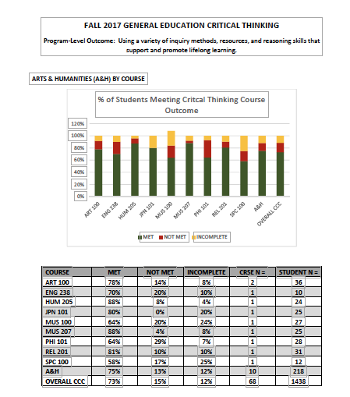

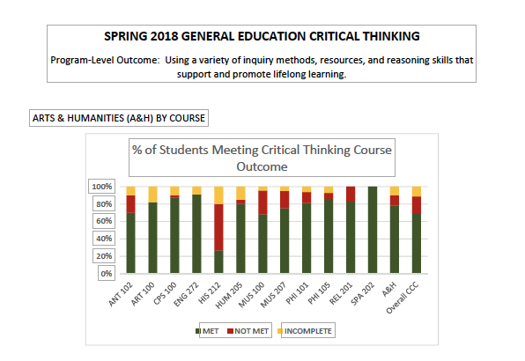

**Percentage of Students Meeting Critical Thinking Course Outcome -- Spring 2018**

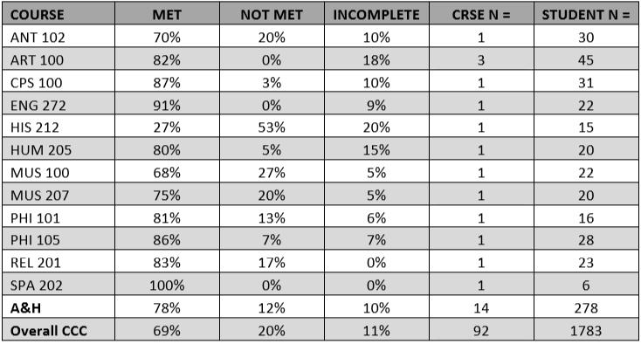

**Reflections on the 2017 and 2018 course level data:** The only highly anomalous outcome is in the History 212 class for the Spring of 2018. It is unclear why this course had such anomalous results.

1. **Facilities and Resources**
   1. Specify any designated space that is primarily for the program’s use since the last program review.
      * *Describe how the designated facilities contribute to the program’s overall student success.*
      * **Art and Humanities**: There are no facilities at CCC designated solely or primarily for the use of faculty or students in the humanities since the last program review. However, a large number of our classes -- especially Hum 241 and Hum 242 -- are taught in the new Zoom (formerly ITV) classrooms. These have been instrumental in making humanities courses available to the students at the CCC campus in Page, Arizona.
   2. Specify any designated equipment purchased primarily for the program’s use since the last program review.
      * *Describe how the designated equipment contributes to the program’s overall student success.*
      * **Art and Humanities**: There has been no designated equipment purchased solely or primarily for the use of faculty or students in the humanities since the last program review.
   3. Specify any designated budget and differential tuition that is primarily for the program’s use. (A program budget will be provided by the assessment team.)

* **Art and Humanities**: There is no differential tuition or budget item designated primarily for the use of faculty or students in the humanities since the last program review.

1. **Analysis and Reflection** 
   1. Strengths, Weakness, and Challenges Analysis

*This section should include related industry trends/academic program educational trends that support the program and its decisions in relation to the preparation of the students.*

**What do you see as internal strengths of the program?**

**Faculty –** We have gifted and highly dedicated faculty teaching in the arts and humanities. Our students, by and large, have performed well on the critical thinking and thinking skills assessments that have been performed over the last two years.

**Curriculum –** We have solid curriculum that is regularly assessed and updated as required. We offer a good variety of Arts & Humanities courses to students, especially for a small community college. We also do a good job coordinating our program requirements with the AGEC and other requirements of our major transfer institutions.

**Facilities –** Our classrooms are attractive, well-equipped, and highly functional.

**What do you see as internal weaknesses of the program?**

1. The program could be more cohesive in terms of faculty communication and more unified course offerings. We are technically not a unified program, but now that we have completed our first official program review, we can see the areas where we need to improve and can thus make some progress toward becoming more cohesive.

**What do you see as opportunities for the program?**

1. As we continue to revise and create new courses for CCC’s general education curriculum, we can offer a greater variety of courses, perhaps even designing some toward unified themes or topics.
2. We have an outstanding faculty here, and as we add more full-time faculty members to our program, we will only continue to grow as a program. Hopefully, by continuing to hire more high-quality faculty, we will only enhance our communication and expand our course offerings.

**What do you see as challenges of the program?**

1. With the college’s limited financial resources and small core faculty, it will be challenging to expand the Arts & Humanities program, but we are continuing to grow and we expect the program to become more cohesive and comprehensive over the next few years.
   1. Previous Recommendations and Results
      1. List recommendations that were received at the last program review.
         * *Elaborate on actions taken on recommendations and effects on the programs.*
      2. List any recommendations from Program Advisory Committees/Councils (if applicable).
         * *Elaborate on any actions take on recommendations and effect on the program.*
2. **Recommendations**

Provide recommendations for specific actions for continuous improvement of the program.

* 1. Five Year Plan
     + *Where will this program be in five years?*

This is a difficult question to answer as we are not a traditional program. We will do our best to keep on top of any trends at our major transfer institutions and do our best to make students are receiving the kind of broad humanities training that will enable them to think about how to apply their more technical training received in other courses in a humane way that promotes flourishing at the individual and societal level.

More specifically, we are excited to have both a Faculty Senate member and a Lead Faculty for the entire Arts and Humanities program starting in the Fall of 2019. These two positions will provide us with much of the cohesion which has been missing during the last two years. As we learn to think better together as a group we anticipate that new group level initiatives will emerge organically over the next few years.

* 1. Action Plan/Recommendations (To be completed in the next five years). List action items in order of priority of completion.
     1. Action Item #
     2. Anticipated date for completion
     3. List the potential benefits to student success
     4. Status update (Only update at Annual Review Meeting)

**Item #1**: The glaring deficiency which has emerged from our discussion of the data above and that provided in the appendix is that we need to meet as a group in order to discuss the results of the program level and course level assessments which were conducted over the last two years. We need to figure out why the History 212 and relevant Art course students did poorly on their critical thinking and thinking skills assessments. This will also give us an opportunity to meet and share the assignments we each used to conduct our individual assessments in relation to our common rubrics.

We will complete this action item in the Fall of 2019.

* + 1. Last reviewed date

**Appendix A: Arts and Humanities Courses: Success by Instructional Method**

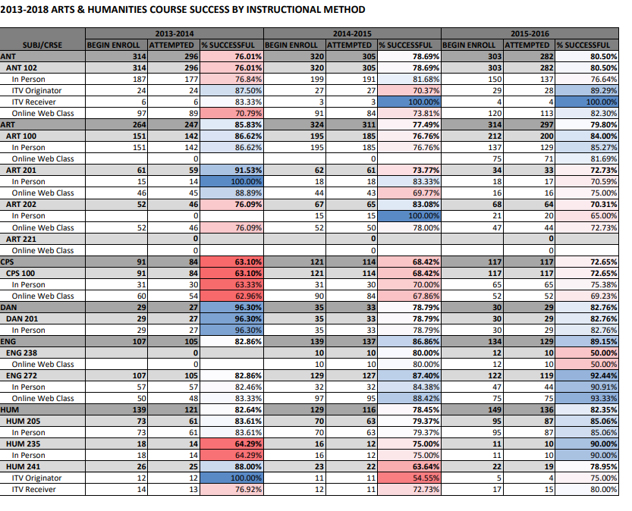

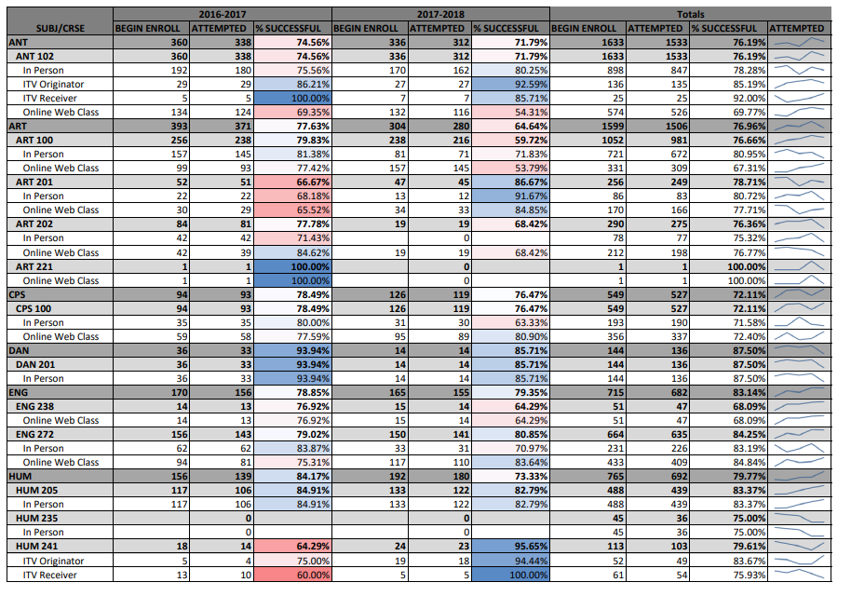

**Appendix B: Mapping of courses to degree completion and AGEC fulfillment**

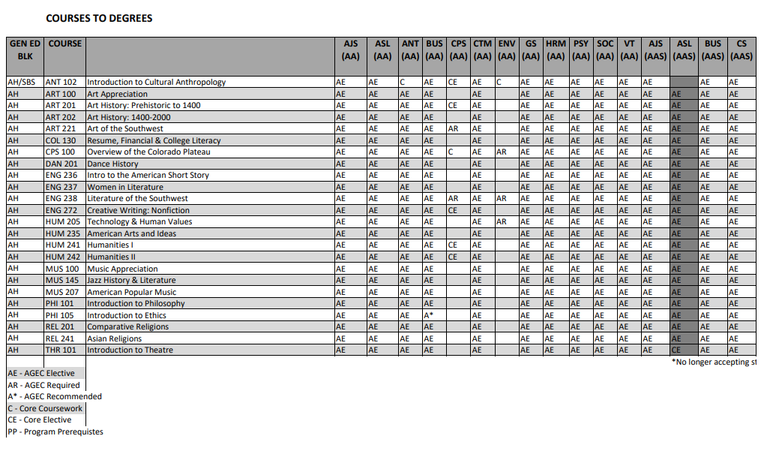

**APPENDIX C: Course success by semester**

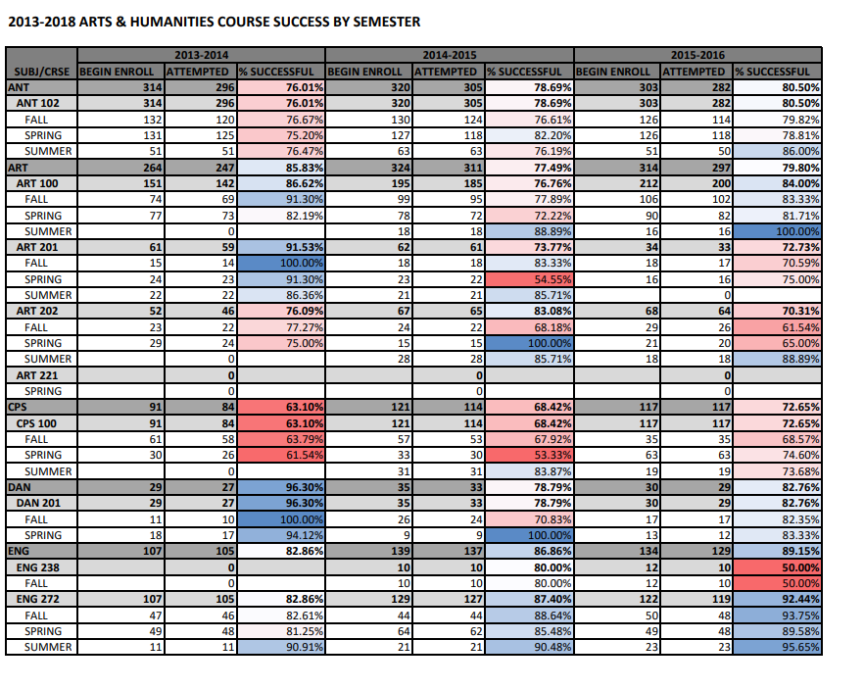

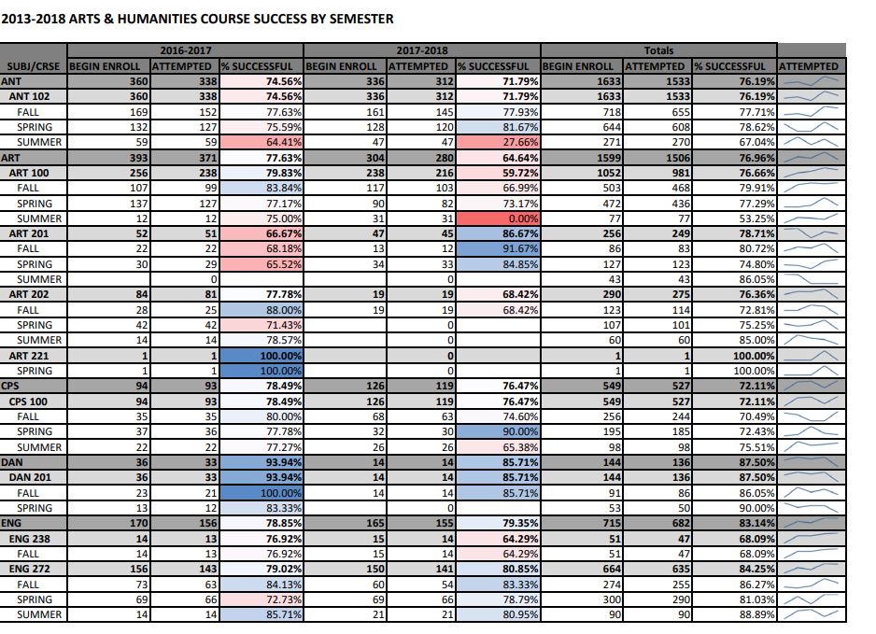

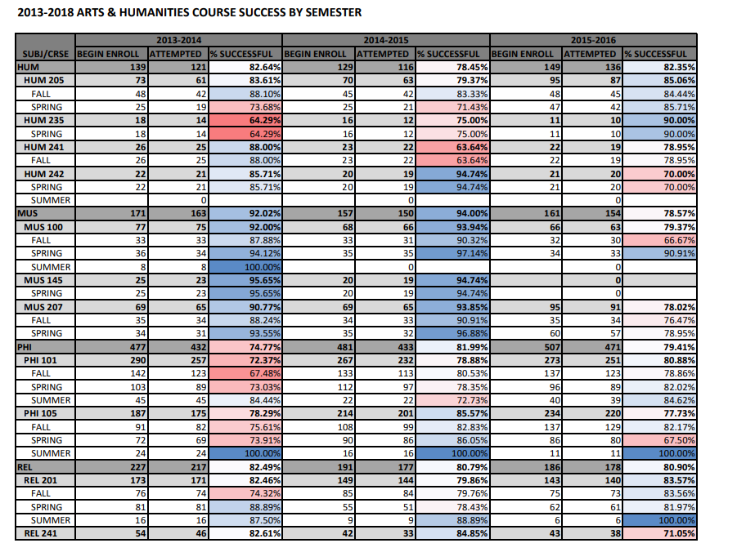

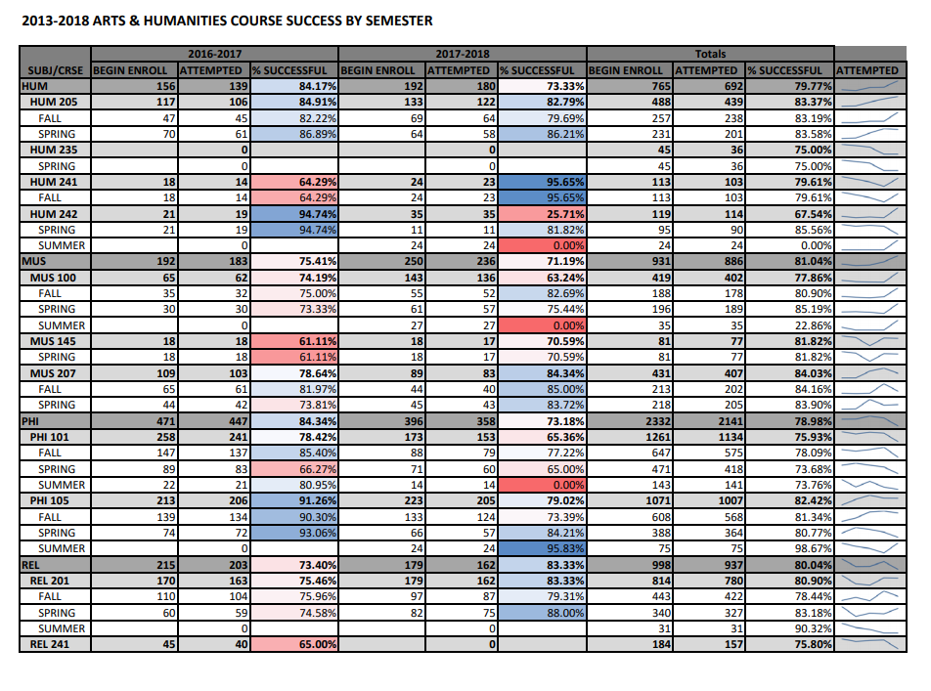

**Appendix D: Art and Humanities Faculty and their Educational Credentials**

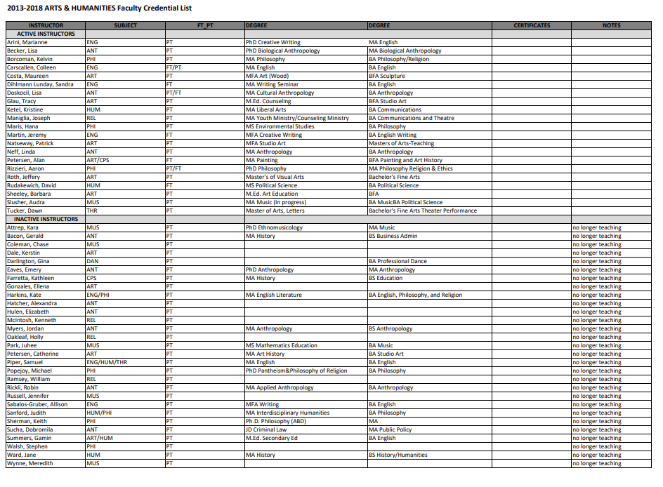

**Note: Joe Maniglia has completed additional graduate level coursework in religious studies in order to meet the HLC credentialin requirements. Hana Maris has completed additional graduate level coursework in philosophy to meet HLC standards.**